 | Worksheet | Sine Law - Toughies
1. | Melissa and Stacey are flying kites when all of a sudden the kites become tangled. At this moment, Stacey is standing 140m from the kites and Melissa is standing 200m from the kites. How far apart are Stacey and Melissa from each other if Melissa sees the situation from a 32º angle of elevation?
2. | Two camera men are filming a helicopter scene from the ground 20m apart. Camera man 1 is shooting the scene from an angel of elevation of 35º and camera man 2 is filming from an angle of elevation of 42º. How high from the ground is the helicopter movie scene taking place?
3. | Karen is taking a cruise to 2 different islands in the Caribbean. The boat departs from Miami, sails to Cuba, Puerto Rico and returns to Miami. How may kilometers has Karen travelled on her cruise?
4. | If N is the midpoint of BC, find the length of segment $\overline{MN}$ in the following.
5. | For the figure beside, find BC to the nearest tenth. | 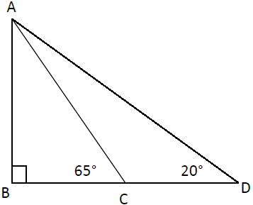  15
6. | For the figure beside, find m$∠EDG$ to the nearest degree. | 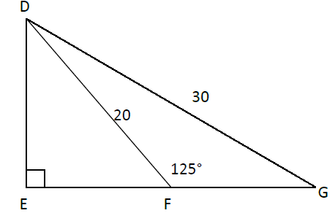
7. | Given that $∠ABC=25°$, find $m\overline{CD}$ to the nearest tenth. | 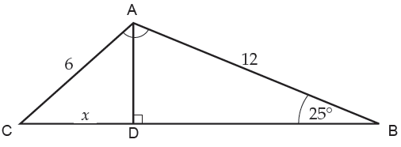
8. | Find the height of the building to the nearest meter. | 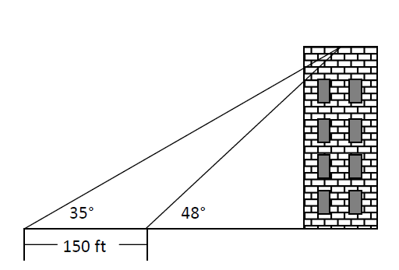
9. | Two lookouts 20 miles apart on the coast spot a ship at sea. Using the figure below find the distance, d, the ship is from shore to the nearest tenth of a mile.
10. | Jeff is landscaping his back yard. His layout for the renovation is given below along with some measurements he has taken.  Jeff needs to fence in 2 sides of the children’s play area along sides $\overline{EG}$ and $\overline{FG}$. How many meters of fencing does Jeff need?
Blast From the Past
11. | What is the measure of $\overline{AH}$ in the following triangle?
12. | $∆DEA\sim ∆CBA$. Find DE to the nearest whole number.

