1. | 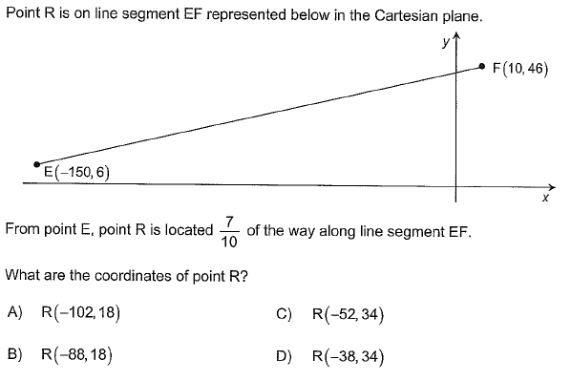
2. | Consider the linear correlation between variables x and y of a statistical distribution. The scatter plot below represents this distribution  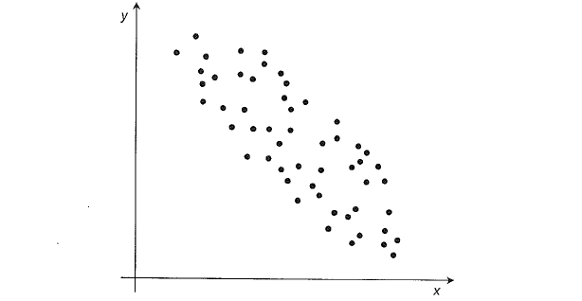  What is the approximate value of the linear correlation coefficient between these two variables?
 | Answer : _______________

3. | Information on two games of chance is provided below.  Game 1  After placing a bet, the player spins a wheel.  This wheel is divided into 8 congruent sectors: 3 are bluer and 5 are red.  - if the pointer is pointing at a blue sector, the player will receive $20  - if the pointer is pointing at a red sector, the player will receive $12  The game is fair.  Game 2  After placing a bet, the player randomly draws a marble from a bag.  The bag contains 20 congruent marbles: 7 are black, 4 are yellow and 9 are green.  - If a black marble is drawn, the player will receive $50.  - If a yellow marble is drawn, the player will receive $2.  - If a green marble is drawn, the player will not receive any money.  A player must bet the same amount of money to play either Game 2 or Game 1.  Is Game 2 to the player’s advantage, to the player’s disadvantage, or fair?  Explain your answer.

