1. | Which of the following half-planes represents the solutions of the inequality $y<\frac{2}{3}x-30$ in the Cartesian plane?  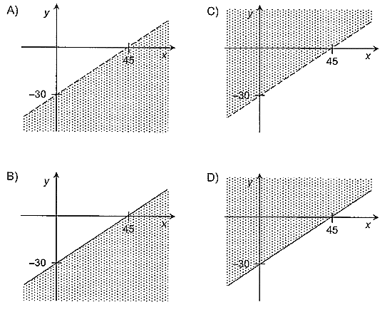
2. | Consider triangle EFG represented below.  What is the area of triangle EFG?
 | Answer : _______________
3. | A baker made an enormous cake with two tiers. The bottom tier was in the shape of a rectangular-based right prism, and the top tier was in the shape of a cube.  The baker decorated the lateral faces of the cake with borders consisting of geometric shapes out of sugar paste icing.

Three lateral faces decorated with these borders are represented below. All the rhombuses are congruent and all the circles are congruent.
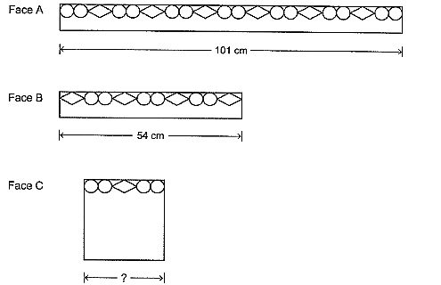
What is the length of the border used to decorate face C of the cake?

