1. | 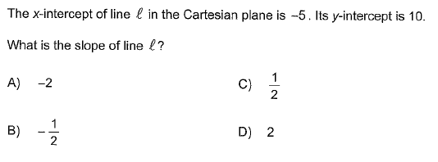
2. | 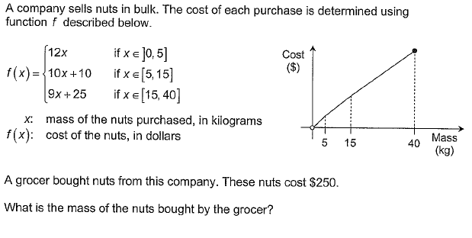
 | Answer : _______________

3. | Consider triangles NRQ, NSR, NTS, and NUT represented below.  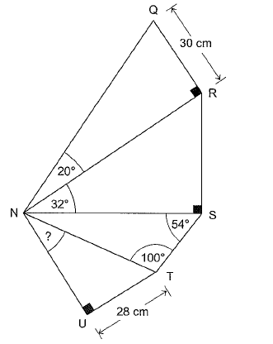  To the nearest degree, what is the measure of angle TNU?

