1. | 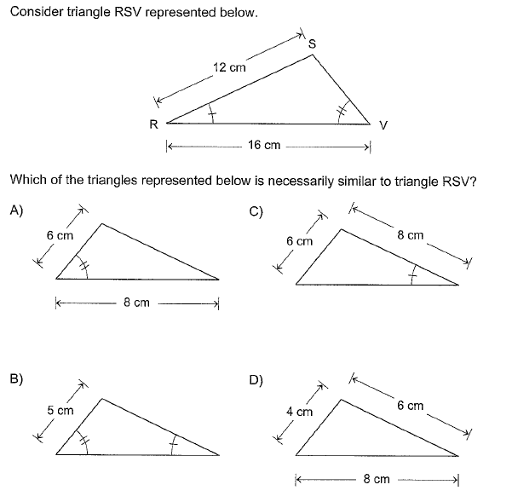
2. | 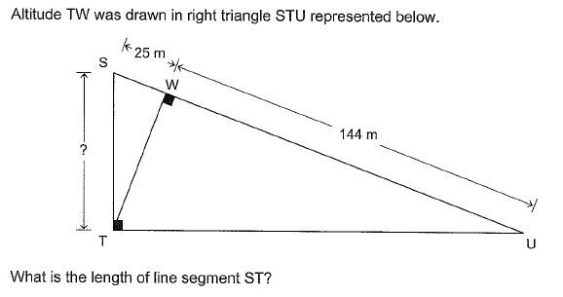
 | Answer : _______________
3. | A few years ago, Farouk and Gregory each made an investment on the same day.  Farouk’s Investment  Function f described below represents the value of Farouk’s investment.  $$f\left(x\right)=3 000(1.05)^{x}$$  where x: time elapsed, in years, since the day the investment was made  f(x): value of Farouk’s investment, in dollars  Today, to the nearest ₵, Farouk’s investment is worth $3 646.52.  Gregory’s Investment  Gregory invested $3 500.  Every year, the value of Gregory’s investment has increased by 4% in relation to its value the previous year.  From the day the investments were made, which of the two investments has gained the most value, in dollars?

