Secondary V English Language Arts D’Arcy McGee H.S.

Literary Codes and Conventions

The following is a list of terms that describe elements of writing and writing devices/techniques (codes and conventions) that are useful when reading, analyzing and writing fiction and non-fiction.
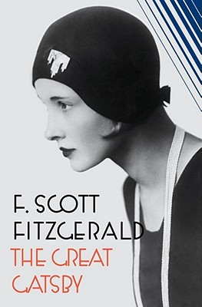

1. Allegory: The term loosely describes any writing in verse or prose that has a double meaning. It is an extended narrative in prose or verse which carries another meaning along with the surface story. The characters usually represent abstract ideas, moral qualities, or other abstractions.
A very good example of allegory is George Orwell’s novel Animal Farm, where farm animals revolt against the farmer. On a literal level it is a simple story about a farm. On a secondary level, it is an allegory of the Russian Revolution with each animal representing an historical person or abstract quality related to the Revolution.

2. Alliteration: The repetition of consonant sounds, especially at the beginning of words usually close together. This technique is used to draw attention to a particular part of a poem or narrative. It also serves to add continuity or fluidity to verse or narrative writing.
Tongue-twisters are good examples of alliteration: ‘Rubber baby buggy bumpers’ or ‘She sells seashells by the seashore.’ Alliteration is often used in newspaper or magazine headlines.

3. Allusion: A casual reference in literature to something familiar (a person, place, event, or another passage of literature): something or someone that the writer hopes the reader will recognize without needing an explanation. Allusions can originate in mythology, biblical references, historical events, legends, geography, earlier literary works or other media. Authors often use allusion to establish a tone, create an implied association, contrast two objects or people, make an unusual juxtaposition of references, or bring the reader into a world of experience outside the limitations of the story itself.

4. Ambiguity: When the meaning or outcome of a text can be interpreted in different ways (as in an open ending). Intentional ambiguity in literature can be a powerful device, leaving something undetermined in order to open up multiple possible meanings. When we refer to literary ambiguity, we refer to any wording, action, or symbol that can be read in divergent ways. Good example: The ending of the Sopranos.

5. Anecdote: A short narrative account of an amusing, unusual, revealing, or interesting event. A good anecdote has a single, definite point, and the setting, dialogue, and characters are usually subordinate to the point of the story. Usually, the anecdote does not exist alone, but it is combined with other material such as articles, expository essays or arguments. Writers may use anecdotes to clarify abstract points, to humanize individuals, or to create a memorable image in the reader's mind.

6. Analogy: The use of a more familiar or simpler thing or event to describe or explain something that is complex or confusing: ‘Think of the human brain as a calculator’.

7. Anti-hero: A protagonist who is a non-hero or the antithesis (direct opposite) of a traditional hero. While the traditional hero may be dashing, strong, brave, resourceful, or handsome, the anti-hero may be incompetent, unlucky, clumsy, dumb, ugly, or clownish. Examples here might include the senile protagonist of Cervantes' Don Quixote. Dexter from the TV show.

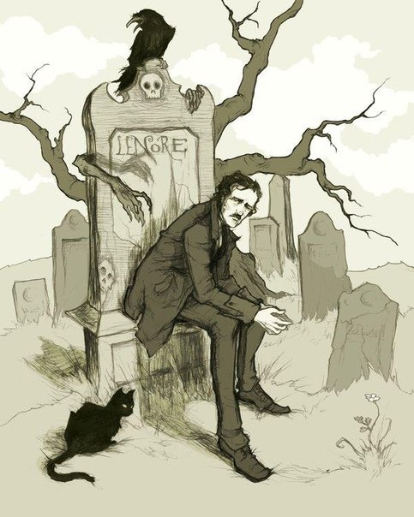Edgar Allan Poe

8. Antagonist: A character that is often seen to be creating conflict in a story. He or she stands opposite to the protagonist but is not always evil (Banquo is the antagonist in Macbeth yet he is not evil).
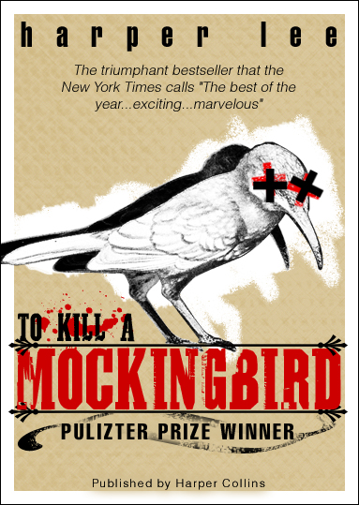

9. Archetype: An original model or pattern from which other later copies are made, especially a character, an action, or situation that seems to represent common patterns of human life. Often, archetypes include a symbol, a theme, a setting, or a character that some critics think have a common meaning in an entire culture, or even the entire human race. These images have particular emotional resonance and power. Archetypes recur in different times and places in myth, literature fairy tales, folklore, dreams, artwork, and religious rituals. The psychologist Carl Jung theorized that the archetype originates in the collective unconscious of mankind, i.e., the shared experiences of a race or culture, such as birth, death, love, family life, and struggles to survive and grow up. These would be expressed in the subconscious of an individual who would recreate them in myths, dreams, and literature. Examples of archetypes found cross-culturally include:
(a) Recurring symbolic situations such as the orphaned prince or the lost chieftain's son raised ignorant of his heritage until he is rediscovered by his parents, or the damsel in distress rescued from a hideous monster by a handsome young man who later marries her. These also include the long journey, the difficult quest or search, the pursuit of revenge, the descent into the underworld, fertility rites, the great flood, the end of the world, etc.

(b) Recurring topics/themes such as the Faustian bargain; pride preceding a fall; the inevitable nature of death, fate, or punishment; blindness; madness; taboos such as forbidden love, patricide, or incest, etc.

(c) Recurring characters such as witches as ugly crones who cannibalize children, womanizing Don Juan’s, the femme fatale, the snob, the social climber, the wise old man as mentor or teacher, star-crossed lovers, the caring mother-figure, the stern father-figure, the villain clad in black, the mad scientist, the victorious underdog.

(d) Symbolic colors such as green as a symbol for life, vegetation, or summer; blue as a symbol for water or tranquility; white or black as a symbol of purity; or red as a symbol of blood, fire, or passion, etc.

(e) Recurring images such as blood, water, pregnancy, ashes, cleanness, dirtiness, phallic symbols, yonic symbols, the rose, the lion, the snake, the eagle, the dying god who rises again, the feast or banquet, a fall from a great height, etc.

10. Bias (stance): In non-fiction pieces, when the writer’s opinion comes through and is detectable by the careful reader. In an objective piece bias is supposed to be avoided, though it is obviously necessary in an editorial or persuasive piece.

11. CARPE DIEM: Literally, the phrase is Latin for "seize the day”. The term refers to a common moral or theme in classical literature that the reader should make the most out of life and should enjoy it before it ends. Poetry or literature that illustrates this moral is often called poetry or literature of the "carpe diem" tradition. Examples include Marvell's "To His Coy Mistress" and Herrick's "To the Virgins, to Make Much of Time."

12. Character types: The four main types of characters are differentiated by how much we know of them and whether or not they change:

a) Flat: A character about whom we know only one or two things. (Two- dimensional)
b) Round: A character about whom we know many things. (Three-dimensional)
c) Static: A character, either flat or round, that does not change at all throughout the story.
d) Dynamic: A character, either flat or round, that does change at some point in the story.

13. CHARACTERIZATION: The process by which a character is described and developed as a story. There are two types:

a) Direct Characterization: The character is described by the narrator or another character as being a certain way. For example, ‘Jack was tough-minded with a strong-jaw to match.’
b) Indirect Characterization: We learn something about the character through the character’s actions, words or how they look. For example, ‘Everyday Jack climbed the steps like he was scaling Mt. Everest,’ or ‘Jack’s pants never seemed to be clean’.

14. Circular structure: A manner of organizing a piece of writing so that its sense of completeness or closure originates in the way it returns to subject-matter, wording, or phrasing found at its beginning. An example of circular structure is "The Secret Life of Walter Mitty," which ends with an ellipsis identical to the opening sequence, indicating that the middle-aged protagonist is engaging in yet another escapist fantasy. Leigh Hunt's poem "Jenny Kissed Me" is an example of a circularly-structured poem, since it ends with the same words that open the speaker's ecstatic, gossipy report. Langdon Smith's poem "Evolution" is circular in its concluding repetition of the opening phrase, "When you were a tadpole, and I was a fish."

15. Cliche: A cliché is a phrase or metaphor that was once fresh and original, but has become unoriginal and uninspired through overuse. Clichés are considered bad writing.
For instance, the phrases bite the bullet, breath of fresh air, at the crack of dawn, flat as a pancake, and in this day and age were once effective and striking phrases, but now are rather blunted in meaning and have little impact on any audience.

16. Colloquialism: A word or phrase used every day in plain and relaxed speech, but rarely found in formal writing: ain‘t, gonna, wanna, kinda, atcha, etc.

17. Coming-of-age story (also known as bildungsroman or a ‘rites of passage’ story):
A type of novel where the protagonist is initiated into adulthood through knowledge, experience, or both, often by a process of disillusionment. Understanding comes after the dropping of preconceptions, a destruction of a false sense of security, or in some way the loss of innocence.

Some of the shifts that take place are these:
◆ ignorance to knowledge
◆ innocence to experience
◆ false view of world to correct view
◆ idealism to realism, and
◆ immature responses to mature responses.

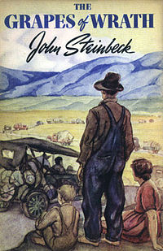
18. Conflict: Conflict is the obstacle a main character faces in a story. There are 2 main types:

a) External: Character vs. one or more of the following: nature (farmer vs. tornado), another character (police officer vs. bank robber), society (student vs. friends’ influence/peer pressure), the supernatural (Van Helsing vs. Dracula), technology (grandmother vs. new computer, Mr. Burke vs. killer robot), fate (disaster survivor vs. insurmountable odds), etc.
b) Internal: Character vs. self. (a murderer vs. his/her conscience, a soldier vs. duty)

19. Connotation: This is the perceived meaning of something. It may be very different from the denotation, or literal dictionary meaning of it. A word can have a positive or negative connotation. For example, the denotation of worm is a long slender animal that burrows in the earth. This word has a negative connotation since we often think of worms as slimy and disgusting. We also refer to someone who is not honest or straightforward as a worm.

20. Convention: A common feature that has become traditional or expected within a specific genre (category) of literature or film. In western films of the early twentieth-century, for instance, it has been conventional for protagonists to wear white hats and antagonists to wear black hats. It is a convention for an English sonnet to have fourteen lines with a specific rhyme scheme - abab, cdcd, efef, gg - and so on. The use of a chorus and the unities are dramatic conventions of Greek tragedy, while, the aside, and the soliloquy are conventions in Elizabethan tragedy.

21. Denotation: This is the dictionary definition of a word.
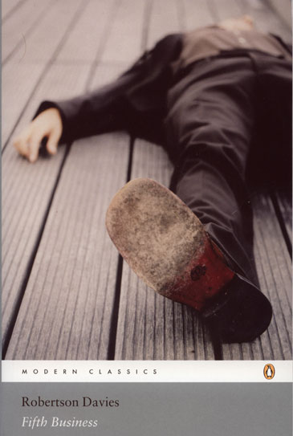Fifth Business by Robertson Davies
22. Deus ex machina: “God from the machine” This term is derived from ancient Greek drama when a device was often mechanically lowered onto the stage to solve some otherwise unsolvable conflict in the plot. It is now taken to mean any unlikely event or feature of a story that the author uses to resolve the conflict in the plot.

23. Diction: An author's choice of words (word choice). Since words have specific meanings, and since one's choice of words can affect feelings, a writer's choice of words has great impact in a literary work. The writer chooses his words carefully. Discussing his novel A Farewell to Arms during an interview, Ernest Hemingway stated that he had to rewrite the ending thirty-nine times. When asked what was the most difficult thing about finishing the novel, Hemingway answered, "Getting the words right."

24. Dystopian novel: The opposite of an utopian novel where, instead of a paradise, everything has gone wrong (often in the attempt to create a perfect society) and the result is a worst-case scenario. For example, the novels Nineteen Eighty-Four (1949) by George Orwell and Brave New World (1931) by Aldous Huxley explore dystopian societies.
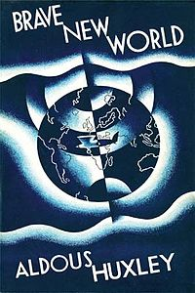

25. Epiphany: Christian thinkers used this term to signify a manifestation of God's presence in the world. It has since become in modern fiction and poetry the standard term for the sudden flare into revelation of an ordinary object or scene. In particular, the epiphany is a revelation of such power and insight that it alters the entire world-view of the thinker who experiences it. (In this sense, it is similar to what a scientist might call a "paradigm shift.") Irish writer James Joyce used the term epiphany to describe personal revelations in the short story "The Dead" in his short story anthology entitled Dubliners (1914).

26. Euphemism: The use of polite language to describe something that is not nice or desirable. For example, one might say, ‘he passed gas’ or ‘he is flatulent’ instead of ‘he farted.’

27. Flashback and Flash-forward: An element of plot whereby an author reveals plotline that occurs before or after the present. For example, the T.V. series Lost made use of both of these plot techniques. Although the “present” in the show involved characters surviving on an island, the show’s characters were developed by flashing back to their lives before crashing on the island and by flashing forward to after they have been rescued.

28. Foil: The word foil comes from the old practice of backing gems with foil in order to make them shine more brightly. In fiction, a foil is a character who contrasts with another character (usually the protagonist) in order to highlight particular qualities of the other character. A foil usually either differs drastically or is extremely similar but with a key difference setting them apart.
In Pride and Prejudice, Mary's absorption in her studies places her as a foil to her sister Elizabeth Bennet's lively and distracted nature. Similarly, in Shakespeare's play Julius Caesar, the character Brutus has foils in the two characters Cassius and Mark Anton.
In the Harry Potter series, Draco Malfoy arguably is a foil to the Harry Potter character; Professor Snape enables both characters "to experience the essential adventures of self-determination" but they make different choices.

29. Foreshadowing: An author’s use of hints or clues to suggest events that will occur later in the story. Not all foreshadowing is obvious. Frequently, future events are merely hinted at through setting, dialogue, description, or the attitudes and reactions of the characters.
Foreshadowing frequently serves two purposes. It builds suspense by raising questions that encourage the reader to go on and find out more about the event that is being foreshadowed. Foreshadowing is also a means of making a narrative more believable by partially preparing the reader for events which are to follow.
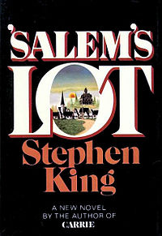

30. Genre: A type of literature. We say a poem, novel, story, or other literary work belongs to a particular genre if it shares at least a few conventions (standard technique or often-used devices), or standard characteristics, with other works in that genre.
For example, works in the Gothic genre often feature supernatural elements, attempts to horrify the reader, and dark, foreboding settings, particularly very old castles or mansions. Poe's short story "The Fall of the House of Usher" belongs to the Gothic genre because it takes place in a gloomy mansion that seems to exert supernatural control over a man who lives in it. Furthermore, Poe attempts to horrify the reader by describing the man's ghastly face, the burial of his sister, eerie sounds in the house, and ultimately the reappearance of the sister's bloody body at the end of the story.
Other genres include the pastoral poem, epic poem, elegy, tragic drama, and bildungsroman. An understanding of genre is useful because it helps us to see how an author uses, plays with, or advances the standard practices that other authors have developed. (http://www.uncp.edu/home/canada/work/allam/general/glossary )

31. Hyperbole (overstatement): An exaggerated statement used to heighten effect. It is not used to mislead the reader, but to emphasize a point or to startle the reader. For example, ‘I’ve told you a million times to do your homework!’ or ‘I haven’t seen you in ages!’

32. Imagery: Imagery describes an author’s use of various techniques (metaphor, simile, personification, allusion, literal description, symbolism, etc.) to create an ‘image’ in the reader’s mind by playing on one or all of our senses. Imagery is not limited to visual imagery; it also includes auditory (sound), tactile (touch), thermal (heat and cold), olfactory (smell), gustatory (taste), and kinaesthetic sensation (movement).
He sat prostrate before his killer, blood streaming from the gash in his throat. Reaching the floor, his life essence lazily painted a red ribbon upon the cold marble of the foyer.

Imagery is sensory: visual, auditory (hearing), tactile (touch) or olfactory (smell).

33. In media res (Latin: "In the middle[s] of things"): The classical tradition of opening an epic not in the chronological point at which the sequence of events would start, but rather at the midway point of the story. Later on in the narrative, the hero will recount verbally to others what events took place earlier. Usually in medias res is a technique used to heighten dramatic tension or to create a sense of mystery.

34. Irony: Language in which the attitudes or values implied are different from those literally expressed.
Basic irony is when something happens that was not expected to happen. There are several types of irony:

a) Situational Irony: When something occurs that we would not expect to occur. For example, Ted is afraid of bears so he doesn’t like to go camping. His wife loves camping so, grudgingly, he agrees to go on a trip, but only in Texas where there are no bears. Unfortunately, the very day he arrives a ferocious Grizzly bear escapes from the Austin City Zoo and mauls Ted as he sleeps unsuspectingly in his tent.

b) Dramatic Irony: When the reader knows something that one (or more) character does not. This means that the audience has knowledge that gives additional meaning to a character's words. Depending on what type of character is left in the dark, the reader may feel pity, happiness, or anxiety as a result of what may be in store for them. An example of dramatic irony is when King Oedipus, who has unknowingly killed his father, says that he will banish his father's killer when he finds him.

c) Verbal Irony:
☞ Understatement: Purposely downplaying something to create the opposite effect of drawing attention to it. For example, a plane is crashing and a passenger says, “Well, this sucks.”
☞ Overstatement (Hyperbole): Purposely exaggerating something to the point of disbelief in order to make someone believe it. For example, ‘I’ve got, like, a billion of those.’
☞ Sarcasm: Purposely saying the opposite of what is meant in order to convey a message. It is usually done in a spiteful way though it can also be used in a humorous way. For example, ‘C’mon, man, everyone knows KFC is the healthiest food available.’ The speaker means the opposite of what they are saying.

35. Juxtaposition: Placing two things closely together that are different in order to create an effect. One common form of juxtaposition is when a story features two characters that are opposites (Macbeth and Macduff). Juxtaposed characters are also called foils. Another form of juxtaposition occurs when one setting is contrasted with another. In Brave New World the poverty-stricken “Reservations” are juxtaposed with the rich Brave New World. A more common example that occurs often in literature is heaven and hell (it appears so often it becomes a motif and even an archetype).

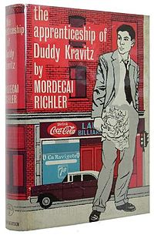

36. Metaphor: A figure of speech in which two dissimilar objects are compared or identified. Metaphors are useful when describing things. For example, ‘That guy is a diamond in the rough.’ Literally, this statement refers to a diamond that is found in a mine in its natural state, before it is cleaned, cut and polished. Figuratively, this expression is used to describe someone who is still pretty rough but offers some potential and with time will be a successful person. Another example is “Love is a many-splendored thing”. Any metaphor that is developed during the course of the text becomes an extended metaphor. An allegory can be considered a very extended metaphor.

37. Mood: (from Anglo-Saxon, mod "heart" or "spirit") (1) In literature, mood is a feeling, emotional state, or disposition of mind -- especially the predominating atmosphere or tone of a literary work. Most pieces of literature have a prevailing mood, but shifts in this prevailing mood may function as a counterpoint, provide comic relief, or echo the changing events in the plot. The term mood is often used synonymously with atmosphere and ambiance. Students and critics who wish to discuss mood in their essays should be able to point to specific diction, description, setting, and characterization to illustrate what sets the mood.

An early example of ‘setting a mood’ is Homer's choice of "the wine-dark sea" in The Iliad. Let us suppose that he had chosen "the blood red sea," or "the glistening azure sea" instead. Each image clearly connotes a different mood, and surely if we can assume Homer had many, many descriptive words at his disposal, this particular pair had a purpose.
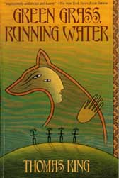

38. Motif: A narrative is any recurring element that has symbolic significance in a story. Through its repetition, a motif can help emphasize and/or develop other narrative (or literary) aspects, such as theme or mood.
A narrative motif can be created through the use of imagery, structural components, language, and other narrative elements. An example from modern American literature is the green light found in the novel The Great Gatsby (1925) by F. Scott Fitzgerald.
Narratives may include multiple motifs of varying types. Shakespeare's play Macbeth (1603) uses a variety of narrative elements to create many different motifs. Imagistic references to blood and water are continually repeated. The phrase "fair is foul, and foul is fair" is echoed at many points in the play, a combination that mixes the concepts of good and evil. The play also features the central motif of the washing of hands, one that combines both verbal images and the movement of the actors.

39. NARRATION, NARRATIVE: Narration is the act of telling a sequence of events, often in chronological order. Alternatively, the term refers to any story, whether in prose or verse, involving events, characters, and what the characters say and do. A narrative is likewise the story or account itself.

40. NOVEL: In its broadest sense, a novel is any extended fictional prose narrative focusing on a few primary characters but often involving scores of secondary characters. The fact that it is in prose helps distinguish it from other lengthy works like epics. We might arbitrarily set the length at 50,000 words or more as a dividing point with the novella and the short story.

41. Onomatopoeia: The use of sounds that are similar to the noise they represent for a realistic or artistic effect. For instance, hiss, bang, buzz, click, rattle, and grunt make sounds akin to the noise they represent.
A higher level of onomatopoeia is the use of imitative sounds to create an auditory effect. For instance, Tennyson writes in “The Princess” about "The moan of doves in immemorial elms, / And murmuring of innumerable bees." All the /m/ and /z/ sounds ultimately create that whispering, murmuring effect Tennyson describes.

42. Oxymoron: Using contradiction in a manner that oddly makes sense on a deeper level. Simple or joking examples include such oxymora as jumbo shrimp, sophisticated rednecks, military intelligence, living dead and controlled chaos. The richest literary oxymora seem to reveal a deeper truth through their contradictions. These oxymora are sometimes called paradoxes. For instance, "Without laws, we can have no freedom." Shakespeare's Julius Caesar also makes use of a famous oxymoron: "Cowards die many times before their deaths" (2.2.32).
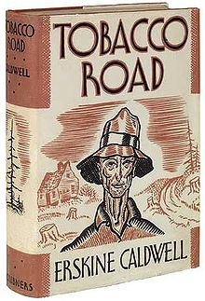

43. Paradox: A statement which appears to be self-contradictory yet involves an element of truth. Paradox uses contradiction in a manner that oddly makes sense on a deeper level. For example, It was both night and day in that frosty part of the world or The child is the father of a man. In Shakespeare’s Hamlet, Polonius observes, “Though this be madness, yet there is method in't." Another famous paradox is Chesterton‘s observation that "Spies do not look like spies." Paradox exists in a simpler form as oxymoron.

44. Parody: A parody imitates the serious manner and characteristic features of a particular literary work in order to make fun of those same features. The humorist achieves parody by exaggerating certain traits common to the work, much as a caricaturist creates a humorous depiction of a person by magnifying and calling attention to the person's most noticeable features. The term parody is often used synonymously with the more general term spoof, which makes fun of the general traits of a genre rather than one particular work or author. Often the subject-matter of a parody is comically inappropriate, such as using the elaborate, formal diction of an epic to describe something trivial like washing socks or cleaning a dusty attic.

45. Personification: When abstractions, animals, ideas, and inanimate objects are given human traits, abilities, or reactions. Inanimate objects (tables, laptops, bedposts) and abstract ideas (love, hate, integrity) are treated as if they were human. For example, ‘The tree swayed in the breeze, its arms waving to me as I passed’ or ‘Love stomped all over my heart tonight’.

46. Plot: The sequence of events in a narrative (a story). Plot typically consists of four main elements. Depending on the genre of the story, certain elements may be more or less evident. In some cases, elements may be completely absent.

a) Initial Situation (exposition): Setting and character are introduced and the reader learns what the conflict is.
b) Rising Action: A series of major events which serve to increase suspense and brings the protagonist closer to solving (or not solving) the conflict.
c) Climax: This is a pivotal event where the protagonist either solves or does not solve the conflict.
d) Resolution (denouement): The outcome of the climax is explained and the reader sympathises or celebrates with the protagonist or in some cases comes to dislike the protagonist.
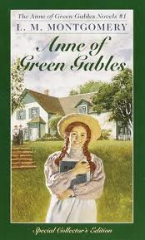
47. Point-of-view (pov): The identity of the narrative voice - the person or entity through whom/which the reader experiences the story. It is usually first-person or third-person. Point-of-view is a commonly misused term; it does not refer to the author’s or characters’ feelings, opinions, perspectives, biases, etc.
Point-of-view is the perspective from which the story is told. Depending on the perspective, we will know varying amounts of information about character’s minds and their perception of events and other characters.
There are three types of p-o-v:
a) First person: Uses “I” or “we“(a character in the story or a direct observer recounts the story) One character is telling the story from her/his perspective.
b) Second person: Uses “you” The author speaks directly to the reader. It is used in non-fiction.
c) Third person: Uses “he,” “she,” “it,” or “they” The author is telling about the characters.

There are three types of third person:

a) Limited omniscient: The author tells us the story through the thoughts and feelings of only one character. Animal Farm is told from the limited point-of-view of the common animals who are unaware of what is really happening as the pigs gradually and secretively take over the farm.

b) Omniscient: The author tells us everything about the story including the thoughts and feelings of all the characters, and even information in the author’s mind that no character knows.

c) Dramatic or Objective: We are only told what happens and what is said; we do not know any thoughts or feelings of the characters. It is called “dramatic” because it is similar to a play where, as an audience, we only know what we see and hear (we must guess what the thoughts of the characters are).

The unreliable narrator is a narrator who describes events in the story, but seems to make obvious mistakes or misinterpretations that may be apparent to a careful reader). Unreliable narration often serves to characterize the narrator as someone foolish, unobservant, naïve, innocent or deceptive.

48. Propaganda: When something is written or produced for the sole purpose of convincing people of a particular point of view we may say that it is propaganda. For example, George Bush’s administration relied heavily on propaganda through CNN to convince the American public that it was necessary to attack Iraq to stop the fundamentalist group Al Queda. Also, fundamentalist Islamic schools rely heavily on propaganda to convince students that they should attack the American infidels.

49. Protagonist: The protagonist in a work of fiction is the character with whom the reader is meant to be chiefly concerned; she or he is the main character, who, whether sympathetic or not, is the focus of the plot.A character facing a conflict in a story or poem that he/she must overcome. Often, the antagonist is creating the conflict though the antagonist may also be seen to be helping the protagonist by “pushing” them along. A work of narrative or drama may have more than one protagonist.
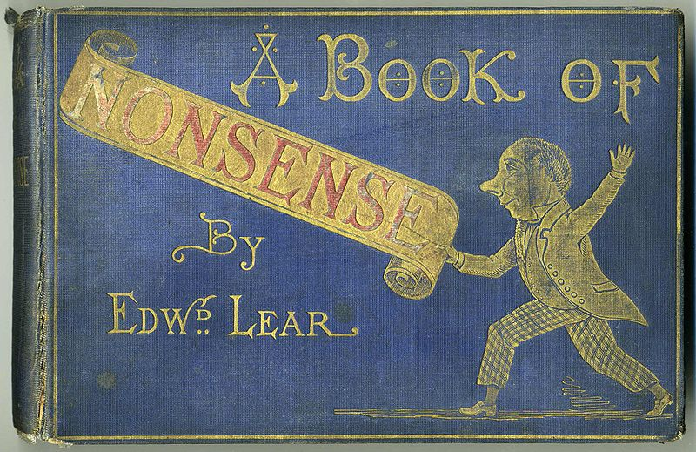
50. Pun: A pun is a play on words. It exploits the multiple meanings of a word, or else replaces one word with another that is similar in sound but has a very different meaning. Puns are sometimes used for serious purposes, but more often for comic effect. Samuel Johnson called the pun the lowest form of humour, but many disagree. Examples of puns include, "Puns are their own rewords," and "It is better to have loved a short person and lost, than never to have loved a tall".

51. Sarcasm: A type of verbal irony where what is meant is the opposite of what is said. For example, a reluctant scholar might tell her teacher, ‘I love studying.’

52. Satire: An attack on or criticism of any stupidity or vice in the form of scathing humour, or a critique of what the author sees as dangerous religious, political, moral, or social standards. Satire became an especially popular technique used during the Enlightenment, in which it was believed that an artist could correct folly by using art as a mirror to reflect society. When people viewed the satire and saw their faults magnified in a distorted reflection, they could see how ridiculous their behaviour was and then correct that tendency in themselves. The tradition of satire continues today. Popular cartoons such as The Simpsons and televised comedies like The Daily Show make use of it in modern media.
Ridicule, irony, exaggeration, and similar tools are almost always used in satire. Horatian satire tends to focus lightly on laughter and ridicule, but it maintains a playful tone. Generally, the tone is sympathetic and good humoured, somewhat tolerant of imperfection and folly even while expressing amusement at it. The name comes from the Roman poet Horace (65 BCE-8 CE), who preferred to ridicule human folly in general rather than condemn specific persons. In contrast, Juvenalian satire also uses withering invective (abusive or violent language used to attack, blame or denounce someone), insults, and a slashing attack. The name comes from the Roman poet Juvenal (60-140 CE), who frequently employed the device.
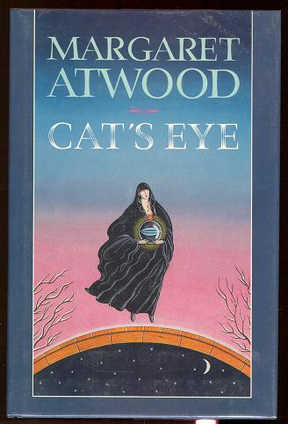
53. Setting: The general locale, historical time, and social circumstances in which the action of a fictional or dramatic work occurs; the setting of an episode or scene within a work is the particular physical location in which it takes place. For example, the general setting of Joyce's "The Dead," is a quay named Usher's Island, west of central Dublin in the early 1900s, and the initial setting is the second floor apartment of the Misses Morkan. Setting can be a central or peripheral factor in the meaning of a work. The setting is usually established through description--but sometimes narration or dialogue also reveals the location and time.

54. Simile: An analogy or comparison implied by using an adverb such as like or as, in contrast with a metaphor which figuratively makes the comparison by stating outright that one thing is another thing. This figure of speech is of great antiquity. It is common in both prose and verse works. Robert Burns states: O, my luve is like a red, red rose
That's newly sprung in June:
O, my luve is like the melodie
That's sweetly played in tune
55. Stereotype: A character that has all of the expected traits of a ‘group’ (for example, the nerd, the jock, or the damsel in distress). Stereotyped characters are usually a sign of bad writing, but in some cases, especially in the case of minor characters or in satires and fables, they are useful.

56. SYMBOL: A common object that has a deeper meaning is a symbol. A symbol is something that stands for something else. There are two kinds of symbols:
In contrast with an archetype (universal symbol), a private symbol is one to which an individual artist arbitrarily assigns a personal meaning. Nearly all members of an ethnic, religious, or linguistic group might share a cultural symbol and agree upon its meaning with little discussion, but private symbols may only be identifiable in the context of one specific story or poem. Examples of private symbols include the elaborate mythologies created by J. R. R. Tolkien in The Silmarillion (such as the One Ring as a symbol of power lust) or the Irish poet Yeats' use of a gyre [a circle or a spiral] to symbolize the cycles of history and the sphinx as an emblem of the Antichrist in the poem "The Second Coming."
A cultural symbol is widely or generally accepted as meaning something specific within an entire culture or social group, as opposed to a private symbol created by a single author that has meaning only within a single work or group of works. Examples of cultural symbols in Western culture include the cross as a symbol of Christianity, the American flag as a symbol of America's colonial history of thirteen colonies growing into fifty states, the gold ring as a symbol of marital commitment, the Caduceus as a symbol of medicine, and the color black as a symbol of mourning. Examples of cultural symbols in other cultures include white as a symbol of mourning in Japan, the Yin-Yang sphere as an oriental symbol of oppositional forces in balance, the white crane as a symbol of longevity in Mandarin China, and so forth. Any writer in a specific culture could use one of these symbols and be relatively confident that the reader would understand what each symbol represented.

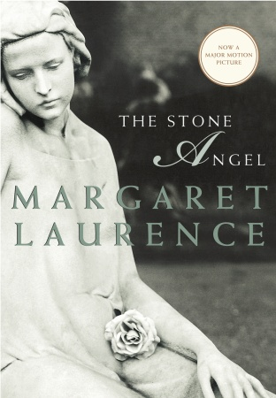
57. Synecdoche: A rhetorical trope involving a part of an object representing the whole, or the whole of an object representing a part. For instance, a writer might state, "Twenty eyes watched our every move." Rather than implying that twenty disembodied eyes are swivelling to follow him as he walks by, she means that ten people watched the group's every move. When a captain calls out, "All hands on deck," he wants the whole sailors, not just their hands.

58. Theme: A theme is the main idea or underlying meaning of a literary work. A theme may be stated or implied. Theme differs from the subject or topic of a literary work in that it involves a statement or opinion about the topic. Not every literary work has a theme. Themes may be major or minor. A major theme is an idea the author returns to time and again. It becomes one of the most important ideas in the story. Minor themes are ideas that may appear from time to time.
Usually we identify themes as consisting of two parts. There is a subject (such as love or prejudice) and the author’s view or comment on the subject (such as love is rare or any act of prejudice demeans all of us).
For example, the subject of a story might be war while the theme might be the idea that war is useless. Theme cannot be stated in one word. They are more complicated than that.
Four ways in which an author can express themes:

a) Themes are expressed and emphasized by the way the author makes us feel. Sharing the feelings of the main character, you also share the ideas that go through his mind.
b) Themes are presented in thoughts and conversations. Authors put words in their characters’ mouths only for good reasons. One of these is to emphasize a story’s themes. What a character says reveals what is on their mind. Look for thoughts that are repeated throughout the story.
c) Themes are suggested through the characters. The main character usually illustrates/reflects the most important theme of the story. A good way to get at this theme is to ask yourself the question, what does the main character learn in the story?
d) The actions or events in the story are used to develop theme. Characters naturally express ideas and feelings through their actions. One thing authors think about is what an action will say. In other words, how will the action express an idea or theme?

59. Tone/Voice: The author’s attitude, stated (said outright) or implied (only hinted at), toward a subject. Tone reflects how the writer or author feels about their subject or listener. Possible attitudes include a pessimistic tone, optimistic tone, concerned tone, serious tone, bitter tone, humorous tone, defiant tone, regretful tone, and incredulous tone. An author’s tone is revealed through choice of words and details.

60. Unity: The term applied to the effect of wholeness in a text which is achieved when there is a convincing relationship of part to parts, and parts to the whole, within the entire text.

