**12.**

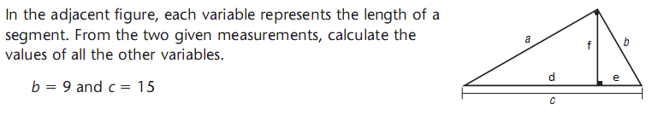

a ___________ d ___________ e __________ f __________

|  |  |
| --- | --- |
| **13**. In the adjacent diagram,  m  = 4 cm  m  = 5 cm  m  = 6 cm  //  //  m  = m  = m  **Calculate the perimeter of ΔDEF ________cm** |  |