Table of Contents
Pages
Unit 1: Algebra  *Algebraic Expressions  *Substitution  *Algebraic Equations   Level 1   Level 2   Level 3   Level 4   Level 5 | 2 to 22  23 to 27  28 to 32  33 to 38  39 to 44  45 to 49  50 to 55
Unit 2: Modes of Representation | 56 to 68
Unit 3: Proportions | 69 to 81
Unit 4: Percent % | 82 to 100
Unit 5: Circles | 101 to 124
Unit 6: Polygons   Angles Review   Triangles | 125 to 146  147 to 153
Unit 7: Dilatations/  Similarity Transformations | 154 to 168
Unit 8: Geometric Solids | 169 to173
Unit 9: Probability | 174 to 185
Review Questions | 186 to 205
Unit 1: Introduction to ALGEBRA
REMEMBER
You cannot ADD or SUBTRACT unlike terms
EXAMPLE: 6x – 4 + 8x
*Bring like terms together 6x + 8x – 4
14x – 4

14x – 4 is the simplified expression, we cannot subtract 14x & 4 because they are unlike, 14x is a variable term & 4 is a constant term [number only]

Give an algebraic expression for the perimeter
of each figure.
3x
❶ ❷
3x
5x
3x
2x

3x
4n + 7
P = 3x + 3x +3x + 3x
= ______

n
❸ ❹
4x – 3

n + 3
n + 3
n
n

6n – 2
4x – 3

❺ ❻
4n + 5
4n + 5

4x + 2
4x + 2

3x – 2
3x – 2

2x – 3

2n – 1
SIMPLIFY each of the following algebraic expressions.
*Remember, you can ONLY + & — LIKE terms!

❶ a + a + a | ❷ 2b + 5b | ❸ 4a + 2a + 5
❹ x –x + x + 3 | ❺ y + y + y + y + 2 + 5 | ❻ 3b + 2 – 2b – 3
❼ –8a + 2a + 5 | ❽ 10b – 9b | ❾ 3a + 2a + 3x
❿ 12a – 6a | ❶❶ 15x – 10 | ❶❷ 2x + 8x
❶❸ x + 2x + 5x | ❶❹ 2a + 5 + 3a | ❶❺ 20a + 18 + 2a + 5
❶❻ –x + –7x | ❶❼ 8t – 12t | ❶❽ –8a – 12a
❶❾ –18r – 12r | ❷⓿ –7a – 9a | ❷❶ –10c + 2c

Translating Words into an Algebra Expressions

Example: the sum of three times a number and eight means 3x + 8

Write an algebraic expression for each statement.

❶ The sum of a number and six ______________

❷ The quotient of fifteen and a number ______________

❸ The difference between a number and twenty ______________

❹ The product of seven and a number ______________

❺ The difference between the square of a number and three _____________

❻ The sum of triple z and double n ______________

❼ One quarter of a number ______________

❽ Three times a number decreased by nine ______________

❾ Double a number less one hundred ______________

❿ Ten less than half a number ____________
Translating Words into an Algebra Expressions

Example: twenty less than triple a number means 3x – 20

Write an algebraic expression for each statement.

❶ The sum of double a number and two ______________

❷ The quotient of twice a number and three ______________

❸ The difference between fifty and a number ______________

❹ The product of ten and a number ______________

❺ The difference between five times a number and seven ___________

❻ The difference of triple x and double z ______________

❼ One third of a number ______________

❽ Six times a number decreased by fifteen ______________

❾ Triple a number less seventy ______________

❿ Nineteen less than one quarter of a number ____________
Translating Words into an Algebra Expressions

Example: Fifteen less double a number means 15 – 2n

Write an algebraic expression for each statement.

❶ The sum of five and seven times a number ______________

❷ Ten more than two times a number ______________

❸ Eight less than five times a number ______________

❹ The product of three times a number and four ______________

❺ Eleven less than four times a number ______________

❻ The square of the sum of six times and two ______________

❼ One fifth of a number ______________

❽ The sum of a number and twice the same number ______________

❾ The sum of an even number and the next even number ______________

❿ The sum of a number and then next two consecutive numbers __________
SIMPLIFY each of the following; simplify means to combine LIKE TERMS.

❶ | 6x + 3x | ❷ | –6n + –5n |  |  | ❸ | 15s + –4s
❹ | –7b – –4b | ❺ | 9x – –2x |  |  | ❻ | –5n – 8n
❼ | 1 + 3x – 5x + 7 | ❽ | x – 1+ 4x – 6 |  |  | ❾ | 7x + 8 + 3x – 3
❿ | 8 + 2x + x – 3 | ❶❶ | 7x – 10 – 3x + 5 |  |  | ❶❷ | –4x – 6 – 4x + 1
❶❸ | 6x + 4 – 3x – 9 |  |  | ❶❹ | –6n + 3 + 9 – 2n
❶❺ | –10 – 4x + 5x +6 |  |  | ❶❻ | 3s + 6s – 13 + 5
❶❼ | 2t – 10 – 6t |  |  | ❶❽ | 8 – 3x – 7x

Algebraic Expressions in Word Problems

❶ The rate for a taxi is $5.00 plus $1.35 for each kilometer traveled. Write a simplified algebraic expression to represent the cost of a taxi ride for x kilometers.

❷ Jason sold x yearbooks the first week, he sold double that in the second week and during the third week he sold 5 less than during the second week. Write an algebraic expression for each week and then write a simplified expression to represent the total number of yearbooks that Jason sole.

Week #1: ____________ Simplified expression:

Week #2: ____________

Week #3: ____________

❸ Pencils cost p¢ each [taxes included]. How many pencils can be purchased for $d?

❹ If a represents a person’s age in years, give an expression to represent the person’s age:
a) in months? b) in days?

❺ If a student has x classes in n days, how many classes does the student have per day?

❻ Todd weighed x kg and lost n kg in each of four consecutive weeks. Give an algebraic expression to represent Todd’s weight after four weeks.

❼ If there are x boys and n dogs in the park, write an algebraic expression to represent the total number of feet in the park.

❽ Write an algebraic expression to represent your average on math tests where you scored, x %, n % and y %.
SIMPLIFY each of the following:
STEPS to REMEMBER

EXAMPLE: (6x – 4) – (8x + 3)
*Notice minus sign between brackets
Step ❶ 6x – 4 – 8x – 3
Remove brackets & make necessary changes
Step ❷ 6x – 8x – 4 – 3
*Bring LIKE TERMS together
Step ❸ ⁻2x – 7
*Simplified, cannot subtract unlike terms!

❶ | (2x + 4) + 6 | ❷ | (3x + 1) + 3x |  |  | ❸ | (4x – 2) + 4
❹ | x + 3 – 2x | ❺ | 8x + 5x + 5 – 2 |  |  | ❻ | (x + 3) + (4x + 2)
❼ | (5x + 4) – (2x + 2) | ❽ | (6x – 5) + (x – 2) |  |  | ❾ | 11x – (9x – 4)
❿ | (8x + 7) – (9x + 3) |  |  | ❶❶ | (8x – 10) – (7x – 12)
❶❷ | (2x – 5) – (9 – 7x) |  |  | ❶❸ | 14x – (20x + 3)
❶❹ | (3x – 1) + (5x – 4) |  |  | ❶❺ | (x + 3) – (3x + 1)
❶❻ | (x + 1) + (2x + 4) |  |  | ❶❼ | (x – 2) – (2x – 3)
❶❽ | 2x − 4 + 3x + 8 − 5x

Simplifying Algebraic Expressions
MULTIPLICATION & DIVISION
REMEMBER: You CAN multiply & divide unlike terms

EXAMPLE ❶: 9 • 15x
135x
*Multiply the integers, then include variable & you have the expression

EXAMPLE ❷: ⁻56x ÷ 8
⁻7x
*Divide the integers, then include variable & you have the expression

Remember: You can MULTIPLY or DIVIDE unlike terms!

❶ | 7 • –6s | ❷ | –5x • –9 | ❸ | 4 • –3x
❹ | 15n ÷ –5 | ❺ | 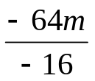 | ❻ | –84x ÷ 12
❼ | 6 • 2x | ❽ | –3x • 5 | ❾ | –8 • –9x
❿ | –2(4x + 3) | ❶❶ | –1(5x – 9) | ❶❷ | 4(4x – 2)
❶❸ | (15x + 9) ÷ 3 | ❶❹ | 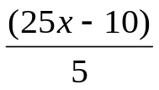 | ❶❺ | (–21 – 14x) ÷ 7
❶❻ | 9 • –15s | ❶❼ | –3n • –12 | ❶❽ | –8 • 7x
❷⓿ | 24n ÷ –8 | ❷⓿ | 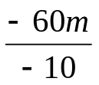 | ❷❶ | –81x ÷ 9
❷❷ | 9 • 6x | ❷❸ | –3x • 14 | ❷❹ | –12 • –9x
❷❺ | –4(5x + 6) | ❷❻ | –7(2x – 9) | ❷❼ | 8(3x – 2)
❷❽ | –3(7x + 4) | ❷❾ | –1(8x – 7) | ❸⓿ | –5(9x – 12)
❸❶ | 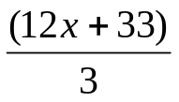 | ❸❷ | (20x – 35) ÷ 5 | ❸❸ | 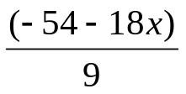

❶❽ 2(x – 8) – 3(4x – 2) | ❶❾ 2(4x + 5) – 3(x + 2)
❷⓿ 3(2x – 5) + 4(x + 1) | ❷❶ 7(3x + 2) + 4(5x – 5)
❷❷ 9(2x – 3) – 8(4 – 5x) | ❷❸ 4(6 + 8x) – 3(5 – 7x)
❷⓿ 5(2x + 1) – 4(x – 3) + 8(2 – 3x) – 4(3 – 5x)

Algebraic Expressions in Word Problems

❶ A repairman earns $x per hour plus $30 for traveling expenses. Write an algebraic expression to represent a bill for 7 hours of work (excluding taxes).

❷ Sophie buys x packages of graph paper for $2.55 each (tax included). She pays with a $20 bill. Write an algebraic expression to represent the amount of change the cashier should give back to Sophie.

❸ Jasmine pays $x for one dozen multigrain bagels. Write an algebraic expression to represent the cost of 5 bagels.

❹ Sam sells tickets for the Hadley Junior High School Fall Talent Show, he sells (3x – 4) $3 tickets and (2x + 5) $4 tickets. Write a simplified algebraic expression to represent the money Sam made.

Simplify each of the following expressions.
*Remember: The minus sign between the brackets means the sign inside the brackets changes to the opposite of what is was, + to — or — to +
❶ | (5x + 4) – (x – 2) | ❷ | (6 – 3x) + (x – 5x)
❸ | (4x + 5) – (3x – 2) – 6 | ❹ | 9x + 5 – 7x
❺ | 2 • –7x | ❻ | 3(2x – 6)
❼ | 7x – 4(x + 2) | ❽ | (12x – 6) ÷ 3
❾ | 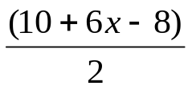 | ❿ | 2(3x – 2) + 3(x + 5)

❿ Find the simplified algebraic expression for the perimeter of this polygon.

3x + 4
6 – x

2x – 5
4x + 1
8 – 6x

B I N G O
ALGEBRA
BINGO
On the next page are a series of Algebraic Expressions and Phrases.
1. Cut out each of the expressions and phrases;
2. Match each phrase to an expression;
3. Glue 24 of the algebraic expressions to the above BINGO card;
4. Get some bingo chips & you are ready to play ALGEBRA BINGO! ☺

Algebra

Bingo

Card

Cut out each of these rectangles, there are 52 expressions and phrases in total. After you cut them out, match the expression with the phrase. Once your teacher has checked your matches you will glue JUST the expressions onto your BINGO card! ☺
5 + x | Double a number decreased by 5 | 6 – x | Six times a number less one
6(x + 1) | The quotient of three and a number less two | 4x – 2 | Product of six and a number decreased by 1
2x – 5 | Six less a number | 9 + x | Five times a number plus 1
4x + 3 | Nine minus five times a number | (x – 2)² | The square of a number minus three
6x – 1 | Five more than a number | 8 – x | Four times a number decreased by 2
x + 6 | Nine increased by a number | 2 – 3x | A number divided by six
5 – 2x | Eight decreased by a number | 2(x + 5) | Seven decreased by two times a number
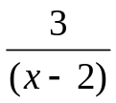 | Two less than three times number | 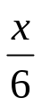 | Three times a number plus two
2x - 6 | The difference between triple x and double n | 9 – 5x | Three more than quadruple a number
x – 5 | Two times five more than a number | 7 – 2x | Eight less than the cube of a number
3x – 2 | Five minus double a number | 3(x + 2) | Five less than a number
3x – 2n | Six less than double a number | x² – 3 | The square of a number decreased by two
5x + 1 | A number increased by six | x³ – 8 | Two decreased by three times a number

This pages needs to be torn out and cut up to make your

ALGEBRA

BINGO

CARD

☺Unit 1 Extra Practice

❶ | 10x – 8x + 7x + 2 | ❷ | (3y + 5) + (7y – 8)
❸ | (12a + 6) – (8a – 4) | ❹ | 11n + 5 – 9n + – (7n + 4)
❺ | 7u – 2(u + 5) | ❻ | 3(y – 2) + 5(6 + y)
❼ | (4x + 10) – 2(3x – 5) | ❽ | (24n – 16) ÷ 4
❾ | y + (y + 4) + (y – 4) | ❿ | 5(2x) + 3(3x – 4) – 6(7x)
❶❶ | (8x – 6) – (3x – 6) | ❶❷ | (4s – 5) – (4s – 5)
❶❸ | (8 – n) + (n – 8) + 4n | ❶❹ | 3(5 – 2x) – 6(x + 8)

Substitution

The replacement set is a set of numbers chosen for a particular situation.

Each time a variable is replaced by a number from the replacement set, the algebraic expression becomes a numerical value.

E.g.: What is value of 3x² + 2x – 5 if Є {2, 4}

If x = 2 then 3x² + 2x – 5 becomes: If x = 4 then 3x² + 2x – 5 becomes:
3(2)² + 2(2) – 5 3(4)² + 2(4) – 5
3 •4 + 2 • 2 – 5 3 • 16 + 2 • 4 – 5
12 + 4 – 5 48 + 8 – 5
11 ← numerical value → 51

The steps to calculate the numerical value of an algebraic expression are:
- Write the algebraic expression;
- Replace each variable with the selected value;
- Calculate according to the order of operations;
- Write your calculations vertically, with only one operation per line.

❶ Find the values of 4x + 5 if the replacement set of x is {0, 2, 4}

If x=0 then 4x + 5 becomes: If x=2 then 4x + 5 becomes: If x = 4 then 4x + 5 becomes:
4(0) + 5 4(2) + 5 4(4) + 5
= 4 + 5 = 8 + 5 = 16 + 5
= 9 = 12 = 21

❷ Find the value of each algebraic expression given the following replacement
sets.
(a) 6 – x given x Є {2, 1, 0 –1, –2} (b) (x + 4)² given Є {–3, –2, –1, 0}

(c) 2(x – 1) given Є {–5, 0, 5, 10} (d) (2x + 1) (x – 5) given Є {–3, –1, 0, 1, 3}

⬥ If a = 2 and b =–3, calculate the numerical value of each algebraic
expression.

(a) 2a – 3b (b) (a + b) (a – b) (c) 3a² + 2ab – 1

❹ Given a =–2, b = 3 and c = 5, calculate the numerical value of each.
(a) –2c^{b}a (b) (a + c) + bc (c) c^{b} + b • a

❺ Calculate the numerical value of each of the following algebraic expressions,
given that a = 4, b = –5 and c = 3.

a) 3a + 2b b) 5(2c – 3)²

c) 3a² – 2b + c d) 2b + 3a
ac

❻ Complete each of the following tables.
a) b)

x | 2x² + 5x – 4
–3
1
3
5

x | 3x + 4
–2
0
2
4

❼ Find the value of each algebraic expression with each given replacement set.

a) 4x – 3 given x ∈ {⁻3, 1, 5} b) 4(3x – 2) given x ∈ {⁻2, 0, 2, 4}

❽ A repairman earns $3x per hour plus $60 for traveling expenses. Write an algebraic expression to represent a bill for 15 hours of work (excluding taxes).

❾ Lauren buys x packages of lined paper for $2.25 each (taxes included). She pays
with a $20 bill. Write an algebraic expression to represent the amount of change
the cashier should give back to Lauren.

❿ Charlotte pays $x for one dozen Sharpie markers. Write an algebraic expression to represent the cost of 5 Sharpie markers.

❶❶ Simplify each of the following expressions.

a. (5x + 4) – (x – 2) b. (6 – 3x) + (x – 5x)

c. (4x + 5) – (3x – 2) – 6 d. 9x + 5 – 7x

e. 2 • —7x f. 3(2x – 6)

g. 7x – 4(x + 2) h. (12x – 6) ÷ 3

i. (10 + 6x – 8) ÷ 2 j. 2(3x – 2) + 3(x + 5)

❽ Sam sells tickets for the Hadley Junior High School Talent Show, he sells
(7x – 9) $3 tickets and (4x + 8) $4 tickets. Write a simplified algebraic
expression to represent the money Sam made.

❾ Find the simplified algebraic expression for the perimeter of this polygon.

5x + 4
6 – 3x

6x – 4
9x + 1
12 – 6x

Level I Equation Practice
Level I (addition)
x + 5 = 9
– 5 – 5
x = 4
Level I (subtraction)
x – 9 = 6
+ 9 + 9
x = 15

Level I (division)
x = –9
4
x = –9
4 1
x • 1= 4 • –9
x = –36

Level I (multiplication)
6x = –42
6x = –42
6 6
x = –7

❶ | x - 3= 1 |  | ❷ |  | x + 3 = 5 |  |  | ❸ | 2x = 22
❹ | x – 3 = –2 |  | ❺ |  | 4 = x – 1 |  |  | ❻ | x + 2 = 7
❼ | x – 9 = 3 |  | ❽ |  | x – 1 = 11 |  |  | ❾ | 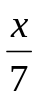 = 1
❿ | –2x = 14 |  | ❶❶ |  | 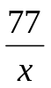 = 7 |  |  | ❶❷ | –5 = x – 10
❶❸ | –6x = 42 |  | ❶❹ |  | 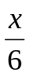 = 10 |  |  | ❶❺ | x – 5 = –2
❶❻ | x + 8 = 17 | ❶❼ |  |  | x + 10 = 7 |  | ❶❽ |  | x + 2 = 5
❶❾ | 13 = x + 3 |  | ❷⓿ |  | –7x = 21 |  | ❷❶ |  | 5 + x = 8
❷❷ | 4x = 0 |  |  | ❷❸ | 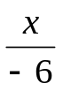= –16 |  | ❷❹ |  | x + 5 = –12
❷❺ | x – 10 = –11 |  |  | ❷❻ | x + 4 = 8 | ❷❼ |  |  | x + 4 = 0
❷❽ | –6x = –72 |  |  | ❷❾ | –4 + x = –8 |  | ❸⓿ |  | x + 1 = 4

Write an algebraic equation for each statement, and then SOLVE for x

❶ The sum of a number and six is fourteen.

❷ The quotient of fifteen and a number equals three.

❸ The difference between a number and twenty is seventeen.

❹ The product of seven and a number equals fifty-six.

❺ The difference between the square of a number four is twelve.

❻ The sum of triple z and double n equals forty-four.

❼ One quarter of a number is ten.

❽ Three times a number decreased by nine equals eighteen.

❾ Double a number less one hundred is sixty.

❿ Ten less than half a number equals fourteen.

❶❶ The quotient of sixty and a number is five.

❶❷ A number divided by eight is nine.

❶❸ The product of double a number and three equals twenty-four.

❶❹ One-fourth of a number increased by nine is fifteen.

❶❺ Eight less than quadruple a number equals forty-four.

❶❻The difference of a number and twelve is nine.

❶❼ The product of twenty and a number equals one hundred and forty.

❶❽ The sum of a number and twenty-seven is forty-three.

❶❾ The quotient of thirty-two and a number equals eight.

❷⓿ The sum of seven and a number squared is fifty-six.

❷❶ The difference of triple n and one-half n equals twenty-five.

❷❷ One fifth of a number is fifteen.

❷❸ Four times a number decreased by eleven equals twenty-five.

❷❹ Triple a number less eighty is seventy.

❷❺ Thirty less than one-third a number equals zero.

❷❻ The product of one-quarter of a number and eight is forty-eight.

Level II Equation Practice
A Level II equation will require you to do two opposite or inverse operations to solve for the variable (letter). Always do the opposite of any addition or subtraction first, and then proceed to do the inverse operation of any multiplication or division.
E.g.: x + 7 = 9.3
5
– 7 – 7
x = 2.3
5
x = 2.3
5 1
x • 1 = 5 • 2.3
x = 11.5
Always + or – the # with the variable, then cross-multiply or divide accordingly.
E.g.: 5x – 9 = 8
+ 9 + 9
5x = 17
5x = 17
5 5
x = 3.4

Solve each of the following equations.
❶ | –7x + 1= 64 | ❷ |  | 4 + 3x = 10 | ❸ |  | –5 – 7x = –5
❹ | 3x – 1 = 23 | ❺ |  | 3x – 10 = 5 | ❻ |  | 2x + 3 = 19
❼ | 7x + 2 = 9 | ❽ |  | –7x + 10 = –60 | ❾ |  | 8 + 2x = 20
❿ | 7x – 3 = 50 |  | ❶❶ | 3 + 2x = 20 | ❶❷ |  | 10 – 3x = 1
❶❸ | 1 – 7x = –83 |  | ❶❹ | 7 – 4x = 41 | ❶❺ |  | –6x + 1 = –29
❶❻ | –6x – 8 = –56 | ❶❼ |  | 7x – 9 = –65 |  | ❶❽ | –6x + 4 = –2
❶❾ | 6x – 1 = –31 | ❷⓿ |  | –2x – 7 = –7 |  | ❷❶ | 2x – 1 = 23
❷❷ | 3x – 2 = 7 | ❷❸ |  | 4x – 7 = –43 |  | ❷❹ | 5x + 8 = –7
❷❺ | 3x + 4 = 25 | ❷❻ |  | –5x + 8 = –54 |  | ❷❼ | –6x + 1 = –59
❷❽ | –6x – 4 = –4 | ❷❾ |  | 2x + 10 = 18 |  | ❸⓿ | 4x – 10 = 14
❸❶ | 7x + 9 = 30 | ❸❷ |  | 7 + 6x = 49 |  | ❸❸ | 7x + 1 = –27
❸❹ | –2x + 5 = –11 | ❸❺ |  | –6x + 4 = 58 |  | ❸❻ | –6x + 3 = 63
❸❼ | 5x – 7 = 53 | ❸❽ |  | –5x – 2 = –12 |  | ❸❾ | x + 6 = –9  3
❹⓿ | x + 5 = –1.2  8

Write an equation for each problem, then solve for x.

❶ A number increased by 8 equals 32. Find the number.

❷ A number decreased by 12 equals 52. Find the number.

❸ Four times a number is 48. Find the number.

❹ Double a number decreased by 18 is 116. Find the number.

❺ My height increased 24 is 204 cm. What is my height?

❻ When 7 is added to a number the result is 56. Find the number.

❼ When a certain number is multiplied by seven the product is seventy-two. Find the number.

❽ When a number is decreased by forty-five, the result is seventy-five. Find the number.

❾ In five years Karen will be twenty-three. How old is she now?

❿ When a number is multiplied by eight the product is ninety-six. Find the number.

❶❶ Decrease triple a number by seven and you get twenty-eight. Find the number.

❶❷ Add twelve to eight times a number and the result is eighty-four. Find the number.

❶❸ A number increased by eight is twenty-three. Find the number.

❶❹ Decrease a number by thirteen and you get sixty-three. Find the number.

❶❺ Increase my age by eleven years and I become thirty-seven. Find my age.

Level III Equation Practice
A Level III equation is one with more than one group of variables. To solve you must first gather like terms on each side of the equal sign.
3x + 2 = x – 5
– 2 – 2
3x = x – 7
– x – x
2x =–7
2x = –7
2 2
x = –3.5
9 – 5x = 9x + 5 – 9 – 9
⁻5x = 9x – 4
– 9x – 9x
–14x = –4
–14x = –4
–14 –14
x = –0.29
For Example:
⬅Add or subtract the # with the variable➔
from each side

⬅Add or subtract the variable ➔
from each side

⬅Divide by the integer beside the variable ➔
***each side

Solve each of the following
❶ | 7 + 7x = 2x + 2 | ❷ | –7x + 1 = –23 – 3x
❸ | x + 8 = –7x + 88 | ❹ | 8 + 7x = –6x + 164
❺ | 5x + 6 = 4x + 17 | ❻ | 3x – 6 = ⁻x + 38
❼ | ⁻7x – 4 =⁻2x + 26 | ❽ | 3x + 10 = 94 – 4x
❾ | 5x + 6 = 6 + 3x | ❿ | 6x + 5 = 14 – 3x
❶❶ | ⁻4x + 5 = ⁻5x – 4 | ❶❷ | 4x – 1 = ⁻1 + 3x
❶❸ | ⁻10 + 3x = 4x – 5 | ❶❹ | ⁻3x – 9 = ⁻9 + 4x
❶❺ | 8 – 6x = 7x + 21 | ❶❻ | 3 – 4x = 6x + 93
❶❼ | 5x + 5 = x + 13 | ❶❽ | –x + 2 = 6x – 5
❶❾ | 4x + 5 = ⁻5x – 4 | ❷⓿ | 6x + 5 = 5x + 4
❷❶ | 3 – 6x = 7x + 55 | ❷❷ | 6x – 10 = 7x – 19
❷❸ | –6x – 2 = 2x – 66 | ❷❹ | 5x – 10 = 2x – 22
❷❺ | 3x + 6x = 91 | ❷❻ | 6x + 6x + 360 = 600
❷❼ | 12 – 8x = 5x – 14 | ❷❽ | ⁻5x – 3 = ⁻2x + 8
❷❾ | 0.5x + 9 = 2x – 5 | ❸⓿ | 4x – 6 = 12x + 8x

Solve each of the following word problems.

❶ Amber is 7 years younger than her sister Carley. Together their ages total 43 years. How old are Amber and Carley?

Amber: ___ years old Carley: ___years old

❷The sum of two numbers is 27. If one of the numbers is twice the other, what are the two numbers?

The two numbers are ___ and ____ .

❸ Andrew is 4 years older than his brother Geoff. The sum of their ages is 30. How old are Andrew & Geoff?

Andrew: ___ years old Geoff: ___ years old

❹ Twice a number increased by three is the same as four less than three times the same number. What is the number?

The number is ____.

❺ Jordan & Nevin have collected 160 buttons. Jordan has 25 buttons more than twice as many buttons as Nevin. How many buttons do they each have?

Jordan: _____ buttons Nevin: ____ buttons
❻ Write an algebraic expression for each of the following:

a. Two friends have a certain amount of money, Sarah has 3x and Brittany has $10 more than Sarah, what is the sum of their money?
____________________________

b. Stephanie is 5 years older than 3 times Brian’s age.
If Brian is n years old, write and expression for Stephanie’s age.

____________________________

c. Jimmy caught two fish. The first fish measures x cm and the second fish measures (x -5) cm. Write and expression to represent the total length of the two fish.

____________________________

❼ There are three members in the Murphy family. Mom, Dad & Brittany. Dad is 3 years older than Mom. Brittany is 32 years younger than her Dad. If the sum of their ages is 64, find the age of each member of the Murphy family.

Mom: _____years old Dad: ____years old Brittany: ____years old

❽ The sum of three numbers is 138. The second number is twice the first and the third is 7 less than the second. What are the numbers?

1st #: _____ 2nd: _____ 3rd: _____

❾ I am five years younger than 3 times my daughter’s age. Our combined age is 59 years old. How old am I and how old is my daughter?

My age: ____ years old My daughter: ____years old
Level IV Equation Practice
A Level IV equation has one or more sets of brackets. Use the number on the outside of the brackets & multiply it by everything inside the brackets. Then proceed to solve as if it was a Type III or Type II equation.
3(x – 5) = 6
3 • x – 3 • 5 = 6
3x – 15 = 6
+ 15 + 15
3x = 21
3x = 21
3 3
x = 7
4(2x – 7) = 3(5x + 8)
4 • 3x – 4 • 7 = 3 • 5x + 3 • 8
12x – 28 = 15x + 24
+ 28 + 28
12x = 15x + 52
– 15x – 15x
⁻3x = 52
⁻3 ⁻3
x = ⁻14
⬅Multiply the # outside the brackets➔
by each term inside the brackets

⬅Write what it equals➔
⬅Add or subtract the # with the variable term ➔
from each side
⬅Add or subtract the variable term from each ➔
side
⬅Divide by the integer beside the variable ➔
***each side

❶ | 6(2x – 4) = 12 | ❷ | 4(2x + 3) = 5
❸ | 7(3x – 5) = 2(x – 3) | ❹ | 4(3x + 8) = ⁻6x + 99
❺ | 4(3x – 5) + 2(x + 3) = 1 | ❻ | 6(3x – 5) = 12
❼ | 4(3x – 5) + (x + 3) = 1 | ❽ | 7(x + 3) = 10
❾ | 4(x + 2) = 5(x – 3) | ❿ | 7(x – 2) = 5(3x – 8)
❶❶ | ⁻4(x – 5) = ⁻5(x + 4) | ❶❷ | 4(x – 1) = 6(⁻1 + 3x)
❶❸ | ⁻10 + 3x = 4x – 5 | ❶❹ | ⁻3(3x – 5 ) = ⁻9(2 + 4x)
❶❺ | 2(8 – 6x) = 3(7x + 2) | ❶❻ | 5(3 – 4x) = 4(6x + 9)
❶❼ | 5(x + 5) = 4(x + 3) | ❶❽ | ⁻3(–x + 2) = 2(6x – 5)
❶❾ | ⁻2(⁻4x + 5) =⁻6(⁻5x – 4) | ❷⓿ | 4(6x + 5) = 3(5x + 4)
❷❶ | 5(3 – 6x) = 7(x + 5) | ❷❷ | 6(2x – 4) = 7(x – 1)
Solve each of the following.
❶ The sum of the ages of two people is 100 years. In five years, the sum of their ages will be equal to 5 times the age of the younger person. How old are each them now?

❷ If I add $8.00 to 4 times the money I have, the result is the same as if I were to subtract $15.00 from 5 times what I have. How much money do I have?

❸ The ages of three brothers are consecutive multiples of 5. The sum of their ages is 90 years. How old is Benjamin, the youngest brother?

❹ In their hockey league, the trio of Mario, Eric and Paul have scored 25 goals in 8 games. Of this total, Mario has 6 goals. Eric has 3 goals less than Paul. How many goals did Paul score?
❺ A student said to his teacher : "You are four times older than I am". His teacher replied: "Yes, but in 5 years, I will be only 3 times older than you!". How old is the student?

❻ The perimeter of the triangle below is 44 cm. The sides are respectively (x + 4), (2x − 1) and (3x − 7) centimetres. What is the length of each side?

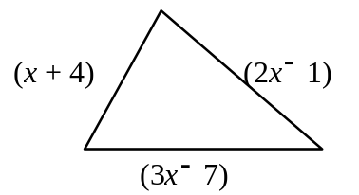

❼ The sum of the ages of 3 people is 78 years. The second person is twice as old as the first, and the third person is 2 years younger than the second. What is the age of each person?

❽ Simplify the following algebraic expression.

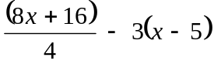

❿ Solve the following equation.

2(5x − 1) = 3 − 5(2 − x)

Level V Equation Practice
A Level V equation is made up of two ‘fractions’, one on either side of the equal sign. To solve these equations we first have to ‘cross-multiply’, this means that we multiply the means and extremes. Then we place one result on each the right side of the equation and the other on the left side. We then proceed to solve as if it was a Level III or Level II equation.
x = ⁻3
6 2
⬅Cross multiply the numerator on the left by the denominator on the right and then the numerator on the right by the denominator on the left➔
by each term inside the brackets
⬅Add or subtract the # with the variable term ➔
from each side
⬅Divide by the integer beside the variable ➔
***each side
⬅Write what it equals➔
⬅Add or subtract the variable term from each ➔
side

x • 2 = ⁻3 • 6
2x = ⁻18

❶ 6 = 5 ❷ 3x + 6 = 5
x 8 2 4

❸ ⁻3 = ⁻4 ❹ x = 5x + 2
x 8 7 1

❺ 3x + 8 = 2x + 8 ❻ ⁻8(x + 3) = ⁻2(x + 5)
5 9 2 3

❼ 3(x + 5) = 7(2x + 3) ❽ 7x + 3 = 6x – 5
2 4 4 2

❾ 8x – 2 = 4(x + 2) ❿ 6x + 5 = 7x + 3
3 1 2 8

❶❶ 3x = ⁻8 ❶❷ 0.6x = 9
5 2 0.3 6

❶❸ 3 = ⁻3 ❶❹ 2x + 8 = 6x + 36
7x 2(x + 5) 5 4

❶❺ 3(⁻2x + 5) = 1 ❶❻ 0.5(4x + 2) = 7
7 2 3 2

❶❼ 2x – 3 = x + 2 ❽ x + 2 = ⁻x – 2
6 4 5 3

❶❾ 4(x + 5) = ⁻6(⁻5x – 4) ❷⓿ 4(6x + 5) = 3(5x + 4)
3 8 7 9

Word Problem Practice

❶ The second line of a hockey team scored twice as many goals as the first line
while the third line scored eighteen goals less than the second.

If the total number of goals scored was eighty-two, find the number of goals
scored by each line.

❷On a recent math test Tracy received five more marks than Bram. Rebecca’s mark was four less than Bram’s. Jodi’s mark was twenty more than Tracy’s while Jodi’s mark was fifteen more than Rebecca’s.

If the marks totaled two hundred and twenty-six, find what score each student received.

❸ The perimeter of the following rectangle is 48 cm. What is the width x and length of this rectangle.
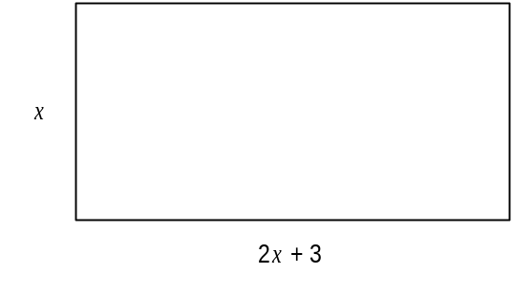

The width is: _______cm The length is: ______cm
❹
Given the triangle illustrated at the right.  The length of each side is represented by an algebraic expression. | 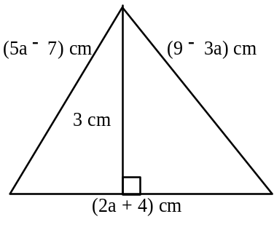
a) Calculate the perimeter of the triangle.

b) Calculate the area of the triangle.

❺ Three friends have a total of $60. Jennifer has $5 less than Lucy. Silvia has twice as much money as Jennifer. How much money does each of them have?

❻ If I add $3.00 to 5 times the money I have, the result is the same as if I were to subtract $18.00 from 6 times what I have. How much money do I have?

❼ The perimeter of the following rectangle is 48 cm. Calculate the width x of the rectangle.
❽ The price of a bicycle is 3 times that of a pair of skis. The cost of both the bicycle and the pair of skis is $540. What is the price of the bicycle?

❾ Twice a certain number increased by 40 is equal to 86. What is the number?

❿ In planning for a vacation out of town, you have to take into account that the average price of breakfast in a restaurant is half the price of lunch. Supper is double the price of lunch. If the total amount spent on meals for one day is $35, what is the average price of a breakfast?

❶❶ Martin, Louise and Denis have $12 400 to share among themselves. If Martin is to get twice Louise's share and Denis gets $8500 more than Louise, how much money will each of them will receive?

❶❷ Three times a number minus 70 is equal to 113. What is the number?

Unit 2: Modes of Representation

Summer Job Activity
This past summer you had a part time job at a local ______________ (you decide where you worked). You worked between 10 and 25 hours each week, your hourly wage was $8.30. You receive your paycheck every Sunday afternoon. You decided you needed a job because you only had $50 in your bank account and you wanted to purchase a ________________ (item must be > $100 including taxes, 5 % GST and 7.5% PST).

You started your job Wednesday, July 2nd and you had 10 hours of paid training that week. You are lucky because you were paid for the training but you were charged $14.50 for a staff t-shirt which was deducted from your paycheck. The second week of July [6th to 12th] you worked 17.5 hours, the third week 15 hours, the fourth week 19.5 hours. The last week of July [July 27th to August 2nd] you worked 23 hours because you worked an extra shift for a friend. On August 3rd you purchased a _____________________ (the item you were saving for) for $____________.

Item purchased description: _________________________________________________
Calculations: cost of item plus 13% tax

The first week of August [3rd to 9th] you worked 14 hours, the second week you worked 12 hours and the third week 21 hours. On Saturday August 23rd you went shopping for back-to-school supplies and spent $47.29 [total, this includes taxes]. The last week of August you worked 18 hours, on the last Friday in August [29th] you went shopping for clothes and bought a pair of jeans for $52.99 and two shirts that were $24.99 each, this does not include the tax.

Your task is to complete the table on the reverse side of this paper to track your bank balance over the summer. You must also create a graph to illustrate your bank balance over the eight week period on graph paper.
Summer Job Activity
Week | Hours worked | Amount earned | Expenditures | New Balance
 |  |  |  | $50.00
❶July 2 - 5 | 10 h
❷

❸

❹

❺

❻

❼

❽

50

NOTE: Table and graph [complete graph on next page] will each be marked out of 50 marks for a total of 100 marks.

50

100

Activity 2
Now that you have completed your summer job activity, your task is to create a similar situation that involves numbers and a graph to represent the information. The situation should not be money and hours worked, be creative and come up with your own. You must also create an answer key for your situation. A classmate will complete your situation, so be clear with your explanations.



Table of Values & Rules

A table of values is a chart (in columns or rows) that shows pairs of numbers that are related to each other.

The rule for a table of values is a mathematical expression that represents (explains) the relation.

***Use the example that this is a machine, numbers are inputted, then the rule is applied and the output is obtained.

❶ ❷
I | O
0 | 0
1 | 2
2 | 4
3 | 6
4 | 8
… | …
n

I | O
0 | 0
1 | 1
2 | 4
3 | 9
4 | 16
… | …
n

⇦ Rule ⇦ Rule

❸ ❹
I | O
0 | 0
1 | 0.5
2 | 1
3 | 1.5
4 | 2
… | …
n

I | O
0 | 0
1 | 5
2 | 10
3 | 15
4 | 20
… | …
n

❺ ❻
I | O
0 | -2
1 | -1
2 | 0
3 | 1
4 | 2
… | …
n

I | O
0 | 1
1 | 3
2 | 5
3 | 7
4 | 9
… | …
n

I | O
1 | 9
2 | 11
3 | 13
4 | 15
5 | 17
… | …
n

I | O
0 | 1
10 | 31
-1 | -2
1 | 4
100 | 301
… | …
n

❼ ❽

❾
I | 0 | 5 | 10 | 3 | 4 | … | n
O | -2 | 8 | 18 | 4 | 6 | …

I | 0 | 4 | 8 | 16 | 32 | … | n
O | 0 | 1 | 2 | 4 | 8 | …

❿

Translating Words to Mathematical Sentences

❶ A number increased by eight ____________________________

❷ The product of two and a number _________________________

❸ Three times a number increased by four ___________________

❹ A number less than five ________________________________

❺Twelve less than three times a number ___________________

❻ Six less than double a number _____________________

❼ Three more than seven times a number _____________________

❽ The sum of a number and three squared ____________________

❾ The product of the square of a number and six ________________

❿ A number increased by seven divided by three _______________
Battle Ship MATH #1
Plot each of the following points on the battle ship math Cartesian plane below. If the point corresponds with ship then record it as a hit, if it does not correspond with a ship then record it as a miss.
X | Y | Hit or Miss
3 | -3
-4 | -3
-8 | 0
3 | 3
2 | -2
2 | 2
-4 | -4
3 | -2
3 | -5
-5 | 4
-7 | 3
-6 | -2
-7 | 2
-7 | -2
-7 | -1
y
x
65
4
321

1 2 3 4 5 6
-6 -5 -4 -3 -2 -1
-1 -2 -3 -4 -5
-6
321

① How many ships were HIT? _____
② How many ships were SANK? ____
Battle Ship MATH #2
X | Y | Hit or Miss
2 | 2
-6 | -6
-2 | 5
-7 | 1
4 | 2
2 | -4
7 | 0
0 | 4
-5 | -6
2 | -2
7 | 2
0 | 3
-2 | 6
5 | 2
-7 | -6
-3 | 4
y
x

① How many ships got HIT? _____

② How many ships were SANK? ____
③ Create Battle Ship Math #3 on this page for a classmate to complete. You must create the table of coordinates, the grid [5 or 6 battleships] plus an answer key!
X | Y | Hit or Miss

BattleShip #3 Answer Key
X | Y | Hit or Miss

Complete each of the following questions.

❶ Mary went for a bicycle ride. The following graph shows the relationship between distance and time.
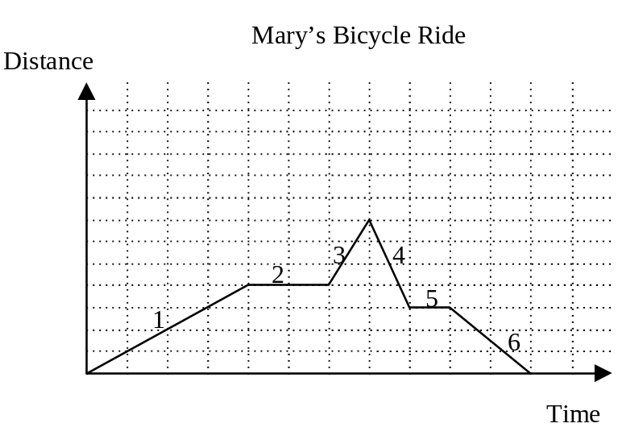
In your own words describe what you has taken place during her bike ride.
________________________________________________________________________________________________________________________________________________________________________________________________________________________________________________________________________________________________________________________

❷ The Smith family went on a picnic last weekend. The following graph shows how far from home the Smith family was located at different times that day.
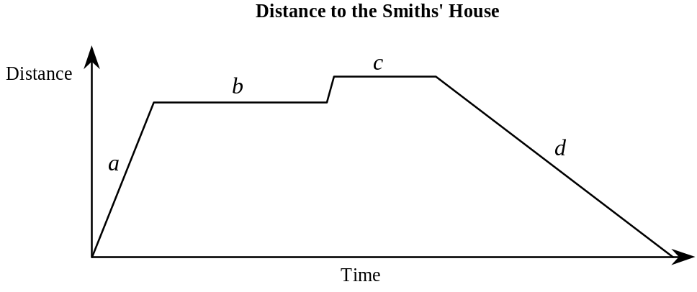
In your own words describe what you has taken place during the picnic.
________________________________________________________________________________________________________________________________________________________________________________________________________________________________________________________________________________________________________________________
❸ A sailboat leaves from the marina at La Ronde and heads towards Quebec City without making any stops. It has to pass under two bridges. It is traveling at a speed of 10 km/h.

Which one of the following graphs represents this situation?

A) | 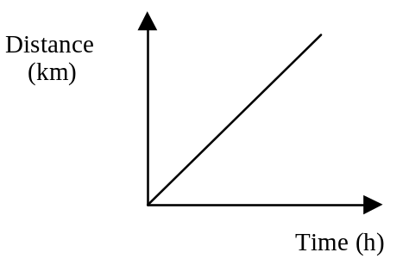 | C) | 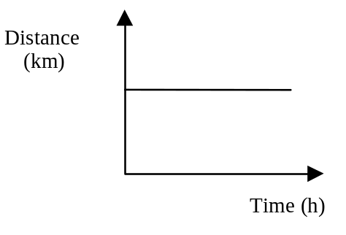
B) | 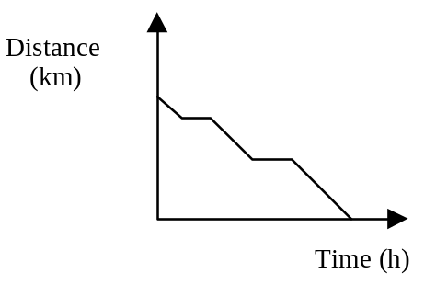 | D) | 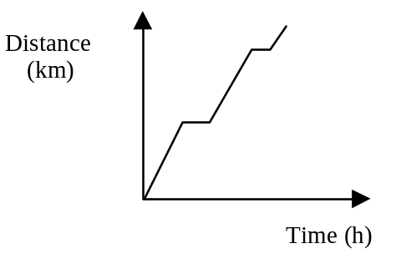
❹ Which statement corresponds to the table of values below?

1st number (x) | 1 | 2 | 3 | 4 | 5
2nd number (y) | 5 | 8 | 11 | 14 | 17

A) | The rule that explains the relationship between x and y is (y + 2) ÷ 3.
B) | The second number is two more than three times the first number.
C) | The first number is four less than the second number.
D) | The expression that represents the second number is 3x − 2.

Explain why you made the choice you did:

________________________________________________________________________________________________________________________________________________________________________________________________________________________________________________________________________________________________________________________
❺ Michael delivers newspapers on foot. This morning he left his home and headed for his first customer, walking at a regular clip. He stopped to deliver the paper, but hearing a dog bark, he quickly took off, running towards his next customer’s house. He stopped again to deliver the paper, and then walked back to his own house. Which graph below represents the distance Michael covered in that time?
 | A) | 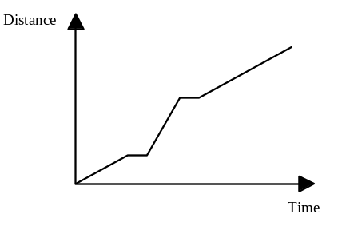 |  | C) | 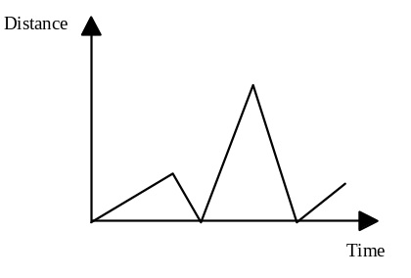
 | B) | 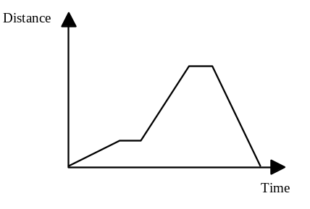 |  | D) | 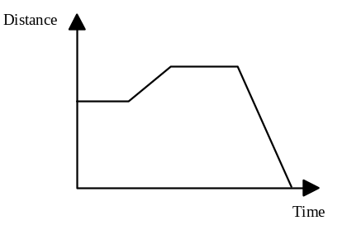
❻  A truck travels along a road at a constant speed, as shown on the right. |  |  | 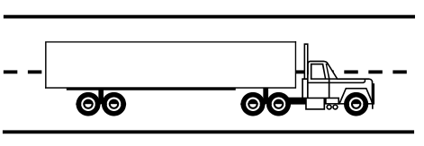
Which of the following graphs represents the distance travelled in relation to time?
A) | 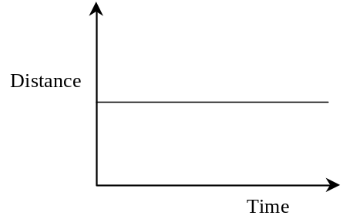 | C) | 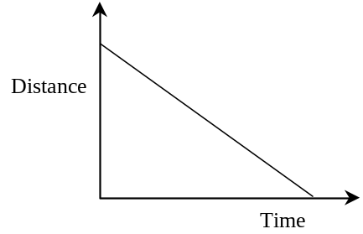
B) | 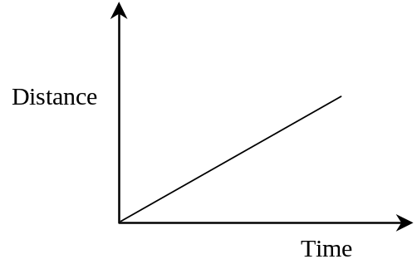 | D) | 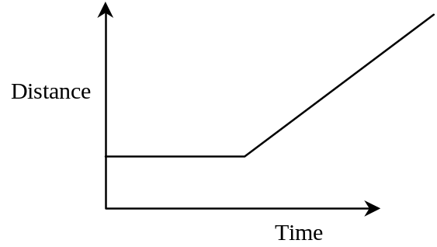
Unit 3: PROPORTIONS

Fractions, decimals & percents are ways we compare numbers.
- Fractions compare the number of parts to the whole
  - Joe ate of the pizza

- Decimals compare tenths, hundredths, thousandths, etc. depending on the number of decimal places
  - Mackenzie ran 100 m in 10.149 seconds

- Percents compare the number of parts out of 100
  - Steph scored 96% on her math test

Fraction to Decimal
Divide the denominator into the numerator E.g.: = 5 ÷ 8 = 0.625

Decimal to Fractions
0.45 = 45 *The denominator is determined by the place
100 value of the last number in the decimal.

Fraction to Percent
Set up a proportion where x is the number out of 100
13 = x
20 100 OR 13 ÷ 20 = 0.65 • 100 = 65%

x = 13 • 100/20 = 65%

Percent to Fraction
Always write the percent over 100, then reduce if possible
88% = ? 88 = 44 = 22
100 100 50 25

Decimals to Percent Percent to Decimals
Always multiply the decimal by 100 Always divide by 100
0. 72 = ? % 36% = 36 ÷ 100
∴ 0.72 • 100 = 72% = 0.36

Fraction-Decimal-Percent Review

 | Fraction | Decimal | Percent | Equivalent  Fraction
❶ | 1/3
❷ |  | 0.08
❸ |  |  | 4%
❹ |  | 0.8
❺ | 6/10
❻ |  |  | 85%
❼ |  | 0.47
❽ | 350  100
❾ |  |  | 150%
❿ |  | 0.3

What is Ratio?

❶ Sort your CUBES by color.
Record the quantity of each color
Color Amount

❷ What is the total number of cubes? ________________

❸ Choose two colors, how can you compare the number of one of the colors to the other?

❹ How many different ways can you compare the cubes? Write each way you find.

❺ Discuss your findings with a classmate. Can you add to each other’s comparisons?

Part-to-Whole Ratio and Part-to-Part Ratio
*Part means the portion and whole means the total being referred to, for example:
I have 10 yellow marbles, 8 green marbles and 7 purple marbles.
Ratio of YELLOW to TOTAL [part to whole] is 7 : 25
Ratio of GREEN to PURPLE [part to part] is 8 to 7

At a friend’s party, there were 15 girls, 16 boys, and 4 adults. What is the ratio of…

❶ boys to girls? ________________________

❷ girls to adults? _________________________

❸ adults to the total number of people at the party? _____________________

❹ Use the above to explain Part-to-Whole Ratio

❺ Use the above to explain Part-to-Part Ratio

❻ Are you sure? Explain each again using the following:

5 sports cars
7 trucks
3 buses
8 vans

Ratio

❶ The ratio of shirts to shorts in Tom’s closet is 5:2

Write the ratio of shorts to the total number of garments ________________

❷ a) What is the ratio of boys to girls in your class? ______________________

b) What is the ratio of girls to boys in your class? _____________________

c) What is the ratio of boys to the total number of students in your class?

______________________________________

d) If two boys leave the room, what is ratio in part c now? _______________

❸ a) Draw two different diagrams to show the ratio 3:5

b) Draw a diagram to show a ratio of 7:1

Jelly Beans, Jelly Beans…

❶Beth shares some jelly beans with Scott. Beth says, “Three for you, five for me, three for you, five for me…”

Anne-Marie watches and at the end she says, “So, Scott got of the jelly beans.”
Do you agree with Anne-Marie? Give reasons for your answer.

❷ Crayons, crayons, and more crayons…
a] box contains 8 red, 5 green, 2 brown, 3 purple, 1 blue, and 6 yellow

Write each of the following ratios:

red : purple _________________ green : blue _________________

purple : green _______________

brown and yellow : total crayons _________________________

b] If 3 red, 2 green and 4 yellow crayons are broken, what would the ratios be for each of the following:
red : purple _________________ green : blue _________________

purple : green _______________

brown and yellow : total crayons _________________________
Fraction-Decimal-Percent Practice

 | Fraction | Decimal | Percent | Equivalent  Fraction
❶ | 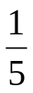
❷ |  | 0.12
❸ |  |  | 9%
❹ |  | 0.9
❺ | 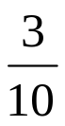
❻ |  |  | 55%
❼ |  | 0.43
❽ | 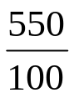
❾ |  |  | 250%
❿ |  | 0.7

Find the missing term for each of the following proportions.

❶ ❷ ❸
3 = ____ 5 = 25 12 = 2
4 12 6 3

❹ ❺
8 : 11 = : 44 7 : = 49 : 35

❻ Fill in the table with the missing terms.

1 | 7 | 9
 |  | 36
1 | 5 | 24
 | 45

❼ Complete the following table of values representing a proportional situation.

Questions | 3 | 6 | 9 | 12
Results | 4 |  |  |  | 20

❽Solve the following problems.

- If the average number of absences is 3 students per group of 33 students, how many absences are there in a school of 693 students?

- In a city, 3 cars out of 10 are foreign. How many foreign cars are there in a shopping mall parking lot of 500 cars?

- At Hadley, the teacher to student ratio is 1 : 29. How many teachers are needed in the school if there are 551 students?

Ratio, Rate & Proportion Word Problems

❶ Joel scores an average of 1.75 points per game in hockey. How many points should he score in 35 games?

❷ The ratio of the length of a rectangle to its width is 7 : 4. If the width is 42 cm, what is the length?

❸Which is the better buy?
a) 5 kg of apples for $2.85 or b) 7 kg of apples for $3.85?

❹A 24 m tree casts a 42 m shadow. How tall is a building with a 147 m shadow?

❺ If an electrician earns $27.50/hour, how much does the electrician earn in a 50 hour week?

❻ Bananas are advertised at 3 kilograms for $1.47. How much would 7 kilograms cost?

❼ On a map 2.5 cm equals 400 km. What distance would 3.8 cm equal?

❽ How long would it take to cover a distance of 800 km at a rate of 120 km/h?

❾ If a dozen eggs cost $1.56, how much would 16 eggs cost at the same rate?
❿ Two partners in a business share the profits in a ratio of 3 : 5. If the partner with the larger share received $8 000, how much would the other partner receive?

❶❶ Sales tax in one province is $7 for every $100 spent. How much sales tax would a person have to pay for an article worth $350?

❶❷ In an election John received 3 votes for every 2 votes Peter received. If John received 291 votes, how may votes did Peter receive?

❶❸ The ratio of the height of a boy’s shadow to a telephone post’s shadow is 1: 6. If the boy is 160 cm tall, how tall is the pole in meters?

Missing Term Practice

❶ ❷ ❸
1 = ____ 9 = 27 12 = 4
4 12 6 3

❹ ❺
8 : 15 = : 90 7 : = 56 : 64

❻ Fill in the table with the missing terms.

1 | 6 | 12
 |  | 48
1 | 4 | 24
 | 44

❼ Complete the following table of values representing a proportional situation.

Questions | 3 | 6 | 9 | 12
Results | 5 |  |  |  | 30
Unit 4: % PERCENT %
Calculate each of the following.
How to calculate PERCENT of a NUMBER
- Convert percent to a decimal
- Multiply the decimal by number

E.g.: 15% or 60
1. 15% = 15/100 = 0.15

2. 0.15 x 60 = 9

❶ 27% of 300 ❷ 8% of 1250

❸ 12.5% of 85 ❹ 43.2% of 300

❺ 3.85% of 820 ❻ 0.9% of 15.3

❼ 15% of 40 ❽ 68% of 10

❾ 0.5% of 450 ❿ 15% of 222

❶❶ 25% of 250 ❶❷ 7% of 1750

❶❸ 15.75% of 105 ❶❹ 63.2% of 600

❶❺ 8.5% of 630 ❶❻ 0.4% of 27.3

❶❼ 35% of 80 ❶❽ 78% of 20

❶❾ 0.5% of 350 ❷⓿ 12% of 333

Percent in Word Problems

❶ At what price must a skateboard be sold to make a 20% profit if its cost price is $50?

❷ A contagious disease spreads across an island and infects 15% of the inhabitants, which is equal to 630 people. How many people live on this island?

❸ The 168 secondary two students in a school make up exactly 42% of the student population. How many students go to this school?

❹ During a shooting contest, Shawn hit 75% of the targets, which equaled 135 targets. How many targets were there in the contest?

❺ What is the retail price of a watch if the buyer saves $8 because of a 15% discount?

❻ Jodi, Betsy and Colleen are softball players. This season, Jodi had 63 base hits in 158 at-bats. Betsy batting average was 0.389, and Colleen hit safely 39% of the time. Who was the best hitter?

❼ A bicycle with a retail price of $340 is reduced to $289, what is the percent discount?

❽ a) If I borrow $3000 at an annual interest rate of 11%, how much interest will I have to pay for one year?

b) If I pay the loan off in one year (12 equal payments), what would my monthly payment be?

❾ Allison borrowed $6000 for one year at an annual rate of 9.75%. She wants to pay off her loan in 12 equal payments. How much will her monthly payments be (covering capital and interest)?

❿ Danick paid $455 for a television set that was discounted by 35%. What was the original price of the television?

❶❶ Amanda bought a bicycle and then sold it for $180. If she made a 20% profit, how much did she pay for the bicycle?

❶❷ There are 600 students at a school, 54% of the students are girls. How many of the students are boys?

❶❸ Two stores are selling the same video camera at a regular price of $895. During a sale, the first store offers a 15% discount on the regular price, while the second store reduces the price by $140. Which store has the better deal?

❶❹ A piece of land in Wakefield cost $14 000 two years ago. If it value increases by 20% each year, what is the land worth today?

❶❺ Jason sold his cottage for $125 000. He had to pay a 7% commission to the real estate agent, and $1500 in various taxes. How much does he have left?

❶❻ Steven invests $1500 at an annual rate of 6%. If the interest is added to the capital at the end of each year, how much will he have after 5 years?

❶❼ A local company must lay off 30 workers due to economic difficulties. If this represents 8% of the workers, how many employees does the company have?

❶❽ Sarah received 16% of the family inheritance. If she received $7000, what was the total inheritance?

❶❾ Calculate the number corresponding to 100%, given that:

a) 20% of a number is 43 b) 58% of the number is 87

The number is ____ The number is ____

c) 250% of the number is 80 d) 18.5% of the number is 25.9

The number is ____ The number is ____
Mission #1
You are shopping for gifts, you have $350.00 in Hadley bucks to complete this gift shopping mission. The following gifts must be purchased:
- One gift for your best friend;
- One gift for you mom and dad, [these can be separate or combined];
- Special gift for someone special [aunt, uncle, cousin, grandparent, etc.];
- You also need some school supplies, 4 binders, 3 packages of paper, 4 sets of dividers, geometry set, 30 cm ruler, package of 12 pencils, calculator, pencil case/kit, 1 package of highlighters, & 1 package of markers.
You can spend $350.00, including taxes on this mission.

Use this table for your calculations.
MISSION #1
Name: ________________ 80__ Date: __________
Quantity | Description | Unit Price | Total
Sub-total:$__________
Calculate with sales tax: GST 5%, PST 7.5% GST:$ __________
Sub-total:$__________
GST:$ __________

Total: __________

Mission #2
Part 1:
In mission #1 you needed gifts & supplies for back to school. You had $350.00 Hadley bucks to complete this mission. Now all the items you purchased for mission #1 are on sale, the gifts you purchased are now 35% off & the school supplies are now 25% off. Recalculate your new total and find the exact amount of savings to you!

MISSION #2
Name: ________________ 80__ Date: __________
Qty | Description | Unit Price | Discount | Sale Price | Total
Sub-total:$__________
Calculate with sales tax: GST 5%, PST 7.5% GST:$ __________
Sub-total:$__________
GST:$ __________

Total: _______

Part 2: Calculate how much Hadley bucks you saved on:

- Gifts? __________________

- School supplies? __________________
Mission #3

When you were born a relative of the family put $750.00 into a Registered Education Savings Plan [RESP] for you. Each subsequent [following] year the family relative contributes 7.5% more than the year before into your RESP.

To promote RESP contributions the Canadian Government adds an additional 20% of the amount deposited to the RESP annually.

The RESP earns 8.25% interest annually.

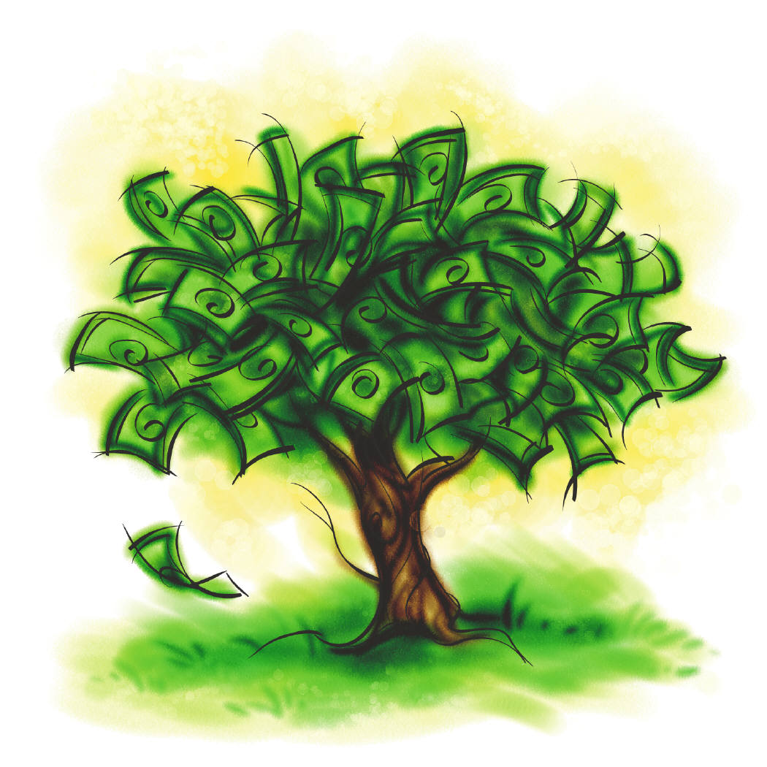
Mission #3

Complete the following chart to determine:
- How much would be in your RESP today? $ __________
- How much will be in your RESP account when you are 17? $____

Y  E  A  R | Balance  forward | RESP  Contribution | Government Contribution  20% | Total | 8.25%  Interest | Balance
0
1
2
3
4
5
6
7
8
9
10
11
12
13
14
15
16
17

3. Create a broken-line graph on the next page to represent the growth of your RESP over the entire 17 year period.

____________________________

Mission #4

After high school you need to borrow money in order to attend school and learn your trade. Your program of study will take three years. Each year of schooling will cost you $15, 000.00.

You have applied for a student loan, in the application you read that you will be charged 4.5% interest on the amount borrowed.

The student loan is cumulative and the interest is added annually.

How much will you owe once you have completed your program?

Balance  forward | Y  E  A  R | Capital  [Amount borrowed] | New Balance | 4.5%  Interest | Total
- | 1 | 15 000.00
 | 2 | 15 000.00
 | 3 | 15 000.00

As soon as your course is done you have to start paying off your student loan. You get a job and make enough money to pay $750/month.
Interest on your student loan is charged annually at a rate of 3.75%. Approximately how many years will it take you to pay off the loan?

YR | Loan Balance | Annual Payment | Total | 3.75%  Interest | New  Total
1

2

3

4

5

6

7

Mission #5

You are hired by Mr. Kharyati to sell Hadley Junior High School yearbooks for the next five weeks. You will earn $45.50 per week plus a 9.25% commission on each yearbook that you sell. Yearbooks will be sold for $45.00 each.

Please see your teacher to determine how many yearbooks you will sell for each of the five weeks:

Week 1: ________
Week 2: ________
Week 3: ________
Week 4: ________
Week 5: ________

- What will be your salary for each week?

- What will be your total salary for the five week period?

WEEK | #  Yearbooks sold | Total  Sales | 9.25%  Commission | Salary | Weekly Total
1
2
3
4
5
Total Salary: ________

Percent Check for Understanding

❶ Calculate: 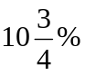 of $2000

❷ Emily paid $200 for a used bicycle. This was 80% of its initial value. What was the initial price of the bicycle when it was new?

❸ Alex, Danick and Kyle won $25 000 in a lottery. The jackpot will be divided among them based on their initial contributions. Thus, Alex should get 35 % of the jackpot and Danick 22 %. How much money should Kyle get?

❹ The total budget of a certain municipality is $144 000 000. To create jobs, the city council decided to put aside $3 600 000 for the construction of public housing. What percent of the total budget is set aside for this construction project?

❺ Matthew buys a bicycle for $239.95. He has to pay tax [5% GST & 7.5% PST] on this amount. How much tax does he have to pay?

❻ Three years ago Andrew bought a computer for $1250, he sold it this year for 65% of its original price. How much did he sell his computer for?

❼ Of the 560 students at Hadley Junior High School, 312 are girls. What percentage of the students are boys?

❽ Renee buys a bicycle for $189.99, the tax is 15 %, how much will the bicycle cost with tax?

❾ Jessica has a part time job working at a clothes store. She is paid $8.25 per hour and she receives a 5% commission on her total sales. Last week she worked 18 hours and her sales totalled $2750. What was her salary for the week?

❿ Philemon Wright High School has 1020 students, 31 girls were absent on Monday. If 45% of the students in the school are boys, how many girls were present that day?

❶❶ Nils is a member of a cycling club. He plans to complete a trip of 84 km in 3 stages. He will cover of the trip in the first stage. The second stage is 4.2 km shorter than the first. What percent of the complete trip is the third stage?

❶❷ Complete the bill of sale below.
Murphy’s Discount Clothing Store
Item Description | Unit Rate | Total Cost
2 shirts | $26.00
3 pairs of socks | $4.00
1 pair of shoes | $75.00
1 pair of pants | $88.99
Sub-total:
40% DISCOUNT
New Price after DISCOUNT
15% TAX
YOU PAY ONLY

APPLICATION Question
The slats in a vertical blind are four different colours: green, white, red and yellow.
The green slats and the white slats are in a 3: 4 ratio.
There are 4 times more white slats than red ones.
There are 27 green slats in the blind.
The green, red and white slats represent 75% of all the slats in the blind.
How many yellow slats are there in this blind?

UNIT 5: CIRCLES

❶ Draw three different sized circles that each touch point A below.

●A

How many circles can you draw that can touch point A? ___________________

❷ Draw three different sized circles that touch points A and B below.

A●

●B

How many circles can you draw that can touch point A & B? ___________________
❸ How many circles DO YOU THINK you can draw that will touch points A, B and C?

_________ TRY IT ☺

A●

●B

C●
Explain your answer:
__________________________________________________________________________________________________________________________________________________________________________________________________________________________________________

❹ How can you find the center of a circle?
__________________________________________________________________________________________________________________________________________________________________________________________________________________

Find the center of this circle.

❺ Draw circles with the given RADII, label the radius on each circle.

a) 6 cm b) 4.5 cm c) 2 cm

❻ Draw circles with the given DIAMETERS, label the diameter on each circle.

a) 10 cm b) 3 cm c) 5 cm

❼ Find the length of the DIAMETER for each of the following. Use π ≈ 3.14.

a) b)
r = 2.3 cm
r = 8.5 cm

c) d)

C = 21.98 cm
C = 26.69 cm

❽ Find the length of the RADIUS for each of the following. Use π ≈ 3.14.
a) b)
d = 9.8 cm

d = 12.2 cm

c) d)
C = 12.56 cm
C = 50.24 cm

❾ Find the PERIMETER [circumference] for each of the following. Use π ≈ 3.14.
✪ C = π d OR C = 2π r

a) b)
d = 25 cm
d = 18.5 cm

c) d)

r = 12.5 cm
r = 1.5 cm

Find the PERIMETER [circumference] for each of the following. Round your answer to the NEAREST HUNDREDTH [two decimal places].
*Remember: C = π d or C = 2 π r
❶ r = 12 cm | ❷ d = 17.88 m | ❸ r = 22.36 mm
❹ d = 22 cm | ❺ r = 24.56 dm | ❻ d = 35 dm
❼ r = 13.51 cm | ❽ d = 46mm | ❾ r = 16.16 mm
❿ d = 0.66 m | ❶❶ r = 0.03 mm | ❶❷ d = 24 cm
CENTRAL ANGLES & ARCS
Circumference PROPORTION
Arc = C A
C 360°

❶ Draw a circle with a radius of 5 cm below, indicate the radius on your disk.
a) Use your protractor to create a CENTRAL ANGLE of 60°.
b) What is the measurement of the ARC created by this central angle? ________

❷ Draw a circle with a diameter of 8 cm below, indicate the diameter on your disk.
a) Use your protractor to create a CENTRAL ANGLE of 100°.
b) What is the measurement of the ARC created by this central angle? ______

❸ Find the length of the arc created by a 130˚ central angle in a circle with a radius of 6 cm.

❹ Find the length of the arc created by a 100˚ central angle in a circle with a diameter of 4 cm.

❺ Find the length of the arc created by a 50˚ central angle in a circle with a radius of 10 cm.

❻ Find the length of the arc created by a 200˚ central angle in a circle with a circumference of 94.2 cm.

❼ Find the measurement of the central angle in a circle with a diameter of 12 cm if the arc measures 18.84 cm.

❽ Find the measurement of the central angle in a circle with a radius of 20 cm if the arc measures 31.4 cm.

❾ Find the measurement of the central angle in a circle with a diameter of 8 cm if the arc measures 18.84 cm.

❿ Find the measurement of the central angle in a circle with a circumference of 157 cm if the arc measures 15.7 cm.

Find the SQUARE ROOT for each of the following.

❶ | 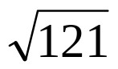 | ❷ | 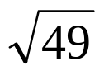
❸ | 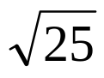 | ❹ | 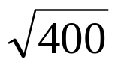
❺ | 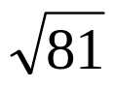 | ❻ | 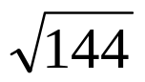
❼ | 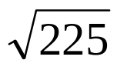 | ❽ | 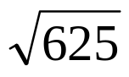
❾ | 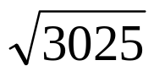 | ❿ | 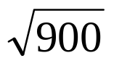
❶❶ | 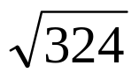 | ❶❷ | 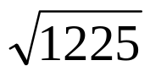
❶❸ | 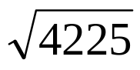 | ❶❹ | 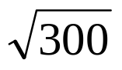
❶❺ | 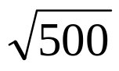 | ❶❻ | 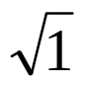

Find the indicated measurement for each of the following:
***Remember your formulas! ☺
r = C d = C r = 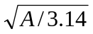 r = d
2π π 2

❶ r = 12 cm C = ? | ❷ C = 17.88 m d = ? | ❸ r = 22.36 mm A = ?
❹ C = 22 cm r = ? | ❺ r = 24.56 dm C = ? | ❻ d = 35 dm A = ?
❼ C = 103.51 cm r = ? | ❽ d = 46mm A = ? | ❾ r = 16.16 mm A = ?
❿ d = 0.66 m A = ? | ❶❶ r = 0.03 mm C = ? | ❶❷ C = 44 cm A = ?

Find the radius of each circle given the following measurements, use π =3.14.
❶ C = 55.22 m | ❷ A = 245.83 mm² | ❸ C = 425 cm
❹ A = 314 m² | ❺ C = 90.64 cm | ❻ A = 75.8 cm²
❼ C = 17.69 m | ❽ A = 705.66 mm² | ❾ C = 9.42 m
❿ A = 56.12 cm² | ❶❶ C = 117.99 cm | ❶❷ A = 199.98 mm²

Find the AREA of each circle, A = π r²
❶ r = 4.29 mm | ❷ d = 40.84 mm | ❸ r = 8 m
❹ d = 20 m | ❺ d = 39.1 m | ❻ r = 25.82 cm
❼ d = 48 mm | ❽ d = 4.26 cm | ❾ r = 3 m
❿ d = 39.82 cm | ❶❶ r = 17 mm | ❶❷ d = 27.24 mm
❶❸ r = 12 mm | ❶❹ d = 43.08 cm | ❶❺ r = 10 cm
❶❻ d = 30 mm | ❶❼ r = 7.25 mm | ❶❽ d = 6 mm
❶❾ r = 16 mm | ❷⓿ r = 54.32 mm | ❷❶ d = 7.6 m
❷❷ d = 15 cm | ❷❸r = 32 cm | ❷❹ d = 9 mm
❷❺ r = 12 mm | ❷❻ d = 14.14 mm | ❷❼ r = 62mm
Find the AREA of each sector
created by the given CENTRAL ANGLE.
Area PROPORTION
Sector = C A
Area 360°
A = π r²
❶ r = 12 cm & Central Angle of 70° | ❷ d = 17.88 m & Central Angle of 110°
❸ d = 22 cm & Central Angle of 300° | ❹ C = 254.34 m &Central Angle of 30°
❺ r = 17 m & Central Angle of 100° | ❻ C = 1256 cm & Central Angle of 300°
❼ d = 17 m & Central Angle of 150° | ❽ C = 1962.5 cm & Central Angle of 50°

Solve each of the following.
❾ The Ferris wheel at the Super Ex has 50 seats. If the length of the arc between each seat is 4.5 m, determine the diameter of the Ferris wheel [round your answer to the nearest hundredth].

❿ The wheels of a mountain bike have a diameter of 80 cm. How many rotations does each wheel have to make in order to cover a distance of 400 m.

❶❶ The straight section of a pool is 10 m long. The semi-circle at each end has a diameter of 7 m. Calculate the perimeter of the pool.
10 m

7 m

❶❷ Three congruent circles are placed in this rectangle. Calculate the circumference of one of these circles if the perimeter of the rectangle is 36 cm.

❶❸ Calculate the area of each of the following discs using the information given.

a] b]
10 cm
0.25 m cm

❶❹ A satellite signal transmits over a radius of 100 km, calculate the total area reached by this signal.

❶❺ Find the radius of a disc with:
a] a circumference of 39.25 cm b] a diameter of 34.8 m

c] an area of 78.54 cm² d] an area of 379.94 cm²

Calculate the shaded area in each of the following diagrams. Be sure to show all calculations. Notice the relationship between the square & circle[s].
❶ ❷
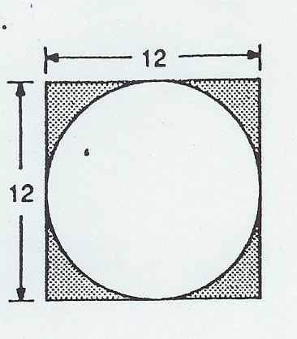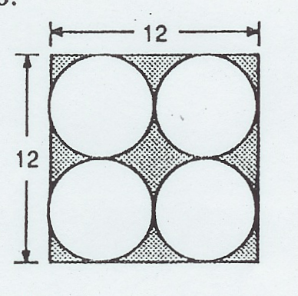
20cm
20cm

❸ ❹
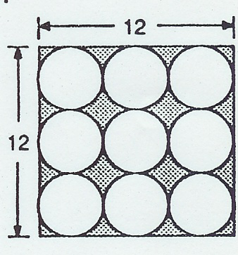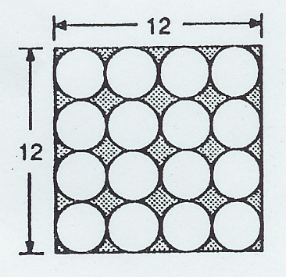
16m
16m
18cm
18cm

❺ ❻
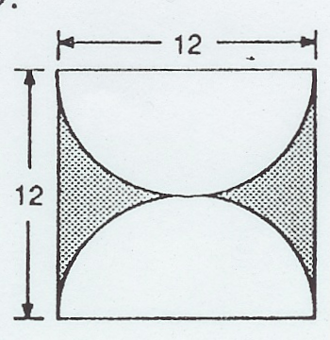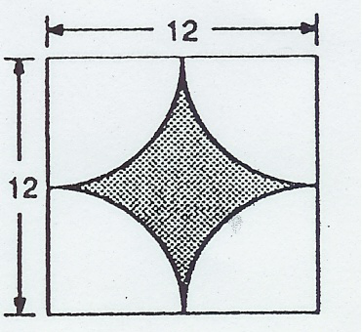
10m
10m
❼ ❽
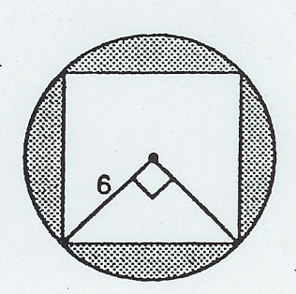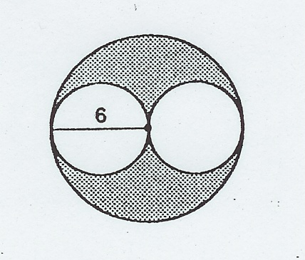

❾ Emma is 2 years older than Megan, the sum of their ages multiplied by 5 is 60. How old is each girl?

❿ The perimeter of this figure is 76 cm. Find the length of each side of the figure in cm.
2x
x
2x
2x

3x

6x

❶❶ Karina worked as a lifeguard at a hotel for 3 summers in a row.
In 2005, she worked 4 weeks more than she did in 2004.
In 2006, she worked 2 weeks less than the sum of the weeks she worked in 2004 and 2005.

During these summers, she worked a total of 30 weeks.
Let x represent the number of weeks Karina worked during the summer of 2004.
How many weeks did she work in 2006?

❶❷A graphic artist is designing the front cover of our new grade 8 math workbook. The length of the front cover of the rectangular book is 4 cm less than double its width. The perimeter of the front cover is 166 cm.

What is the area of the book cover? Draw a diagram to help solve this problem.

❶❸ Solve the following problem by setting up and solving an equation.
A rope is divided into four parts.
The second part is twice the length of the first, the third is three times the length of the first, and the fourth is 6 m longer than the second.

The total length of the rope is 486 m long. How long is each part?

❶❹ In this equation 40x + 5(1.5x) = $712.50, x represents Mary’s hourly wage, $712.50 was her total salary for the week. What was her hourly wage?

CIRCLE Check 4 Understanding
❶ Use your compasses to draw a circle with:
a) a radius of 3.7 cm; b) a diameter of 4.5 cm;

c) a circumference of ≈ 9.42 cm d) an inner area of ≈ 12.57 cm².

❷ Three chalets, A, B and C, are built at a ski hill.
a) Find the exact location where a lamppost must be installed to give the same intensity of light on all three chalets.

A
b) Explain the property of circles that enables you to solve this problem.

B

C

c) Find center of this circle by using perpendicular bisectors.

❸ a) Calculate the perimeter of this circle. b) Calculate the area of this disc.

r = 4.5 cm
d = 11 cm
•

❹ Find the radius of a circle with a circumference of 113.04 cm.

❺ Find the diameter of a circle with a circumference of 204.10 mm.

❻ Calculate the circumference of each of these circles.

[a] [b]
d = 9 cm
r = 6 mm

❼ Calculate the area of each of these figures (π ≈ 3.14).

[a] [b]

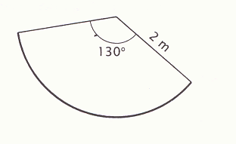
r = 5 cm

❽ Find the radius of a disc that has:
a) a circumference of ≈ 45.53cm; b) an area of ≈ 1520.53 m²

❾ A tricycle wheel has a radius of 12 cm, how many turns does the wheel make if the tricycle travels 100 m?

❿ The blades of a model airplane’s propeller define a disc of approximately 153.92 cm². How long is each blade?

❶❶ If an arc length measures 65 cm and the central angle is 40°, what is the circumference of the circle?

❶❷ Calculate the perimeter of the following shape.
14 cm

14 cm
14 cm

14 cm

____ = _____%
100

Unit 6: POLYGONS

Are these polygons? Justify your answer.

❶a) b) c)

Yes or No – Why/Why not? Yes or No – Why/Why not? Yes or No – Why/Why not?
_______________________ _______________________ _______________________
_______________________ _______________________ _______________________
❷ a) What is a CONCAVE polygon? Use a diagram to illustrate your definition.

__________________________________________________________________________________________________________________________________________________________________________________________________________________________________________

b) What is a CONVEX polygon? Use a diagram to illustrate your definition.

__________________________________________________________________________________________________________________________________________________________________________________________________________________________________________

❸ Classify each of the following polygons as CONCAVE or CONVEX.

a) b) c) d)


d) e) f) g)


❹ What is a diagonal? Draw a diagram to illustrate your definition.
__________________________________________________________________________________________________________________________________________________________________________________________________________________________________________

❺ Draw ALL diagonals for each of the following polygons.
a) b) c) d)


e) f) g) h)

❻ How many diagonals can be drawn in a polygon with each of the following number of sides? Remember: # of diagonals = n(n – 3)
2

a) 6 sides ____ b) 9 sides ___ c) 14 sides ___

❼ Name the polygon which has:

a) 20 diagonals? b) 9 diagonals? c) 5 diagonals?

_____________ ____________ ____________

❽ What is an interior angle? Draw a diagram to illustrate your definition.
__________________________________________________________________________________________________________________________________________________________________________________________________________________________________________

❾ Calculate the sum of the interior angles for each of the following polygons. Remember: sum of interior angles = (n – 2) • 180°

a) HEXAGON b) DECAGON c) PENTADECAGON

❿ Find the number of sides each of the following polygons have if:
a) the sum of the interior angles = 540° b) the sum of the interior angles = 1440°

c) the sum of the interior angles = 1800° d) the sum of the interior angles = 3240°

❶❶ A hexagon has angles measuring 130°, 115°, 95°, 150° and 120°. Find the measure of the 6th angle.

❶❷ a) What is an exterior angle?
__________________________________________________________________________________________________________________________________________________________________________________________________________________________________________

b) Draw a diagram to illustrate your definition?

❶❸ What is a regular polygon? Draw a diagram to illustrate your definition.
__________________________________________________________________________________________________________________________________________________________________________________________________________________________________________

❶❹ Identify whether each of the following polygons are regular or not, justify your answer for each!
a) b)

_______________________________
_______________________________

______________________________
______________________________

c) d)

______________________________ _____________________________
______________________________ _____________________________

❶❺ What is the measure of the interior angles of each of the following regular polygons? Remember: (n – 2) • 180°
n

a) Regular pentagon __________ b) Regular decagon __________

c) Regular octagon __________ d) Regular hexagon __________

❶❻ Which regular polygon has the following interior angle measurement?

a) 102° ______________ b) 60° ________________

c) 108° __________________ d) 144° ________________

❶❼ Draw a circle and construct the following polygons inside each circle:
***Your circle must CIRCUMSCRIBE your polygon, this means each vertex of your regular polygon must touch the edge of the circle.

a) an equilateral triangle b) a regular pentagon

c) an regular decagon d) a regular octagon

❶❽ (a) Construct a regular pentagon (b) Construct a regular octagon
with 3 cm sides. with 2 cm sides.

(c) Construct an equilateral triangle (d) Construct a regular hexagon
with 4 cm sides. 2 cm sides.

(e) Construct a square with diagonals (f) Construct a regular heptagon with
that measure 6 cm. 2.5 cm sides.

❶❾ Complete this table.

Polygon | Octagon | Square | Decagon | Pentagon | Hexagon
Side Length |  | 4 cm | 1.6 cm |  | 8 m
Perimeter | 56 cm |  |  | 45 cm

❷⓿ Complete this table by giving the name of the regular polygon for each of the following:

Side length | 4.6 cm | 8 cm | 2.2 cm | 12 dm | 11.2 cm
Perimeter | 18.4 cm | 72 cm | 6.6 cm | 144 cm | 33.6 cm
Name

❷❶ The loony is shaped like a regular hendecagon (11 sides), if each side measures 7mm:

(a) What is the perimeter? ____________

(b) What is the measure of each interior angle? __________

(c) What is sum of the exterior angles? _____________

❷❷ If a heptagon has a perimeter of 84 cm, what is the side length? _________

❷❸ This figure was created using a rhombus with a perimeter of 16 cm, if pentagons are placed around the perimeter of the rhombus what is the perimeter of this new figure?
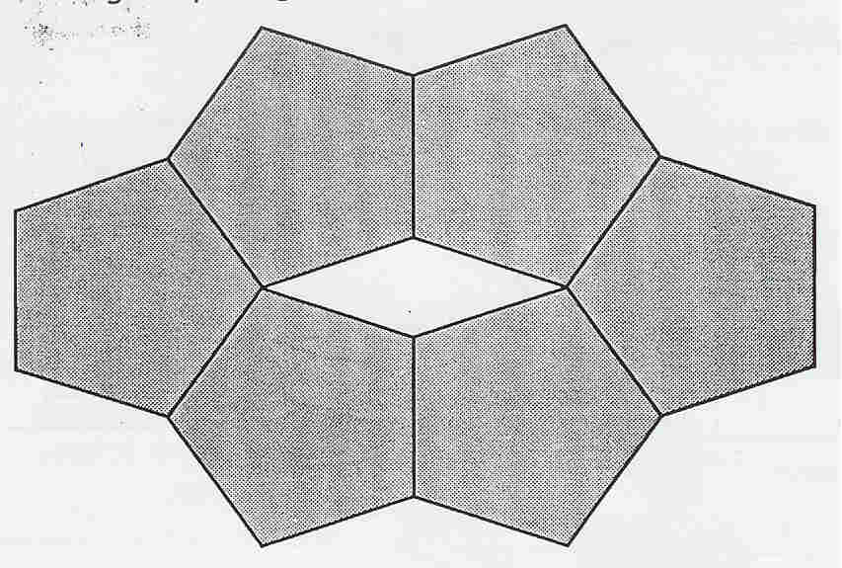 Perimeter = ____________

❷❹ Calculate the perimeter of each regular polygon.
3 cm
8 cm
(a) (b)

a = 4.33cm
a = 6.75cm

❷❺ A regular pentagon is made up of 5 congruent isosceles triangles. Find the area of the pentagon given that the area of one triangle is 14.5 cm².

❷❻ Find the area of a regular pentagon with a side length of 4 cm and an apothem of 2.75 cm.

a = 2.75cm

❷❼ A regular octagon with a perimeter of 32 cm has an apothem of 4.83 cm Find the area of this octagon.

P = 32 cm

a = 4.83cm

❷❽ A regular hexagon has a perimeter of 30 cm and an apothem of 4.33 cm. What is area of this regular hexagon?

P = 30 cm

a = 4.33cm

❷❾ The area of a regular polygon can be calculated using the formula Area = P • a
2
P is the perimeter and a is the apothem. Complete the following table.

POLYGON | APOTHEM  Cm | PERIMETER  Cm | SIDE LENGTH cm | AREA of POLYGON cm²
Octagon | 5.5 | 40
Pentagon | 13.76 |  | 20
Decagon | 4.33 | 300
Hexagon | 5.2 | 36
Octagon | 5.43 |  | 4.5
Decagon | 23.08 |  | 15
Hexagon | 5.54 |  | 6.4
Pentagon | 4.54 | 33

❸⓿ A regular polygon with a side length of 6cm and an apothem of 5.20cm. If the area is 93.60 cm², which regular polygon is it?

❸❶ The living room floor is covered with a hexagonal rug. Each side of the rug measures 1m and the apothem measures 86.6 cm. What is the area of this rug?

❸❷ I would like to build an octagonal gazebo for my back yard this summer, the plans I have call for the sides to be 2 m each, from the center of the gazebo to one of the sides measures 1.65 m. What is the area of the gazebo that I would like build?
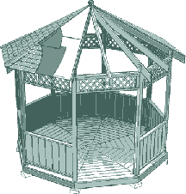

❸❸ Calculate the area of each regular polygon using the measurements given:
a] an regular octagon with sides measuring 10 mm & an apothem of 12.07 mm

b] a regular hexagon with sides measuring 5 cm & an apothem of 4.33 cm

c] a regular decagon with sides measuring 4 m & an apothem of 6.16 m

d] a regular pentagon with sides measuring 8 dm & an apothem of 6.5 dm

❸❹ A regular hexagon is inscribed in a circle, if the radius of the circle is 8 cm and the area of the hexagon is 166.32 cm², what is length of the apothem?
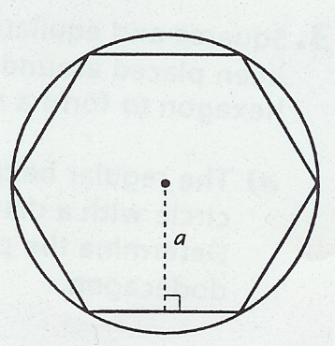

❸❺ A regular polygon has 5 cm sides and an apothem of 6.04 cm. The area of this polygon is 120.8 cm², what regular polygon is it?

❸❻ This regular pentagon has semi-circles constructed on each side, the perimeter of the pentagon is 25 cm. What is the area of the shaded sections of the semi-circles?
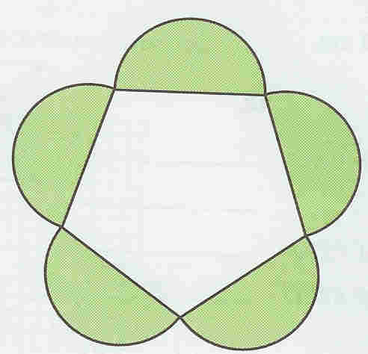

❸❼ A circle is inscribed in this square; calculate the area of this square if the area of the circle is 28.26 cm².
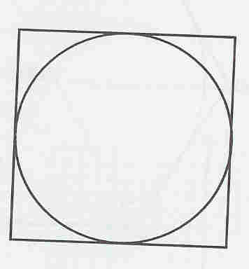

❸❽ The regular dodecagon below is made up of squares and equilateral triangles.
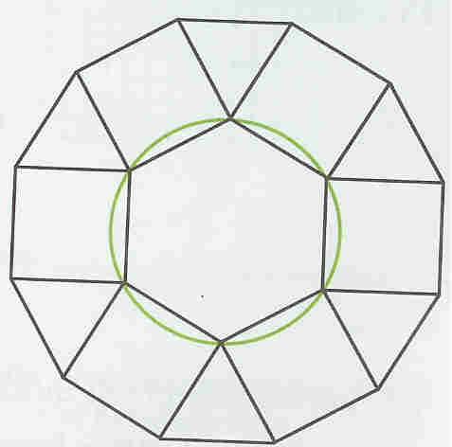
(a) If the circle has a diameter of 6 cm, what is the perimeter of the dodecagon?

(b) If the area of the hexagon is 23.5 cm², what is the area of the regular dodecagon?
❸❾ Complete this table .
#  Sides | Name | # ∆’s  *n-2 | Total Diagonals  *n(n-3)/2 | Sum of Interior <‘s  *(n-2)180˚ | Interior <  Measure  *(n-2)180/n | Central <  Measure  *360˚/n
3 | triangle | 1 | 0 | 180 | 60 | 120
4
5
6
7
8
9
10
12

❹⓿If "x" is the length of one side of this regular pentagon and "2" is the length of its apothem, write an algebraic expression represents the area of the pentagon? | 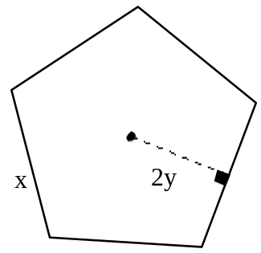
2
❹❶ The area of the equilateral triangle on the right is 15.6 cm².  Its height is 5.2 cm.  What is the perimeter of this equilateral triangle? | 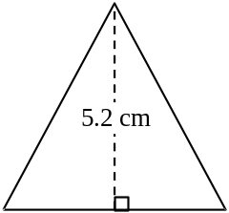

❹❷ A company’s logo is shown on the right.  The area of sector AOB is 75.36 cm² and angle AOB measures 60°.  Each side of the regular hexagon measures 14 cm.  What is the area of the black part of the logo? | 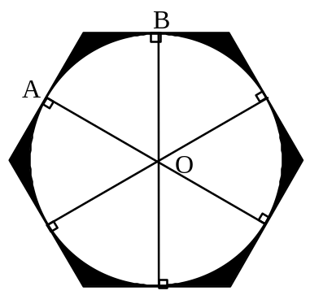

❹❸ Nick built a patio next to his circular swimming pool with diameter 8 m, as shown by the diagram on the right. He wants to cover the patio with carpet that sells for $5.25 a square metre. The length of each side of the patio is equal to the length of the pool’s diameter.  How much will it cost to carpet the patio, to the nearest dollar? | 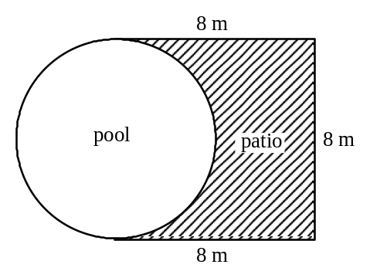

❹❹ The perimeter of a regular hexagon is (30x + 6) units. What is the simplified algebraic expression that corresponds to the length of one of its sides?

❹❺ A circular pool with a fountain in the center has been installed in a town park.  A fence in the form of a regular hexagon is constructed so that the pool touches each side of the hexagon, as shown in the diagram on the right.  The pool has a diameter of 26 m.  The length of each side of the regular hexagon is 15 m.  The town wants to plant grass in the areas that are shaded in the diagram. | 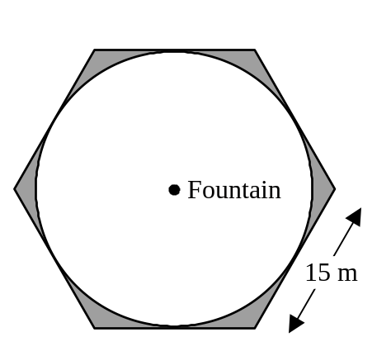
The cost of the grass is $4.25/m². Excluding taxes, what will it cost the town to plant the grass around the pool?

Polygon Construction Assignment

Name: ________________ Group 8____ Date: ____________

***This assignment is to be done on a separate sheet of paper, preferably without lines.
***Be very careful when constructing polygons, you must be within 2° and 2 mm of specifications. Have a friend double check for you!
***Be sure to include all angle measurements and side lengths where required.
***Feel free to add colour to you assignment!

❶ Construct the following polygons using circles and central angles: [5 marks each]

a) a decagon b) a pentagon c) an octagon d) heptagon

❷Construct the following polygons using the side lengths:
[5 marks each]

a) An equilateral triangle with a perimeter of 15 cm

b) A pentagon with a perimeter of 30 cm

c) An octagon with a perimeter of 32 cm

d) A hexagon with a perimeter of 18 cm

Unit 6: Regular Polygons - Check 4 Understanding

❶ Use circles below to construct:
[a] a regular pentagon [b] a regular octagon

❷ Use your geometry set to construct:
[a] a regular hexagon [b] an equilateral triangle
with a perimeter of 18cm with 5 cm sides

❸ Draw all DIAGONALS for each regular polygon.

[a] [b]

Number of diagonals:____ Number of diagonals:_____

❹ Complete this table by giving the interior angle measures or naming the regular polygon given the interior angle measurement.

Regular polygon | Square |  |  | Octagon
Interior angle measure |  | 120˚ | 60˚ |  | 108˚

❺ Jack built a patio shaped like a regular octagon. If one side of the patio measures 3 m, and the apothem is 3.62 m. What is the area of the patio?

Patio Area = _________________

❻ The perimeter of a regular hexagon is given by the algebraic expression
(30x – 42). What is the algebraic expression for one side?

Side length: _________________

❼ Use a compass to draw a circle that has:
[a] a circumference 9.42 cm [b] an area of 7.065 cm²

[c] a central angle of 40° with [d] a central angle of 80° with
an arc length of 1.74 cm a sector area of 4.36 cm²

❽ Find the center of this circle using perpendicular bisectors.

❾ A polygon is composed of 6 triangles when all the diagonals at one vertex are drawn.

a) Name the polygon: _____________________

b) Justify your answer in part a): _______________________________________________________________________________________________________________________________________________________________________________________

❿ The sum of the interior angles of a polygon is 2880°. The number of sides is to be calculated.

a) What statement justifies the equation used to solve this problem?

b) How many sides does the polygon have?

❶❶ Jeffrey and his friends built a cabin in the woods next to the arena. The area of the cabin front, shown in the sketch below, is 3.25 m². What is the height of the cabin?
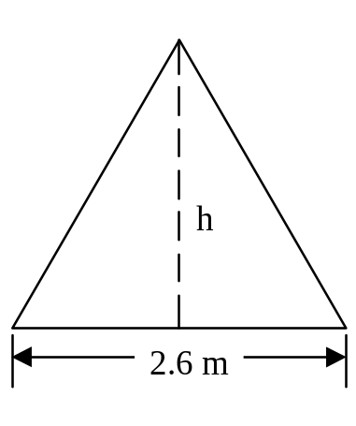

❶❷ The municipal employees must repaint the traffic signs.  The octagonal figure at the right represents a stop sign.  They used the measurements shown on the diagram to calculate the area of the sign. | 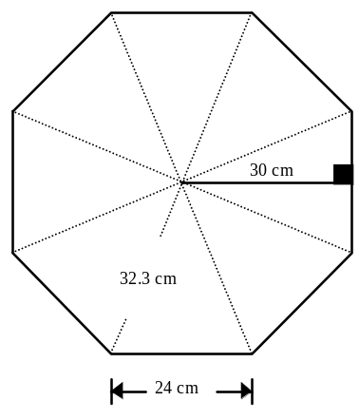
What is the area of this stop sign?

❶❸ A square window has an area of 3.24 m². What is the measure of one side of this window?

❶❹ The perimeter of a regular octagon measures (24a − 16) units. Write an algebraic expression to represent the length of one side of the octagon.

❶❺ The sum of the ages of 3 persons is 78 years. The second person is twice as old as the first, and the third person is 2 years younger than the second. What is the age of each person?

Types of ANGLES
Acute Angles: An acute angle is an angle measuring between 0 and 90 degrees.
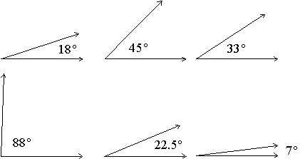

Obtuse Angles: An obtuse angle is an angle measuring between 90 and 180 degrees.
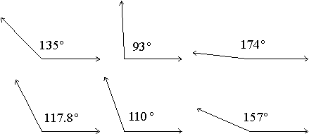

Right Angles: A right angle is an angle measuring 90 degrees. Two lines or line segments that meet at a right angle are said to be perpendicular. Note that any two right angles are supplementary angles (a right angle is its own angle supplement).
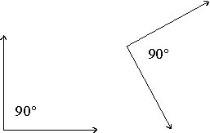

Complementary Angles: Two angles are called complementary angles if the sum of their degree measurements equals 90 degrees. One of the complementary angles is said to be the complement of the other.
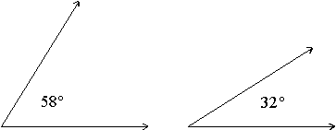
Note that these two angles can be "pasted" together to form a right angle!

Supplementary Angles: Two angles are called supplementary angles if the sum of their degree measurements equals 180 degrees. One of the supplementary angles is said to be the supplement of the other.
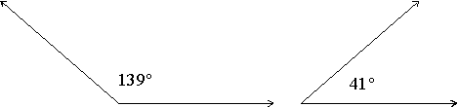
Note that these two angles can be "pasted" together to form a straight line!
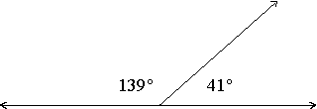

ANGLE PRACTICE
❶ Use the diagram below to name two of each of the following types of angles:
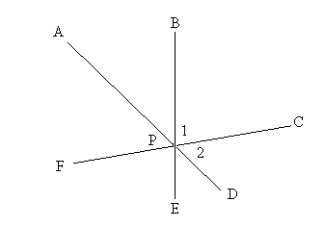
A] Acute _____ _____

B] Obtuse _____ _____

C] Straight _____ _____

D] Supplementary _____ _____

E] Right _____ _____

❷ For each of the following, determine what type of angle[s] and explain how you know:
A. B.
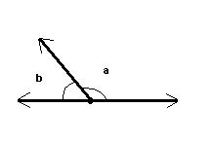 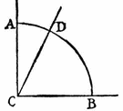
__________________________________ ________________________________
__________________________________ ________________________________
__________________________________ ________________________________

C. D.
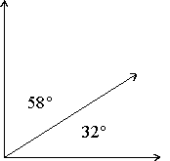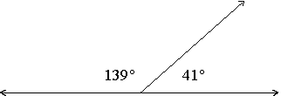

__________________________________ ________________________________
__________________________________ ________________________________
__________________________________ ________________________________

Parallel & INTERSECTING LINES & ANGLES

Lines AB and CD are parallel to one another (the » on the lines means parallel).
Angles a and d are vertically opposite angles. Vertically opposite angles are equal. (b and c, e and h, f and g are also vertically opposite).
Angles g and c are corresponding angles. Corresponding angles are equal. (h and d, f and b, e and a are also corresponding).
Angles d and e are alternate angles. Alternate angles are equal. (c and f are also alternate).
Alternate angles form a 'Z' shape and are sometimes called 'Z angles'.
a and b are adjacent angles. Adjacent angles add up to 180 degrees. (d and c, c and a, d and b, f and e, e and g, h and g, h and f are also adjacent).
d and f are interior angles. These add up to 180 degrees (e and c are also interior).
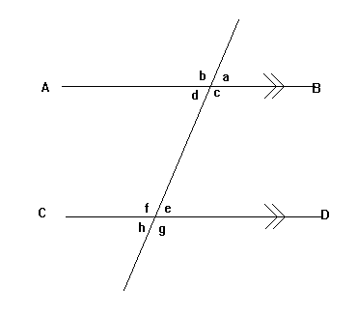

In the diagram above, if angle a measures 75°, what are the measurements of each of the other angles listed in the table. Explain how you know each measurement.

Angle | Measurement | Justification
a | 75° | Given
b
c
d
e
f
g
h

Types of TRIANGLES

Triangle: A three-sided polygon. The sum of the angles of a triangle is 180 degrees.


Equilateral Triangle: A triangle having all three sides of equal length. The angles of an equilateral triangle all measure 60 degrees.
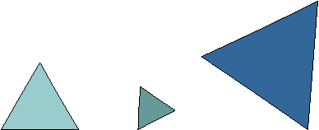

Isosceles Triangle: A triangle having two sides of equal length.
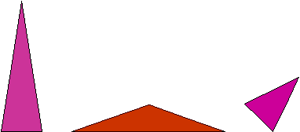

Scalene Triangle: A triangle having three sides of different lengths.
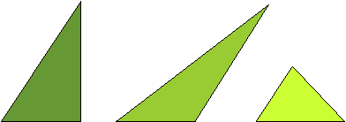

Acute Triangle: A triangle having three acute angles.
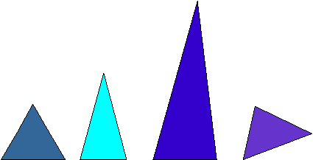

Obtuse Triangle: A triangle having an obtuse angle. One of the angles of the triangle measures more than 90 degrees.


Right Triangle: A triangle having a right angle. One of the angles of the triangle measures 90 degrees.
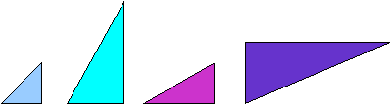

Classify each of the following triangles, state how and why you know what type of triangle it is.

❶ ❷
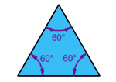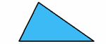

: _________________________ : _________________________
____________________________ ____________________________
____________________________ ____________________________

❸ ❹
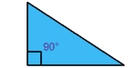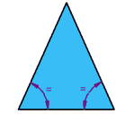

: _________________________ : _________________________
____________________________ ____________________________
____________________________ ____________________________

❺ ❻
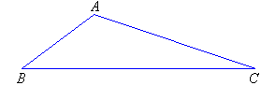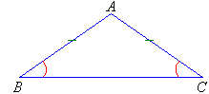

: _________________________ : _________________________
____________________________ ____________________________
____________________________ ____________________________
Angles, Angles, Angles… ☺
Find the measurement of each of the indicated angles WITHOUT using a PROTRACTOR. Use your knowledge of complementary, supplementary, opposite and interior angles as well as polygons to explain/justify/find each angle measure.

❶

a = ____°
b = ____°
c = ____°

c°

80°
a°
50°

65°
85°
b°

❷

57°
d = ____°
e = ____°
f = ____°
g = ____°
e°

g°
50°
f°

d°
46°
60°
90°

❸

j°
45°
i°
55°
h = ____°
i = ____°
j = ____°
k =____°
l =____°
110°
k°

h°

85°

l°

o

❹
90°

90°
90°
m
n
90°
m = ____°
n = ____°
o = ____°
p = ____°

45°
p
UNIT 7: Dilatations/Similarity Transformations

❶ Blast point with a factor of 3 and centre of similarity O

•C
•B
•O
•D

•A

❷ Black hole with a factor of 1 and a centre of similarity O
4
•E

•F

•G
•O
•H

❸ Blast point with a factor of 2.5 and centre of similarity O

A

•O

C
B

❹ Black hole with a factor of and a centre of similarity O
L
I

•O
V
E
❺ Draw the image of this triangle if the ratio of similarity is 5 : 2.

S

O

I T

❻ Draw the image of point P AND of triangle ABC using the given similarity transformation.
***To find the RATIO = New ÷ Old [i.e. OA’ ÷ OA]
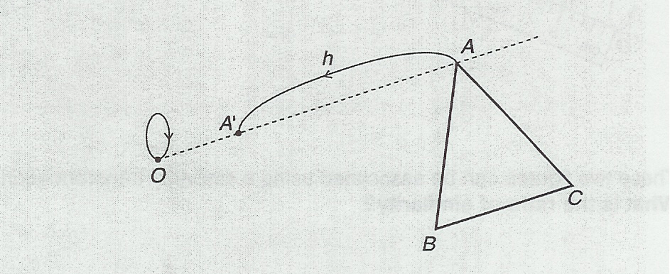

P

❼ Which of the given figures is the IMAGE of ΔABC using similarity transformation h with centre O and a ratio of 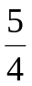.
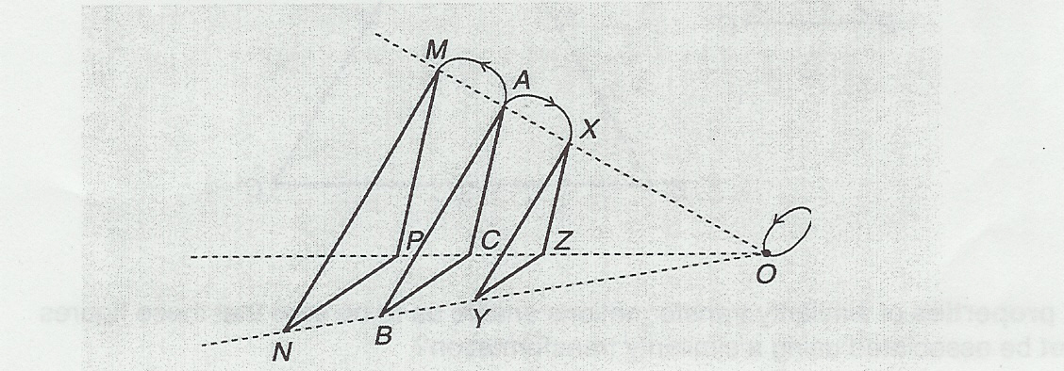

Answer: Δ_________

❽ Draw the image of ΔXYZ using the given similarity transformation. [5 marks ea]

A.) Similarity transformation with

B.) Find the center of similarity & ratio, then draw the image of ▲XYZ

center O and a ratio of 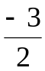.

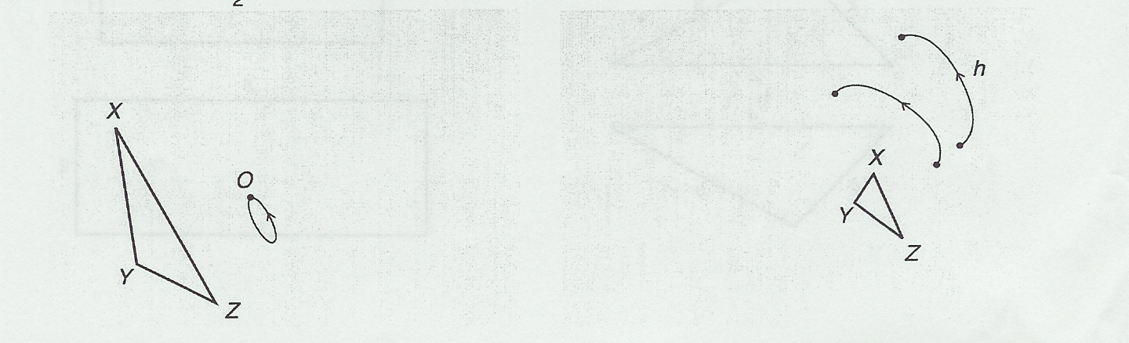

❾ Find the ratio of similarity. [Ratio = New ÷ Old]
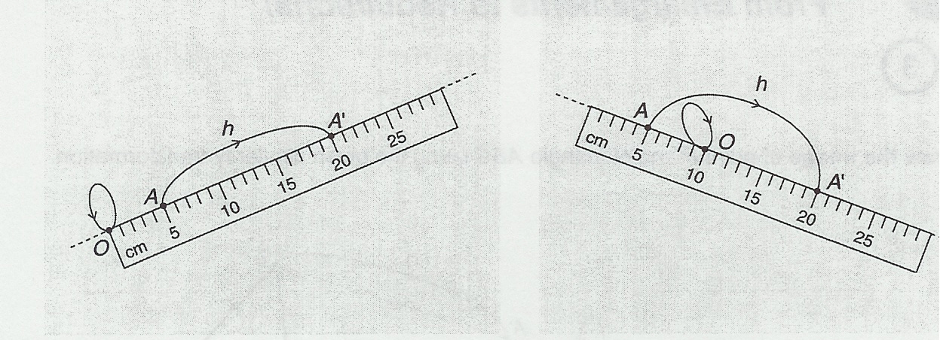
A.)
B.)

A. Answer: __________ B. Answer: __________

❿ Find the center of similarity & ratio, and then draw the image of ▲ABC
F
●
A

●
E
●
F’

●
E’

C
B

❶❶ Understanding RATIOS/FACTORS: state whether each of the following ratios will result in a REDUCTION, ENLARGEMENT or EXACT REPRODUCTION.

a] 2.5 ____________________________ b] 4 ____________________________
5

c] 2 : 3 ___________________________ d] 4 : 1____________________________

e] 1 ___________________________ f] 0.4 ____________________________

g] -5 ___________________________ h] -1 ____________________________
2

i] -0.75 _________________________ j] -3 to 1 __________________________

❶❷ A rectangle measures 9 cm by 15 cm, if the ratio of similarity is 1/3, what are the dimensions of the new rectangle.

Answer: ___cm by ___cm

❶❸ Draw the image of each of the following figures resulting from the described similarity transformation.

Center O and a ratio of 2/5

O
T

I
P

B. Center O and a ratio of 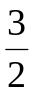

T
E

O

M
R

❶❹ In a similarity transformation, a ratio of _____ would produce an enlargement.

a] 7 : 6 b] 7 : 7

c] 7 : 8 d] none of these

❶❺ In a similarity transformation, a ratio of _______ would produce a reduction.

a] 7 : 6 b] 7 : 7

c] 7 : 8 d] none of these

❶❻ These two figures can be associated using a similarity transformation. What is the ratio of similarity?
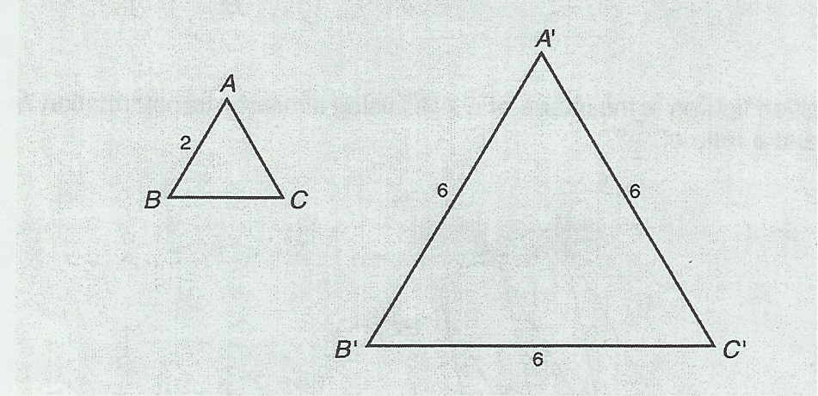

Answer:
ratio = _________

❶❼ What properties of similarity transformations enable us to be sure that these figures cannot be associated using a similarity transformation?
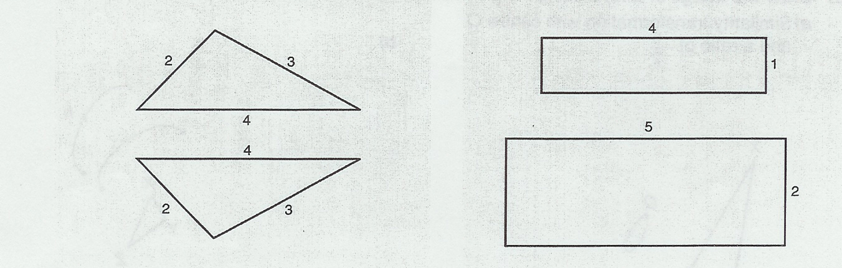
A.)

B.)

A. Answer: _________________________ B. Answer: _______________________
___________________________________ ________________________________

❶❽ Are each of these pairs of figures similar? Circle yes or no.
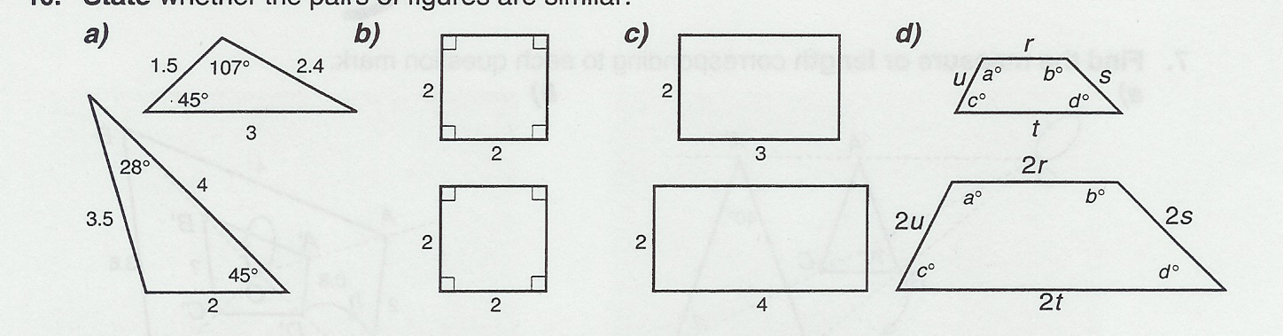

A.) Yes or No
B.) Yes or No
C.) Yes or No
D.) Yes or No

❶❾ Complete the table of values, given that these figures are similar.
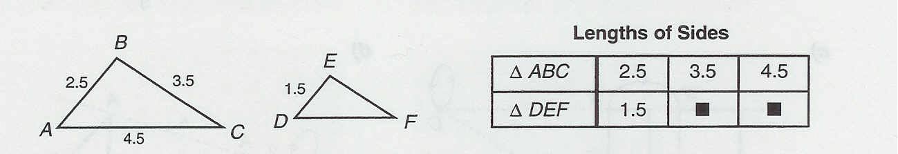

40

❷⓿ What is the actual distance between two cities that are 5.6 cm apart on a map with a 2 cm = 450 km scale?

❷❶ Circle TRUE or FALSE for each of the following statements.

A] All similar figures are congruent. true false

B] All rectangles are similar to each other. true false

C] Angles do not change in a similarity transformation. true false

D] A ratio of similarity of -3 : 1 would produce an enlargement. true false

E] A ratio of similarity of 1 : 5 would produce a reduction. true false

F] A negative ratio of similarity produces an image on the same side of the center of similarity as the original figure.
true false

Complete the following tables and find the RATIO of SIMILARITY for each.
❷❷
Image(Prime) | 5 |  | 4.4 | 10
Original Figure | 2 | 6

Ratio of Similarity =

❷❸
Image(Prime) | -2.2 | -0.8 |  | -5
Original Figure |  | 3.2 | 12.6

Ratio of Similarity =

❷❹
Image(Prime) | 5 |  | 1 | 4
Original Figure |  | 1.3 |  | 5

Ratio of Similarity =

Unit 7: Similarity Transformation/Dilatation
Extra Practice

❶ Draw the image of the given figure under dilatation with center 0 and a scale factor of 1.5.
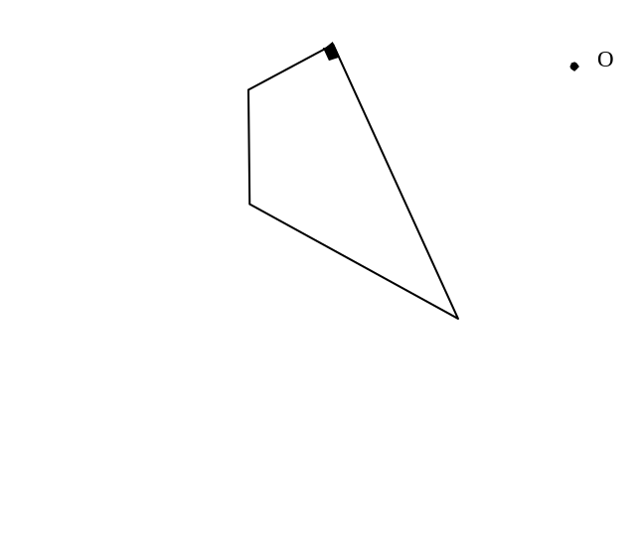

❷ Construct the image of the figure below using a factor of  with center O.

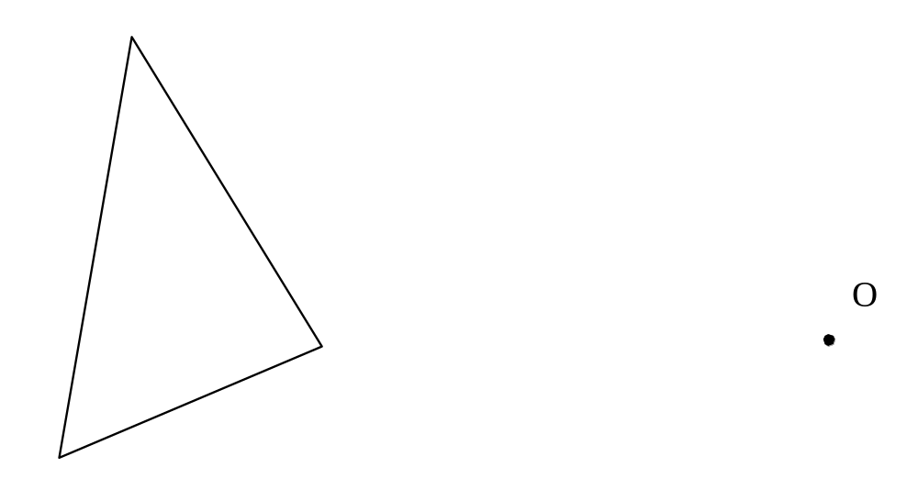

❸ Given triangle ABC and the figure below :

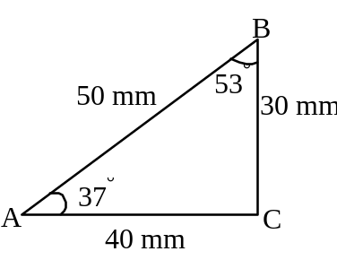
Which of the following triangles in the figure are similar to triangle ABC?
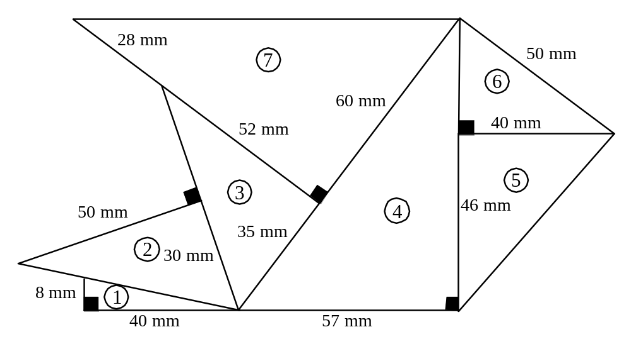

❹ Draw the image of quadrilateral ABCD using a similarity transformation with center O and a ratio of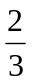.
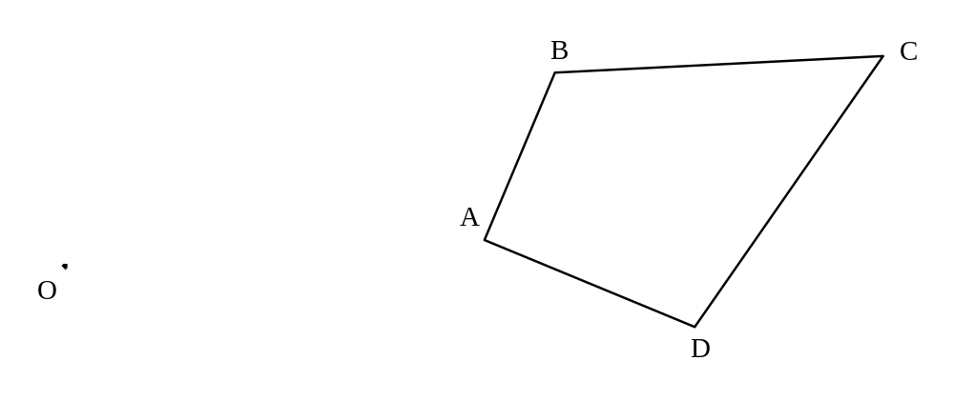
❺ Construct the image of this triangle using a scale factor of 2.

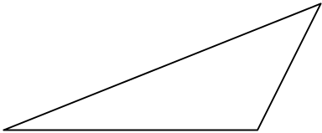

❻ Construct a figure similar to the triangle below. The resulting image is to be a dilatation (enlargement) using a scale ratio of 3:1 and point O as the dilatation center. Name the original triangle and its image.

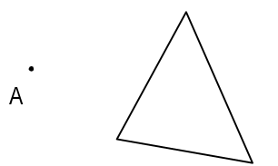
O•

❼ Construct triangle A'B'C' similar to triangle ABC below using the scale factor of .

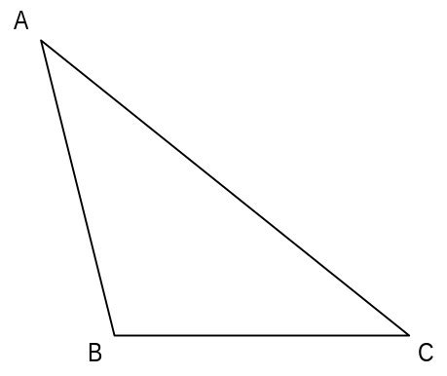
Similarity Transformation/Dilatation
Check 4 Understanding
Perform each of the following similarity transformations in the space provided using the method of you choice. Use a ruler and show all calculations.
***Each question is worth 10 marks! ☺

❶ Ratio of similarity of 1.5

A B

• F C
O

E D

❷ Ratio of similarity of ½

G A

•O

E T

❸ Ratio of similarity of 2 : 5
D

O• G

❹ Ratio of similarity of 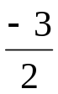

L I
O•

E V
❺ Ratio of similarity of ⁻0.5 [***notice the negative]

S
E

O•

M
L

I

❻ Ratio of similarity of 3 : 5
K H

I
A

O•

T
R

A Y

Unit 8 : Geometric Solids

❶ How much cardboard is needed to make this ice-cream carton?
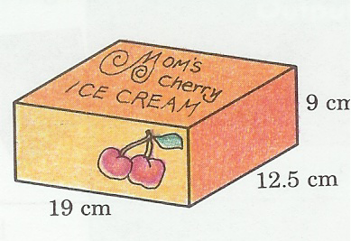
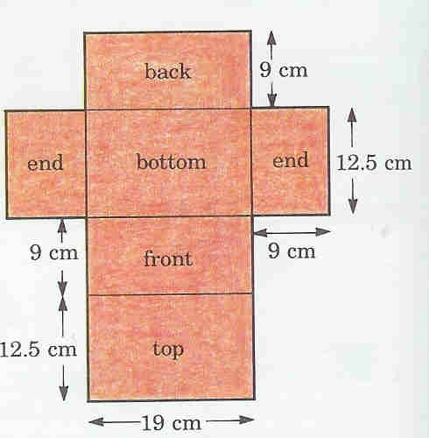

❷ Find the surface area of the box.
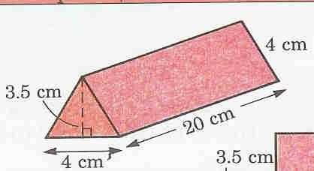

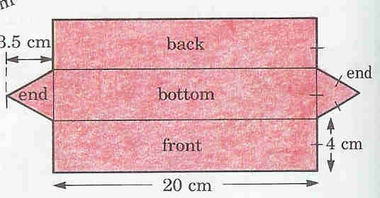

❸ Calculate the surface area; draw the NET if it helps you.
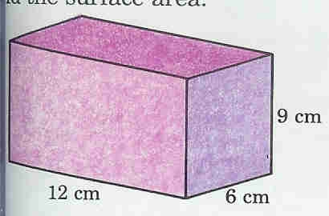

a)

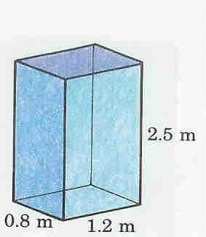

b)

c)
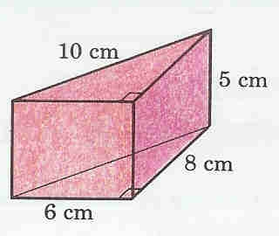

❹ This diagram shows a structure made of 8 cubes.
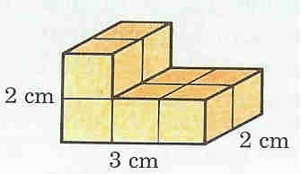
a) What is the surface area of the structure?

b) If you could move around the 8 cubes, what would be the least and greatest possible surface area? Sketch the possible structures.

❺ The four walls and ceiling of a bedroom are painted. The bedroom has
length 5.6m,width 4.2m and height 2.3m.

- Find the total are to be painted.

- From the total area subtract 3.6m² for the doors and 2.5m² for the windows. What area is remaining?

- If one liter of paint covers 10m², how much paint is needed for three coats?

❻ A rectangular prism has a square base with an area of 16m². What is the
height of the prism if its surface area is 192 cm²?

❼ A baking tin is made from a rectangular sheet of metal 18 cm by 28 cm by cutting 4 cm square out of each corner and turning up the sides. The inside surface is to have a non-stick coating. What the area that will be coated?

❽ Here are two geometric solids that you will cover with decorative paper. Which solid will use less paper? How much less decorative paper?
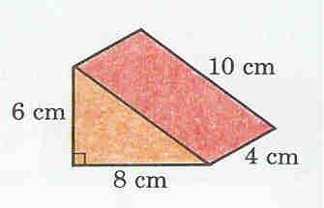
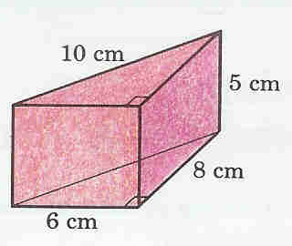

Geometric Solids : Check 4 Understanding

❶ On separate pieces of paper draw nets of any 3 of the following geometric solids:

- cube
- triangular prism
- rectangular prism
- square pyramid
- triangular pyramid
- cylinder

* Each net should take up as much of the sheet of paper as possible that is provided by your teacher.

❷ Label all side lengths or other important measurements.

❸ Calculate the surface area of each of your geometric solids.

❹ Choose one of the three nets that you drew and draw a scaled down version of this solid, use a ratio of 1 : 5 for this net.

❺ If I was to give you a piece of chart paper that measures 88 cm long by 60 cm wide. What is the largest factor of enlargement you could use to make your original net from #4 fit onto this piece of chart paper? [Note: Make this net as BIG as possible!]

Unit 9 Ω Probability

❶ a) What is a random experiment? ____________________________________________________________________________________________________________________________________________________________
b) Give an example of a random experiment.
____________________________________________________________________________________________________________________________________________________________

❷ Are these experiments random? Why or why not?
- Picking a card from a deck of cards Yes or No
_____________________________________________________________________
b) Passing your driver’s test on the first attempt Yes or No
_____________________________________________________________________
c) Rolling a die that is numbered 1 to 6 Yes or No
_____________________________________________________________________
d) Getting a good mark in your grade 8 math Yes or No
_____________________________________________________________________

❸ What is Ω and what does it mean? __________________________________________________________________________________________________________________________________________________________________________________________________________________________________________

❹ For each of the following random experiments give the set of possibilities.
a) Tossing a coin Ω = {_________________________________}

b) Rolling a die Ω = {_________________________________}

c) Guessing a one digit number Ω = {_________________________________}

d) Asking someone the month they were born
Ω = {_______________________________________________________________}

❺ What is the difference between a simple and a compound random experiment?
____________________________________________________________________________________________________________________________________________________________

❻ Determine if each of the following is a simple or compound random experiment?

a) Picking a card from a deck and observing the color simple or compound

b) Playing a game of Yahtzee simple or compound

c) Tossing a coin simple or compound

d) Rolling two dice and recording the sum of the digits simple or compound
❼ Stephanie has just started a new job, to look more professional she buys herself 4 new shirts, 3 pairs of pants and 2 pairs of shoes. How many different outfits can she create for herself?

❽ For the Graduation Ceremonies, the organizational committee has planned a concert. The invited artists are : Claude (song), Eric (monologue), Karine (music) and Veronique (song). Draw the tree that will enable you to find different ways to introduce these artists if the concert begins with a monologue and finishes with a song. (Use the artists' names.)

❾ The president of a cross-country ski club has found an easy and rapid way to contact all of his members. He established a telephone chain in three steps. First, he calls three members. Then, each person contacted must call three other members. Finally, those members just contacted must also call three members.

Draw the tree that corresponds to this situation and determine the number of members in this cross country ski club.

❿ Roger has just been hired by Allouette, a company that produces aluminum. They offered him 2 possible schedules : the day-shift or the night-shift. They offered him 2 types of jobs : manual worker or janitor. Finally they give him the choice of working in a plant in one of 3 different cities : Alma, Chicoutimi or La Baie.

Draw a tree diagram to illustrate all the possibilities offered to Roger.

❶❶ For a neighbourhood survey, residents had to answer a questionnaire made up of 3 true or false questions.

Draw a tree diagram to show all the possible ways this questionnaire could have been answered.

❶❷ Anne, Bernard and Lucy are sitting in the back seat of a car.

Draw a tree diagram to show all the possible seating arrangements that could have Anne and Lucy sitting side by side.

❶❸ The following menu is offered to students in the Michael Howland High School cafeteria for $2.00 :
MENU
Appetizer :  Main course :  Dessert : | Soup or Tomato Juice  Beef or Chicken paté or Ravioli  Fruit or Apple tart

A student may choose one item from each category. Draw a tree diagram and show the number of different combinations that can be chosen.
❶❹ "Cyclobec" manufactures 2 models of bikes: model V1 and model V2.

Model V1 is available in two different frame sizes (40 cm and 50 cm) and in three colors (green, red and blue).

Model V2 is available in three different frame sizes (50 cm, 60 cm and 65 cm) and in four colors (green, red, blue and black).

Kayla cannot ride a bike with a 40 cm frame and she dislikes black. Draw a tree diagram to illustrate all the possible choices of bikes from which Kayla can pick.

❶❺ The following is the lunch menu at a school cafeteria.
Appetizer : | tomato juice  chicken noodle soup
Main course: : | spaghetti with tomato sauce  chicken and chips  fish and chips  shepherd's pie
Dessert : | yogurt  sugar pie  cake  apple  pear
Drink : | apple juice  milk  coffee

For a complete meal a student chooses one item from each category. How many different complete meals are possible for a student who is allergic to tomatoes?
❶❻ A computer-users club has a large number of diskettes. Each diskette is identified by a code made up of a letter followed by 3 numbers as shown in the following diagram.

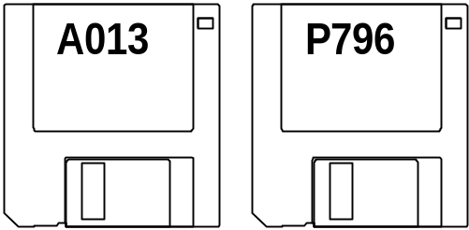

How many different codes can be made if the first one is A000 and all the letters of the alphabet?

❶❼ The cafeteria sells ice cream in both cylindrical cones and in conical cones in four flavours : banana, vanilla, neapolitan and mint.

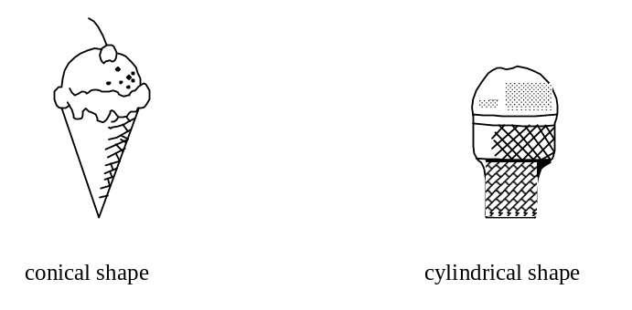

Draw a tree diagram to show all choices.
❶❽ Mrs. Murphy places 4 coloured marbles in a bag, 1 red, 1 green, 1 blue and 1 yellow. She draws a marble from the bag, records the color then replaces the marble in the bag. Then she makes a second draw. How many different pairs of marbles are possible?
***Draw a tree diagram to illustrate all possible outcomes.

2nd marble Outcome

1st marble

Start •

❶❾ Redo question #18 without replacement. Draw the tree diagram to represent the marble draws. How are the outcomes different without replacement?

2nd marble Outcome

1st marble

Start •

❷⓿ These two spinners are spun one after the other.
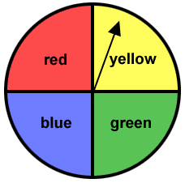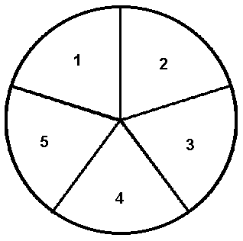

a) Draw a diagram [tree, table, etc.] to show all possible outcomes.

b) How many different outcomes are there? ____________________________________

❷❶ Determine the set of possibilities (Ω) by using the diagrams to help illustrate the outcomes of each compound random experiment.
1

a) b)
A
Red
2
H
B
3
Yellow
4
C
T
D
Green
5
6

# outcomes: ____________ # outcomes: ____________

❷❷ What is an EVENT?
__________________________________________________________________________________________________________________________________________________

❷❸ a) Give an example of an EVENT that is certain. ______________________________

b) Give an example of an EVENT that is impossible. _____________________________
c) What is the difference between compatible and incompatible EVENTS?
____________________________________________________________________________________________________________________________________________________________________________________________________________________________________________________________________________________________________

❷❹ Ten number tiles are placed in a bag, they are numbered 0 through 9. One tile is chosen at random. Determine whether the following events are compatible.

a) Getting a prime number and getting an even number YES NO

b) Getting a multiple of 3 and getting a multiple of 5 YES NO

c) Getting a divisor of 12 and getting a divisor of 15 YES NO

d) Getting an even number and getting an odd number YES NO

❷❺ Mrs. Murphy draws 2 cards from a deck. Are the events ‘drawing a heart’ and ‘drawing a face card’ compatible?

YES NO WHY? WHY NOT? _____________________________________________
__________________________________________________________________________________________________________________________________________________

❷❻ A card is drawn at random from a set of 26 game cards each bearing a different letter of the English alphabet.

Describe the complement of the following event:

{b, c, d, f, g, h, j, k, l, m, n, p, q, r, s, t, v, w, x, z}

❷❼ A bag contains one black ball, two blue balls, three green balls and four red balls. One ball is randomly drawn out of the bag.

What is the probability of picking either a green ball or a blue ball? Express your answer as a percentage.

Probability : Probability Check 4 Understanding
❶ What is the probability of each of the following occurring?

a) Selecting a vowel from among the letters in the French word "oui"

b) Rolling a 6 with a regular die

c) Selecting an ace from a deck of 52 cards

d) Picking out a red marble from a bag containing 12 blue marbles

❷ Students in art class have to hand in an example of their work at the end of the term. They are given several options for their projects.
Step 1 : | The topic  - a portrait (p)  - a landscape (l)
Step 2 : | Material  - water paints (w)  - charcoal pencils (c)  - felt markers (m)
Step 3 : | Method of working  - in a team (t)  - alone (a)

a) How many different ways are there to complete the project?

b) List all of the possibilities by means of a tree diagram.

❸ A company is asked to make license plates for bicycles.
The license plate numbers and letters are to follow a specific pattern: a letter, a number, a letter and a number.

Here is an example: | A2C4

All 26 letters of the alphabet may be used, but only the following numbers:
1, 2, 3, 4, 5, 6.

Any letter or number may appear more than once on the licence plate.
How many different licence plates can the company make, given these conditions?

❹ The ages of 30 secondary 3 students are listed in the table below.

AGE | BOYS | GIRLS
13 | 3 | 4
14 | 4 | 5
15 | 5 | 5
16 | 3 | 1

If one student is selected at random, what is the probability that :

a) the student will be 13 years old?

b) the student will be a 15-year-old girl?

c) the student will not be a 16-year-old girl?

❺ Using a regular deck of playing cards (52 cards), what is the probability of pulling out each of the following :

a) a black card ______________

b) a face card (king, jack, queen) ______________

c) a club ______________

d) an ace ______________

e) an ace of hearts ______________

❻ Albert, Dean and Justin want to slide down a hill on their three-seater toboggan.

How many different ways can they position themselves on the toboggan?

❼ A bag contains 7 greens balls and 4 yellow balls. What is the probability of picking one green ball at random on the first pick?

❽ A lottery was organized to raise funds for the school orchestra. 500 tickets were sold for $100 each. One company bought 25 tickets for its employees. What is the probability that the winning ticket will be one that the company bought?

❾ Michael is a magician. He wants to perform the following tricks :

1- | Draw the ace of hearts from an ordinary deck of cards.
2- | Pull a rabbit out of a hat.
3- | Throw two dice and roll a total of 7.
4- | Make a live poodle disappear.
5- | Toss three quarters and get 3 heads.

Some of these tricks will require real magic. Others can occur because of chance.

Which of these can occur by chance?

❿ At the Super Roulette Game, Allison has to spin the wheel to find out how much money she could win.
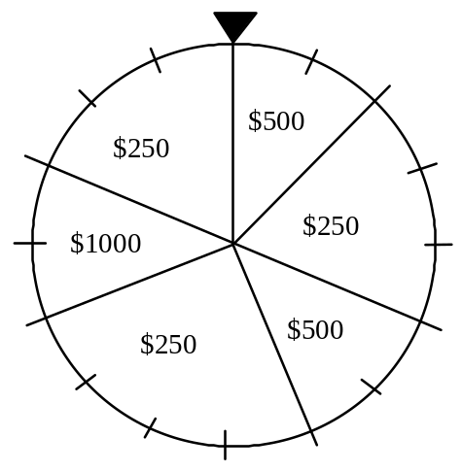

What is the probability of Allison winning $250?

❶❶ Paula, Louise and Genevieve organized a drawing. Each of the 3 prizes to be drawn was a ticket for a Celine Dion concert.

The 8 people invited to the party each took a turn to draw from the bag containing the tickets. The bag held 5 blank tickets and 3 real tickets.

No ticket drawn was put back into the bag.

1st draw : | Cecile picked a blank ticket.
2nd draw : | Laura picked a real ticket.
3rd draw : | Matt picked a blank ticket.
4th draw : | Susan picked a blank ticket.
5th draw : | Genevieve picked ...

What is the probability that Genevieve will pick a real ticket for the concert?

REVIEW QUESTIONS #1

❶ Charlotte leaves school at the end of the day. The following graph represents the distance between Charlotte and her house since she left school.
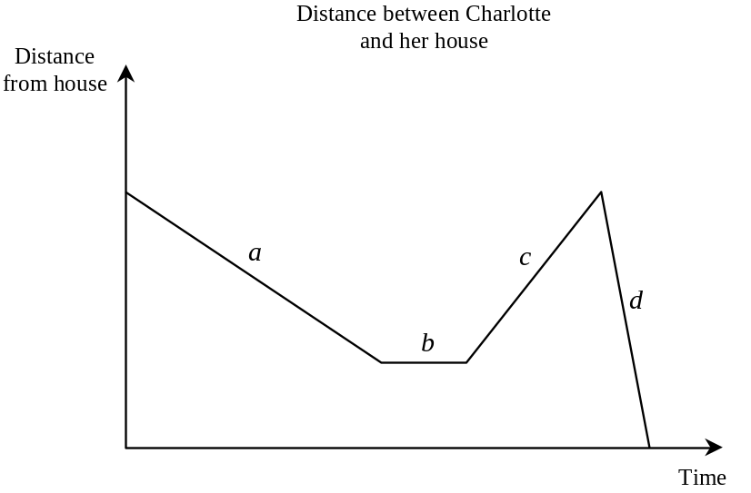
In your own words describe what is happening in the graph above, give reasons for your opinions.
____________________________________________________________________________________________________________________________________________________________________________________________________________________________________________________________________________________________________

❷ Brian spends 24 hours a week on his favourite activities: piano, television and the Internet. He spends twice as much time on the Internet as he does watching television. He spends three more hours playing the piano than surfing the Internet. Given x, the time spent watching television. How much time does Brian spend on each activity?

❸ Jill sometimes dries apples for a healthy snack. At the end of the drying process, the apple slices are reduced to 60% of their original mass. Today she has 4.5 kg of dried apple slices. How many kilograms of fresh apple slices did Jill have to begin with?

❹ In the figure on the right, triangle A'B'C' is the image of triangle ABC resulting from a similarity transformation with centre O.  The measures are given in units.  What is the RATIO of similarity? | 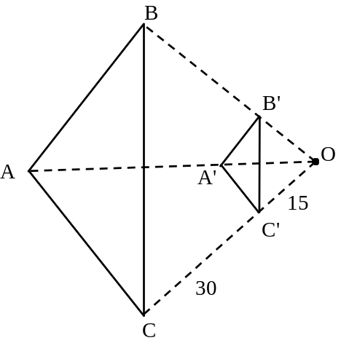

❺ A circle with centre O is shown on the right. Its radius measures 9 cm. Angle AOB is 110°.  What is the measure of arc AB? | 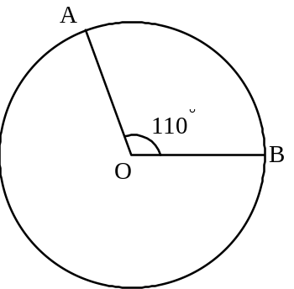

❻ A bag contains 12 blue chips, 8 white chips and 4 red chips. What is the probability of pulling a white chip out of the bag?

❼Amanda, Brigitte, Claire, Diane and Elsa are all equally qualified athletes. Only two of them will be selected to attend the track meet in Québec City. Their names will be drawn at random. What is the probability that Brigitte will NOT be selected?

❽ The basic rate to rent a snowboard is $12 and $3 for each hour it is rented. Complete the table of values representing this situation.
Hours Spent Snowboarding | 2 |  | 5 |  | n
Total Cost of Snowboarding ($) |  | 21 |  | 33

❾ What is the value of x in each of the following equations?
a) 2(3x − 2) − 8 = -2x + 4 b) 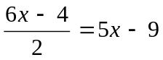

❿ Draw A'B'C', the image of triangle ABC under a similarity transformation with centre O and scale factor. Label the vertices. Show all construction lines.

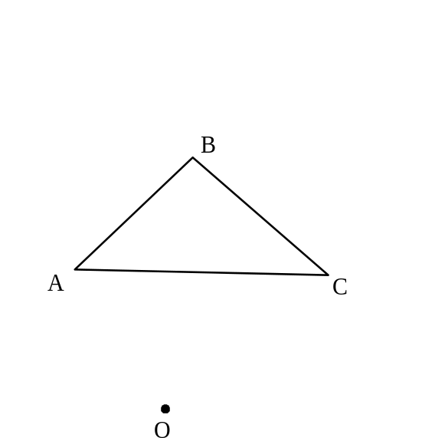

❶❶The area of the equilateral triangle on the right is 15.6 cm².

Its height is 5.2 cm.

What is the perimeter of this equilateral triangle?

❶❷The length of a rectangular photo is 1 cm longer than its height. Michael had the photo enlarged in the ratio 8 : 1. The perimeter of the enlarged photo is 144 cm. What are the dimensions [length & width] of the original photo?

❶❸Kristen picked 30 flowers from her garden and arranged them into a bouquet. She chose her three favourite flowers: carnations, roses and daisies. She picked 5 fewer carnations than roses. She also picked 3 times as many daisies as carnations. How many flowers of each type were in Kristen's bouquet?

❶❹ Sara, Terry and Mark used all the money in the student council budget to buy various items for a school raffle.

Sara spent 4 times as much money as Terry did.
The ratio of Sara's spending to Mark's spending was 2 : 5.
Terry spent $85.

How much money was in the student council budget?

❶❺ In the disc on the right, 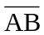 is the diameter.  The striped portion represents 20% of the total surface area of the disc.  The shaded portion measures 12 cm².  What is the total surface area of the disc? | 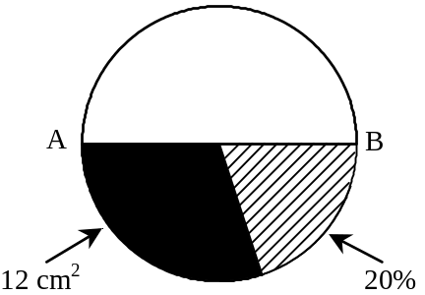

❶❻The adjacent figure is made up of both a regular octagon inscribed in the circle with centre O and an isosceles triangle, AOB.  The area of the regular octagon is 750 cm².  Its apothem is 15 cm.  The circumference of the circle is 102.1 cm.  What is the perimeter of isosceles triangle AOB? | 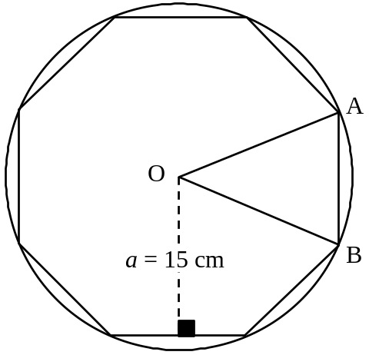

❶❼ Tom randomly places the numbers 8, 10 and 18 into the three empty boxes in the equation below. He uses a number only once in each equation.

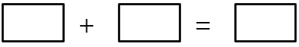

What is the probability that the equation will be TRUE?

REVIEW QUESTIONS #2

❶In Computer Science class, students determine how fast they can accurately type. Sophie is able to type 35 words in 60 seconds. Determine if each of the following students type faster, slower or at the same speed as Sophie and explain how you know.

A] Mackenzie types 32 words in 60 seconds Faster Slower Same
______________________________________________________________________
B] Joey types 35 words in 80 seconds. Faster Slower Same
_____________________________________________________________________
C] Emily types 37 words in 55 seconds. Faster Slower Same
_____________________________________________________________________
D] Mark types 70 words in 120 seconds. Faster Slower Same
_____________________________________________________________________

❷Determine if each of the following situations represents a proportional situation or not? Give good clear reasons for your answer in each case.
A] Is this a proportional situation?
Why or why not?
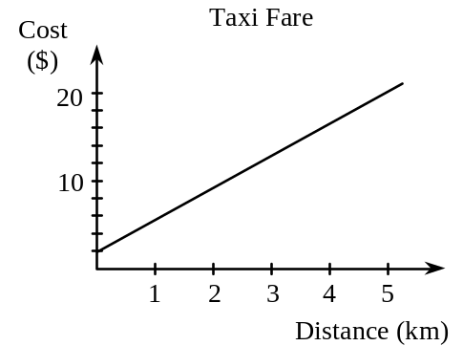
B] Is this a proportional situation?

Why or why not?
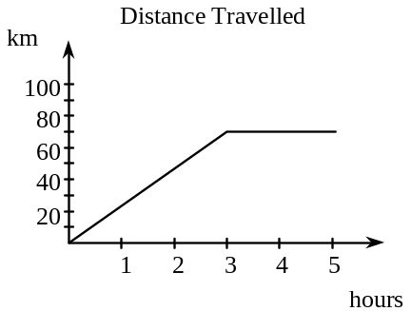
C] Sarah works 15 hours and earns $105; she works 35 hours and earns $280

Is this a proportional situation? Why or why not?

D] Is this a proportional situation?
Why or why not?
 | Store
 | Packs of gum | Price ($)
 | 4  10  15 | 3.20  8.00  12.00

❸Triangle A'B'C' is the image of triangle ABC under a dilatation (similarity transformation) with centre O. The measures of the sides are as given.

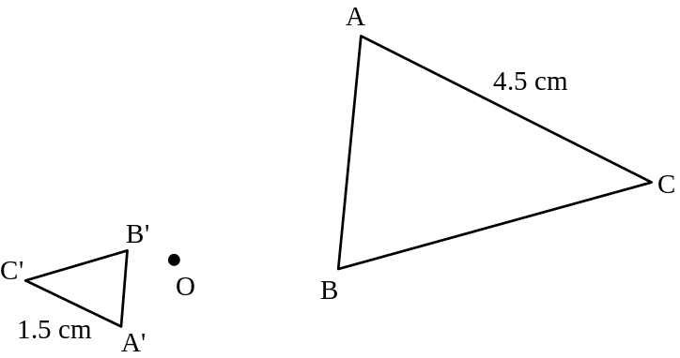

What is the scale factor (ratio of similarity) for this transformation?
❹A picture frame is in the shape of a regular octagon with side 8.3 cm. The artist who designed the frame would like to design another one in the shape of a regular pentagon, but with the same perimeter as the original. What is the length of one side of this new frame?

The length of one side of the new frame is: _____cm

❺Amy (A), Brennan (B), Cary (C) and David (D) have been selected to represent Quebec at a national public-speaking competition. The students' names will be selected randomly to determine the order in which they will give their speeches. In how many of the possible outcomes does Brennan appear first? Use a tree diagram to find the answer.

S
T
A
R
T

•

❻In a word game there are 45 vowel cards. The number of cards for each vowel is listed below.
Vowels | A | E | I | O | U
Number of cards | 9 | 15 | 8 | 6 | 7

A card is drawn at random from these vowel cards. What is the probability of drawing a card with the letter E?
❼a) Ally bought a pair of shoes regularly priced at $90. They were on sale at 20% off.
What was the sale price of the shoes?

7
Answer: $__________

b) Ally also bought a pair of boots for $110 and paid 15% sales tax on this amount.
What was the total price she paid for the boots?

Answer: $__________

❽Simplify each of the following expressions:

a) -2(3a − 5) | b) 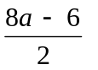

❾Solve for x in the following equations:

a) 3x + 2(4x − 13) = -2x | b) 5x + 18 = 3 − x

❿The sections of the graph below can be described by some of the following statements.

Depth of Snow in a Park | Statements
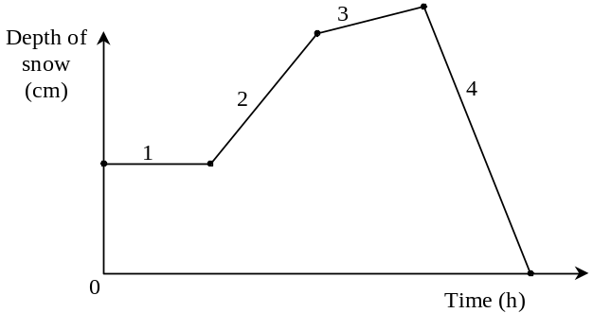  5 | A There is no snow on the ground.  B The snow melts until it is gone.  C No snow is falling.  D Light snow is falling.  E Heavy snow is falling.

Match each section in the graph with the appropriate statement. You may use a statement only once.
Section of Graph | Statement (use letter)
1
2
3
4
5

❶❶Peter wants to rent a bicycle while at the beach. The rental cost is $3.00 plus $2.00 for each hour that he keeps the bike. Complete the table of values that represents this situation.

Number of hours | 2 | 5 | 6
Rental costs ($) |  |  |  | 19.00

❶❷Maria is in charge of mixing fruit drinks for the basketball team. For every 2 servings, she mixes 0.5 L of water, 25 mL of orange juice concentrate and 5 mL of sugar. How much orange juice concentrate will she need to serve the 11 players on the team?
❶❸The sketch of a piece of plastic used to make a kite is shown below. Jill would like to make a similar kite, using a dilatation (similarity transformation). Construct and label the image K'I'T'E' of this kite, using a scale factor (ratio of similarity) of 2 and centre O.
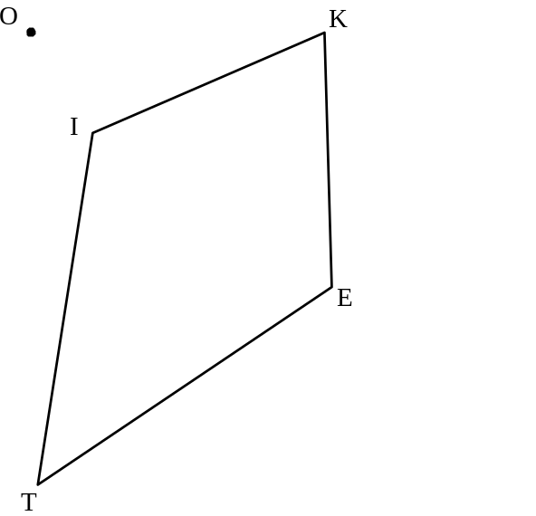

❶❹Stephanie, her brothers Simon and Burch each contributed money to buy their parents an anniversary gift. Simon contributed twice as much as Stephanie and Burch contributed $10 more than three times the amount contributed by Stephanie. Together they contributed $310. How much did each person contribute?

Stephanie contributed $______; Simon contributed $______; Burch contributed $______.

❶❺An artist is designing the front cover of a children's book. The length of the front cover of the rectangular book is 4 cm less than twice its width. The perimeter of the front cover is 166 cm. What is the area of the front cover of this book in cm²?

❶❾Cassie usually pays $20 for a haircut, taxes included. The last time she had her hair cut, she bought some hair conditioner for $13. She had to pay a tax of 15% on this. Her total bill for the hair cut and the conditioner was $40.95. Surprised, Cassie realized that the cost of a haircut must have gone up. By what percent has the cost of a haircut increased?

❷⓿Helene has three "loonies" ($1 coins), and one quarter ($0.25) in her pocket. She randomly takes two coins out of her pocket. What is the probability that she will NOT have taken $2.00 from her pocket?

REVIEW QUESTIONS #3

❶ Immediately after a soccer game, Ronaldo's heart rate was high. It started to drop quickly and then settled at his normal rate. Which of the following graphs represents his heart rate after the game?
A) | 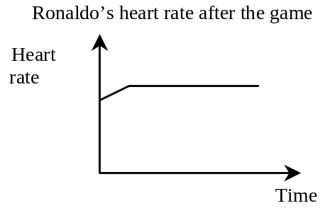 | C) | 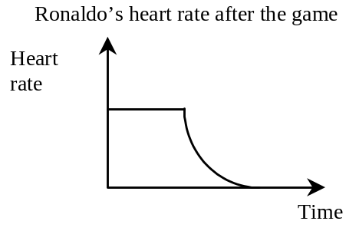
B) | 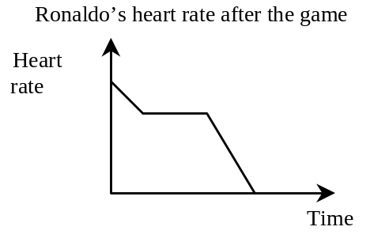 | D) | 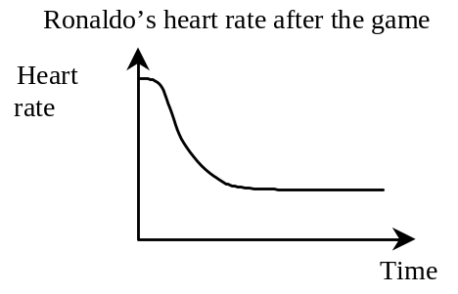

❷ David earns $100 for working 8 hours.

Sheila earns twice as much money as David does for working the same number of hours.

Greg earns the same amount of money as David for working twice as many hours.

Chris earns twice as much money as David for working twice as many hours.

Who earns the highest hourly rate of pay?

❸ Which of the following represents a proportional situation? Explain why it is proportional.
A) | 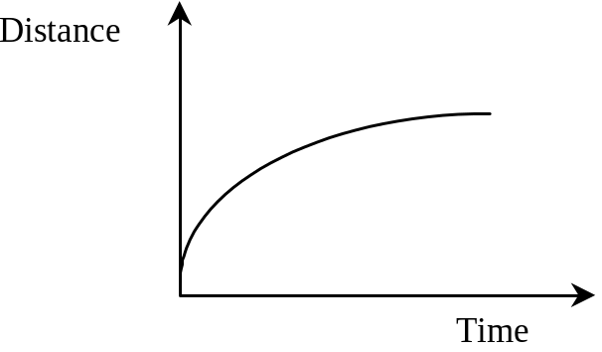
B) | Number of tickets | 3 | 4 | 7
B) | Total cost ($) | 13.50 | 18 | 31.50
C) | 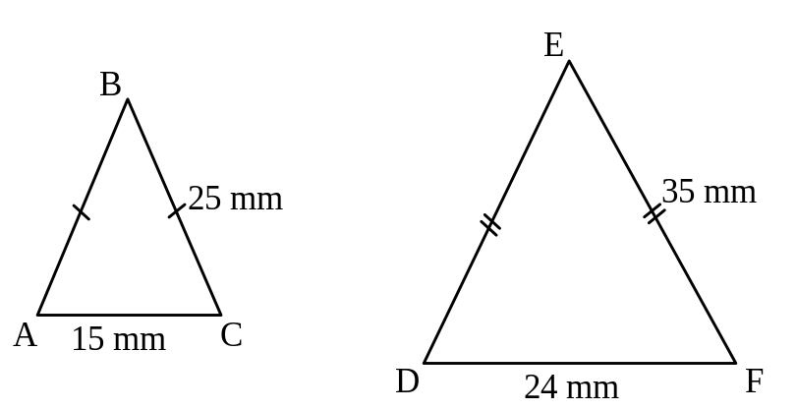
D) | The number of apples on a tree in relation to its height.

❹ Mr. Stevens has won $1000. He decides to donate the money to UNICEF, the Children’s Hospital, and the Cancer Foundation.

• He gives the Children’s Hospital twice as much money as he gives to UNICEF.

• He gives the Cancer Foundation $200 more than the amount he gives to the Children’s Hospital.

Let x represent the amount that he gives to UNICEF. How much does he give to each charity?
❺ A regular hexagon with a side length of (a − 2) cm undergoes a similarity transformation (dilatation) with a scale factor of 3. What is the perimeter of the enlarged regular hexagon?

❻ Which of the triangles below is NOT similar to the triangle at the right?  (Note: The figures are not drawn to scale) | 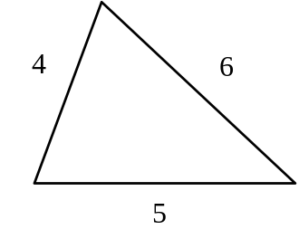

A) | 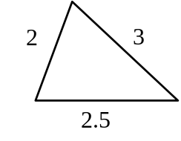 | C) | 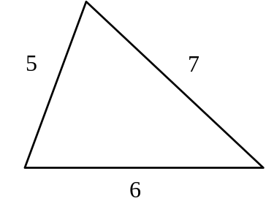
B) | 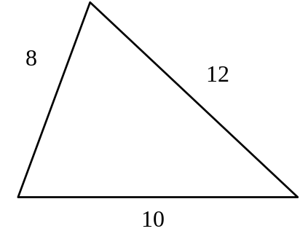 | D) | 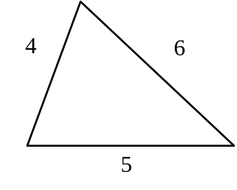

❼ A fair 6-sided die is tossed. Which of the following are complementary events?

A) | Tossing an even number  Tossing an odd number | C) | Tossing a multiple of 2  Tossing a multiple of 4
B) | Tossing a number less than 4  Tossing a number greater than 4 | D) | Tossing a 1 or a 2  Tossing a 5 or a 6

❽ Joe and Daniel are the coolest D.J.s to have at a high school dance. They teach the crowd their hip-hop dance moves.

Joe knows 4 less than twice as many hip-hop dance moves as Daniel.

Complete the following table of values to represent the given situation.

Number of hip hop moves (Daniel) | 5 | 8 |  | rule
Number of hip hop moves (Joe) | 6 |  | 26

❾ a) Simplify b) Solve

3(4x + 2) − (2x + 7) 5x + 4 − 8x = 7x − 12

❿ Rylee bought a T-shirt while on vacation. The T-shirt was on sale at 25% off the regular price of $15.99. The sales tax was 5%. What total amount did Sophie pay for the T-shirt?

.

❶❶ A cook, Henri, is making salad dressing for a large wedding party.

He uses a 1 : 4 ratio of vinegar to oil. Henri pours 2 cups of vinegar and 8 cups of oil into a large bowl.

Henri’s assistant, Jessica, knows that more salad dressing is needed. Jessica pours 3 cups of vinegar into the large bowl.

Exactly how much oil must Jessica pour into the mixture to keep the ratio of vinegar to oil at 1 : 4?

❶❷ The floor area of a room has the shape of a regular pentagon, as shown below.
Its area is 440 m² and its apothem is 11 m.
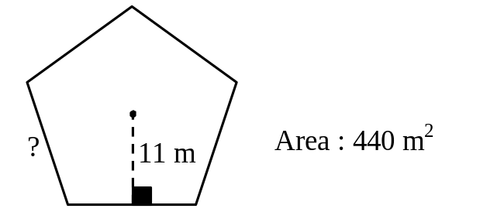
What is the length of one side of the floor?

❶❸ Jane ate a very large slice of pizza. The central angle of the slice was 80°.

The diameter of the pizza was 60 cm.

What was the area of the slice of pizza that Jane ate? (Use π = 3.14)

❶❹ A teacher has a class of 26 students: 14 girls and 12 boys.

The teacher has two prizes to give away and decides to put all the students’ names into a bowl.

The teacher will then draw 2 names.

(Note: The name of the first winner is not put back into the bowl for the second draw.)

What is the probability that both prizes will be won by boys?

❶❺ On his first typing test, Kyle typed 120 words in 5 minutes. Since then, he has been practicing and his typing rate has increased by 25%.

How many words can Kyle type in 12 minutes at his new rate?

❶❻ At the MacDonald Aircraft Company, engineers make up 30% of all the employees.

The ratio of left-handed to right-handed engineers is 1 : 4.

There are 60 right-handed engineers in the company. How many employees are there in the company?

❶❼ Rachel worked as a lifeguard at a hotel pool for three summers in a row.

In 2001, she worked 4 weeks more than she did in 2000.

In 2002, she worked 2 weeks less than the sum of the weeks she had worked in 2000 and 2001.

During these three summers, she worked a total of 30 weeks. How many weeks did she work in 2002?

❶❽ The area of the shaded part of the regular octagon on the right is (5x − 7) cm².  The area of the whole octagon is 44 cm².  What is the value of x? | 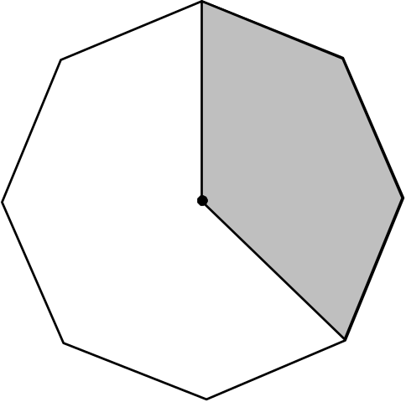

❶❾ The home football team can win the championship only if all three of the following conditions are met:

• The quarterback is healthy.
• The visiting team’s running back plays badly.
• It does not rain on the day of the game.

There is an 80% chance that the quarterback will be healthy.
The visiting team’s running back played badly seven times in the 10-game season.
There is a 25% probability of rain on the day of the game.

What is the probability of the home team winning the championship?

❷⓿ A sports field is in the shape of a rectangle with 2 semicircles.  A running track, shown in bold on the diagram, surrounds this field. | 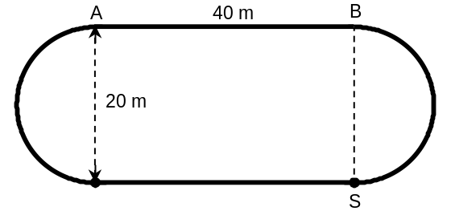
The diameter of each semicircle is 20 m. The distance from A to B is 40 m.

A runner starts from point S and runs 80% of the track. What is the distance covered by the runner? (Use π = 3.14)

❷❶ The City of Gatineau has just built a new park. Its shape and dimensions are shown in the diagram.  James mows the grass for all Gatineau parks. | 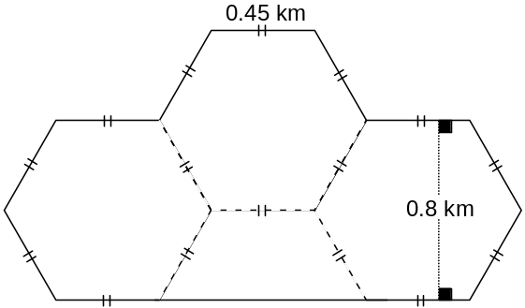

It takes him 2 hours to mow an area of 1.5 km². How long will it take him to mow the grass at this new park?

