|  |  |
| --- | --- |
| Math MCU | Worksheet – Exam Review 3 |

1. What is the slope of the line *x*  *y*   

 What is the slope of the line -2y + 10 + 2x = 0 ?

3. What is the distance between the points (10, 19) and (13, 9) ?

 What is the distance between the points (-6.8, 0.7) and (-2.1, -6.2) to the nearest hundredth?

5. What is the distance between the points (16, -6) and (1, 2) ?

6. Point M is located exactly half way between points A(-4, -6) and B(8, 4). What are the coordinates of point M?

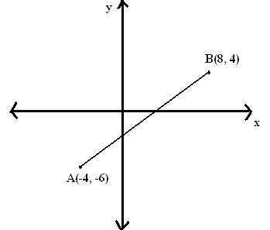

7. What are the coordinates of point B, given that point M is the midpoint of line segment AB?

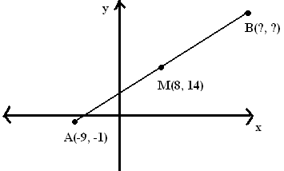

8. Write the equation of a line that passes through the point A(-1,3) and which is parallel to the line of equation 2x-y+7=0.

9. The map below shows two streets in the town of Springfield, Anderson Street and Murphy Street. The streets are perpendicular and intersect at point C(2, 0). Given that Anderson St. is defined by the equation y = 3x -6, what is the equation of the line representing Murphy Street?

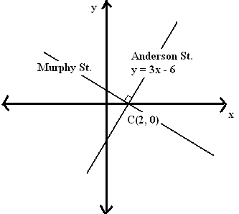

10. The map below shows two streets in the town of Franktown, Lewis Street and Brady Avenue. The streets are parallel. Tom’s Diner is located at coordinates (15, 4), which is on Brady Avenue. Given that the equation of Lewis St. is y = 3/5x + 4, what is the equation of the line representing Brady Avenue?

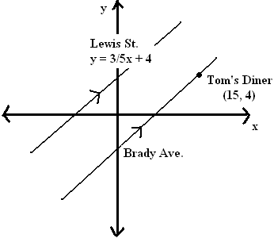

11. What is the equation of the line passing through the points (0, 10) and (10, -20)?

12. What is the equation of the line passing through the points (4, 1) and (-4, 7)?

13. Without graphing, determine the equation of the line that passes through the point (-2, 3) and is perpendicular to the line y = - ¼ x + 4.

14. Amy, Eric and Alana all attend D’Arcy McGee High School. They all live on the Harrison Boulevard as shown on the Cartesian plane below. Eric’s house is exactly 4/5 of the way from Amy’s house towards Alana’s house. What are the coordinates of Eric’s house?

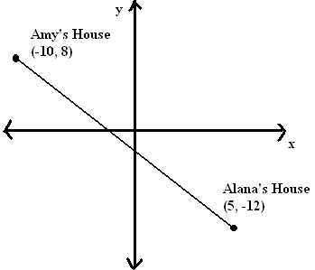

1. Brad, Jacques and Helen all attend D’Arcy McGee High School. They all live on Vanier Rd as shown in the diagram below. Brad’s house is located exactly 2/3 of the way from Helen’s house towards Jacques’ house. What are the coordinates of Brad’s house?

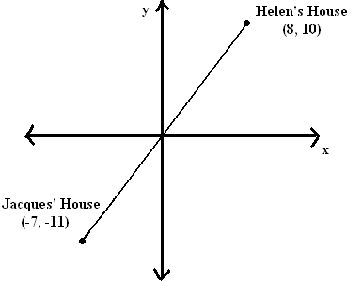

16**.** In a pack of chocolate candies there are 3 red, 5 blue and 7 yellow candies. A candy is randomly chosen. What is the probability of choosing a red candy?

A)  C) 

B)  D) 

17**.** There are 12 girls and 17 boys in a math class. Which of the following statement is correct?

A) The odds of picking a girl from the class are 

B) The odds against picking a girl from the class are 12 to 17

C) The odds of picking a boy from the class are 17 to 29

D) The odds of picking a boy from the class are 17 to 12

18.A class of math students were asked how many hours of sleep they got in a given night. The following data represents their responses.

**4, 5, 5.5, 6, 6, 6.5, 7, 7, 7, 7, 7, 7.5, 8, 8, 8, 8, 9, 9, 9.5, 11**

The number of hours of sleep that David got in a given night has a percentile rank of 57. How many hours of sleep did David get?

A) 6.5 hours C) 7.5 hours

B) 7 hours D) 11 hours

19**.** Below are the marks of the eight finalists in a mathematics contest:

**60, 61, 74, 69, 77, 69, 82, 68**

What is the value of the mean deviation of this distribution?

A) 0 C) 5.75

B) 4.25 D) 6.15

20**.** The scatter plots below represent three distributions.



Which of the following presents distributions, in order, from the weakest to the strongest linear correlation?

|  |  |  |  |
| --- | --- | --- | --- |
| A) | 1, 2, 3 | C) | 2, 3, 1 |
| B) | 2, 1, 3 | D) | 3, 2, 1 |