MCU414 |  | Congruent Triangles Worksheet #1
1. | For questions 6-15, determine whether the following triangles can be proven congruent using the given information. If they can be proven congruent, state which minimum condition allows you to prove it.
 | 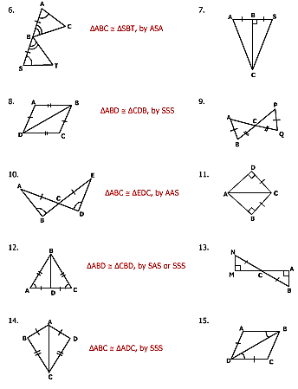
2. | For questions 16-25, state one additional fact that is required to make the triangles congruent, and then state which minimum condition was used to prove congruency.
 | 