**1.** The following are the marks on a math exam in a class of 18 students.

**46, 55, 59, 60, 61, 61, 61, 65, 73, 73, 73, 79, 85, 86, 88, 88, 92, 95**

1. Neil got a mark of 61. What is his percentile?

1. Chris was in the 90th percentile. What was his mark?

**2.** Below lists the number of push-ups completed by Bootcamp students.

|  |  |  |  |  |
| --- | --- | --- | --- | --- |
| **10, 12, 12, 15, 15, 15, 16** | **…………** | **17, 20, 20, 20, 20, 20, 21** | **…………** | **25, 26, 28** |
|  | 10 data values |  | 5 data values |  |

**What is the percentile of the student who completed 20 push-ups?**

**3.** A list of employee’s salaries was drawn up in the company where Fred works. Of the 380 employees,

* 145 earn a salary that is less than Fred’s
* 232 earn a salary that is greater than Fred’s

**What percentile is associated with Fred’s salary?**

**4.**  Given the following data set:

**10, 11, 14, 15, 16, 16, 18, 20**

what is the mean deviation of the data?



**5.**

**6.** Scientists are studying the link between smoking & the possibility of developing cancer. After several detailed studies in different settings, they came to the following conclusion: *“The more smokers there are in a population, the greater the number of cancer cases.”* Which of the following statements is true?

A) The correlation is zero C) The correlation is positive

B) The correlation is perfect D) The correlation is negative

**7.**

**8.** The following scatter plots represent a statistical distribution between two variables.

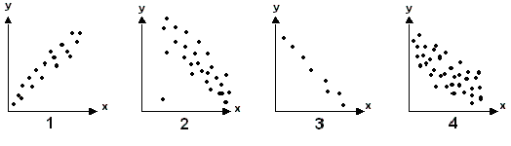

a) Rank the scatter plots from highest to lowest correlation.

b) Which scatter plots show a negative correlation?

c) Which scatter plot represents a scenario where “both

variables vary in the same direction”?

d) Which scatter plot(s) would represent the following situation:

“The resale value of a car and the age of the car.”

**9.** Brooke is applying to an Honours program at CEGEP. Below are her marks:

**Chemistry: 92 Math: 90 Physics: 88 English: 85 French: 80**

The mean of her marks is 87.

To be accepted, she must meet the following conditions:

* The mean deviation of her five marks must be less than 4
* Her math mark must be in the 88th percentile or better of all the applicants’ math marks

The math marks of all applicants, including Brooke’s, are shown below:

|  |  |  |  |  |
| --- | --- | --- | --- | --- |
| **80, 80, 85, 85, 86, 86, 86** | **……………..** | **87, 88, 88,88, 89, 89, 90, 91,** | **…………** | **92, 92, 92** |
|  | 100 data values |  | 65 data values |  |

**Will Brooke meet both conditions & be accepted into the program?**

**From the past…**

**10.** The equation of line  is . Another line  is **perpendicular** to the first line. What is the equation of line?

A)  C) 

B)  D) 

**11.** What is the area of triangle CDE?

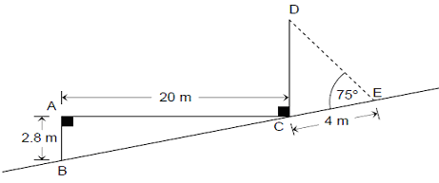

**12.** In a game of chance players must open 1 out of 8 doors. Different designs are hidden behind these doors. The following diagram shows the designs hidden behind these doors.

To play this game, you must bet $5 and randomly chose a door. If the design behind the door is:

* A heart, you receive $8.
* A triangle, you receive nothing.
* A star, you receive a certain amount of money.

If the game is fair, how much will a player receive if they choose the door with a hidden star?